

**VXLAN EVPN Fabric and automation using Ansible**

**LTRDCN-1572**

Faisal Chaudhry, Principal Architect

Lei Tian,  Solution Architecture

**Powered by**



# VXLAN Introduction

VXLAN stands for **Virtual Extensible Local Area Network**. VXLAN is a L2 overlay scheme on top of L3 network or we can say it is a L2 in layer 3 tunnel. It runs over the existing networks and provides the means to stretch the L2 network. Only VMs within the same VXLAN segment can communicate with each other. Each VXLAN segment is identified by a 24 bit segment ID called “**VXLAN Network Identifier (VNI**)”. This help overcome 4094 VLAN scale limitation and able to extend it to 224 segments.

VXLAN uses BGP as its control plane for Overlay. It makes it forwarding decisions at VTEPs (Virtual tunnel end points) for layer-2 and layer-3. Forwarding happens based on MAC or IP learnt via control plane (MP-BGP EVPN) . VXLAN uses IGP, PIM and BGP as its underlay in the fabric.

Below are Some of the terminologies that will be used in the lab

**VNI / VNID** – VXLAN Network Identifier.

This replaces VLAN ID. This is VXLAN ID

**VTEP** – VXLAN Tunnel End Point.

This is the end point where the box performs VXLAN encap / decap

This could be physical HW (Nexus9k) or Virtual (Nexus 1000v, Nexus 9000v)

**VXLAN Segment** - The resulting layer 2 overlay network

**VXLAN Gateway** – It is a device that forwards traffic between VXLANS. It can be both L2 and L3 forwarding

**NVE** – Network Virtualization Edge

NVE is tunnel interface. It represents VTEP

# Ansible Introduction

Ansible is an agentless open source software that can be used for configuration management, deployment and orchestration of deployment. The scripts in Ansible are called **playbooks**; playbook is in **YAML** format that was desgiened to be easy for humans to read and write. Playbooks include one or more plays, each play include one or more tasks. Each task is associated with one module, which is what gets executed in the playbook. **Modules** are python scripts that ship with Ansible installation. During the lab, you will be introduced to multiple NXOS modules and ansible template module. You can find all Ansible modules documentation from

<http://docs.ansible.com/ansible/latest/list_of_all_modules.html>

Below are some of the terminologies that will be used in the lab

* **Host**: remote machines that Ansible manages
* **Group**: several hosts that can be configured together and share common verables
* **Inventory**: file descripts hosts and groups in Ansible.
* **Variable**: names of value (int, str, dic, list) referenced in playbook or template
* **YAML**: data format for Playbook or Variables in Ansible
* **Playbook**: the script to orchestrate, automate, deploy system in Ansible. One playbook can include multiple plays.
* **Roles**: group of tasks, templates to implement specific behavior
* **Jinja2**: a Python based tempting language

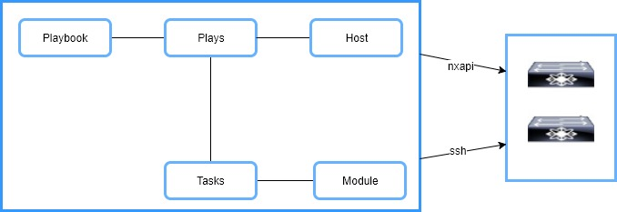

# About This Lab

As a standardized overlay technology, multiple vendors have adopted VXLAN as datacenter solution to provide scalability and allow layer 2 across IP network. MP-BPG EVPN as VXLAN control plane protocol provides a robust scalable solution to overcome the limitation in VXLAN flood and learn mode.

As a open source automation tool, Ansible provides the same framework for network administrators to automate network infrastructure as the rest IT organization.

This lab demostates the possibility of using Ansible to automate datacenter VXLAN fabric day 1 provisiong and day 2 operations.

### Lab Flow

1. Ansible installation
2. Ansible playbook
3. Day 1 automation using Ansible
4. Day 2 automation using Ansible
5. Day 0 automation
6. L4-L7 Service insertion

### Lab Access

|  |  |  |
| --- | --- | --- |
| Spine_1 | 198.18.133.33:1030 | admin/C1sco12345 |
| Spine_2 | 198.18.133.33:1040 | admin/C1sco12345 |
| Leaf_1 | 198.18.133.33:1050 | admin/C1sco12345 |
| Leaf_3 | 198.18.133.33:1070 | admin/C1sco12345 |
| Leaf_4 | 198.18.1333.33:1080 | admin/C1sco12345 |
| Server_1 | 198.18.134.50 | root/C1sco12345 |
| Server_3 | 198.18.134.52 | root/C1sco12345 |
| Server_4 | 198.18.134.53 | root/C1sco12345 |
| Ansible Server | 198.18.134.150 | root/C1sco12345 |
| DCNM | 198.18.134.200 | admin/C1sco12345 |
| Remote Workstation | 198.18.133.36 | demouser/C1sco12345 |

### Lab Topology

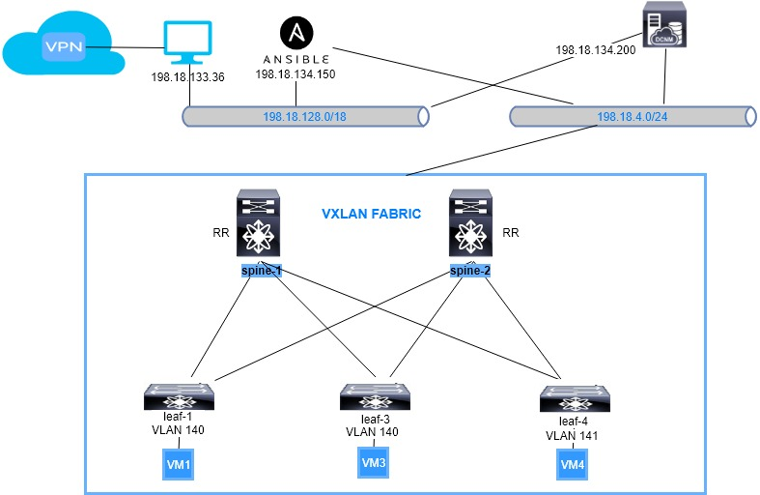

Task 1: Build Ansible node on Redhat server

Step 1: Connect to anyconnect VPN dcloud-lon-anyconnect.cisco.com with the username and password provided (lab admin will furnish that information to the participant).

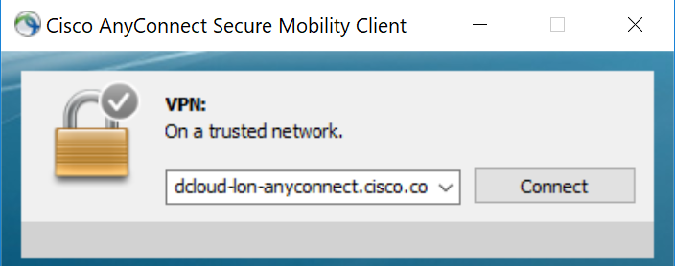

Step 2: After prompted for credentials, use the credentials provided by the lab admin.

* Below is an example of user logging into POD1

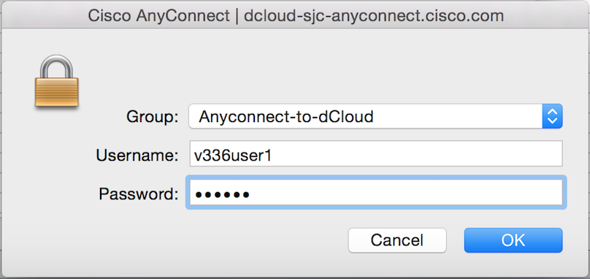

* Hit accept when the prompt appears to accept the VPN connection login

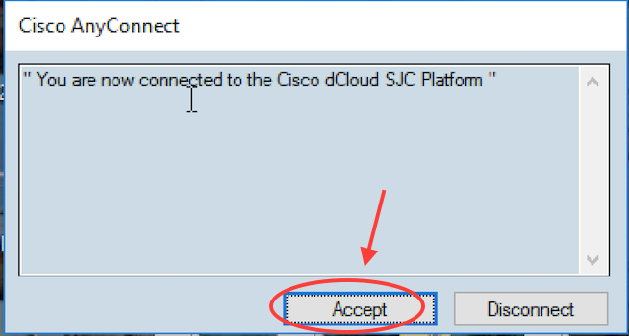

Step 3: Connect to the workstation with RDP client.

* Workstation : **198.18.133.36**, Username: **dcloud\demouser**, Password: **C1sco12345**

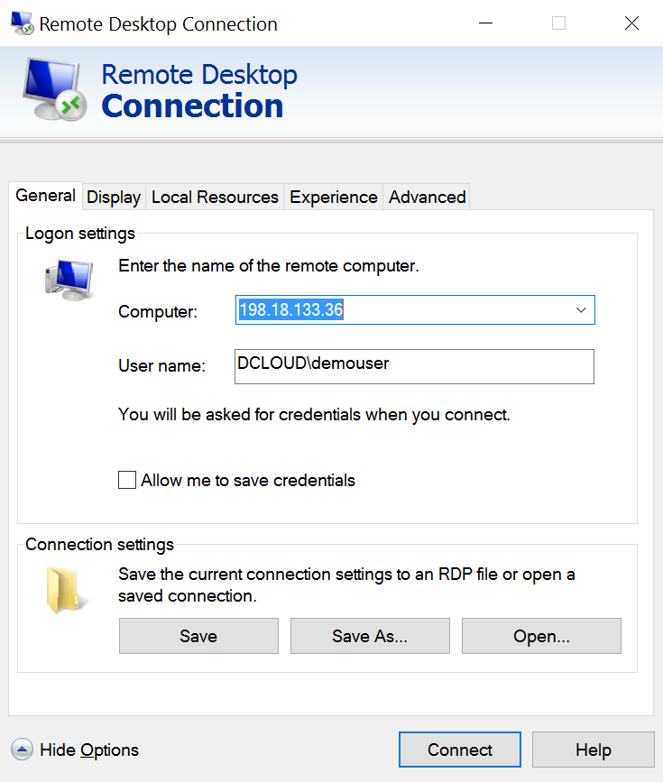

Step 4: Use MTputty to open the console connection to all devices



Step 5: SSH into Ansible node (**198.18.134.150**) by double clicking the Ansible icon on the left pan with username **root** and password **C1sco12345**

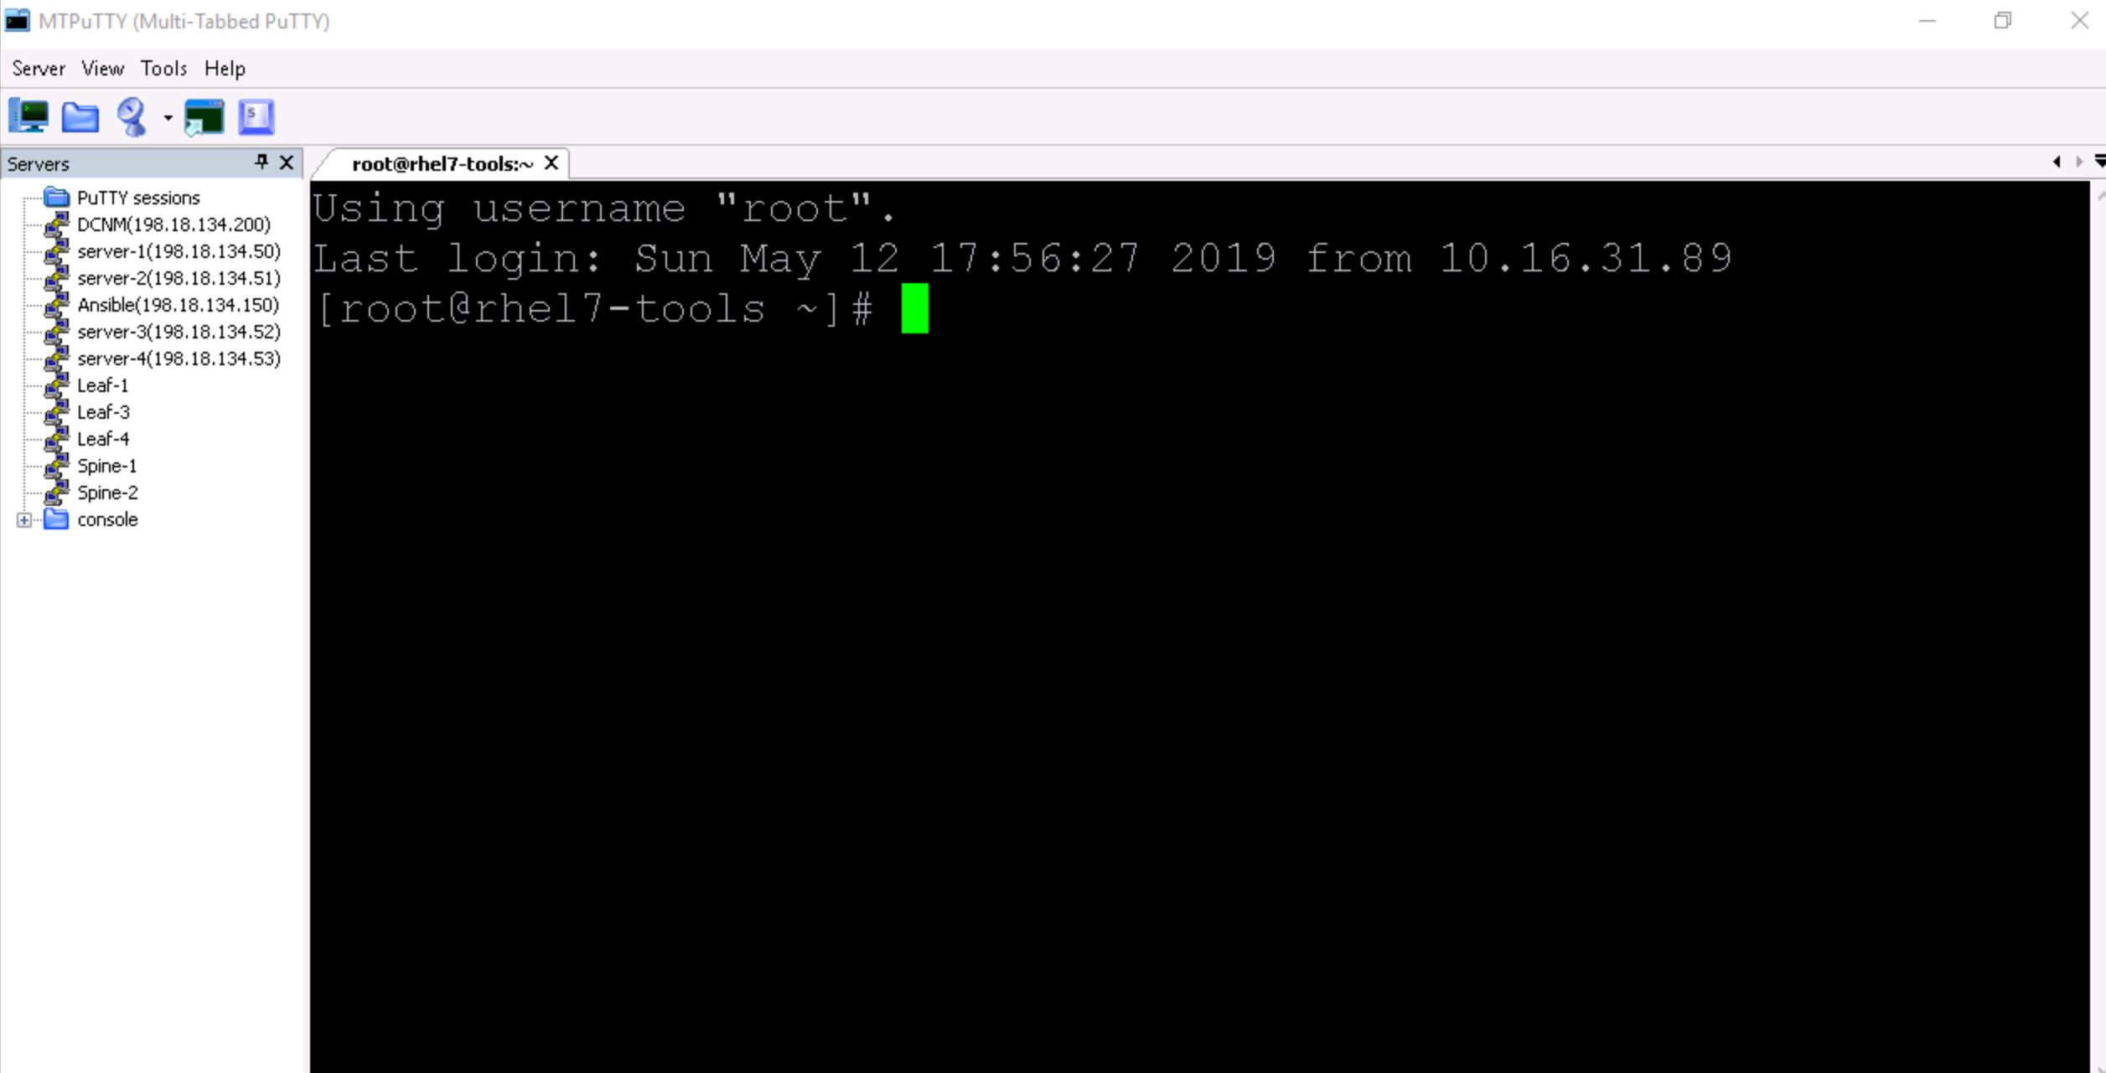

Step 6: The very first thing we are going to do after logging into Ansible server is verify the python version. It is an important step as we need minimum 2.7.5 version of python in order to install some features for ansbile

Ansible can be run from any machine with Python 2 (versions 2.6 or 2.7) or Python 3 (versions 3.5 and higher) installed

|  |
| --- |
| [root@rhel7-tools ~]# python --version  Python 2.7.5 |

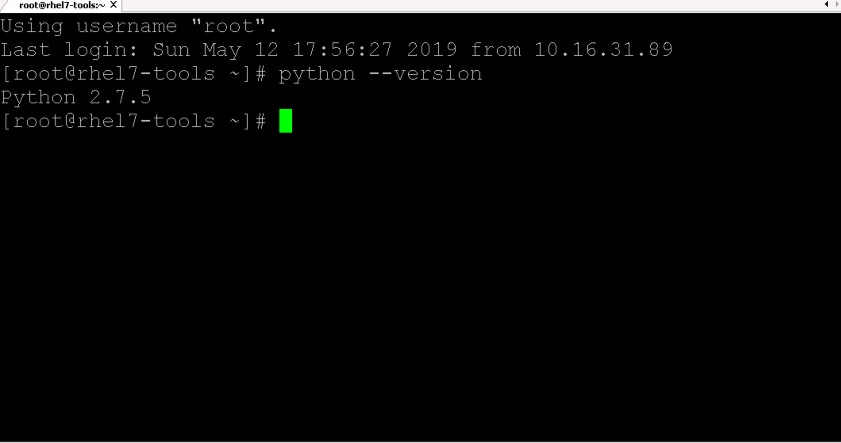

### Step 7: After verifying we have the minimum version of python installed, we are now going to Install PIP python package with the below commands

|  |
| --- |
| [root@rhel7-tools ~]# **easy_install pip**  Searching for pip  Best match: pip 8.1.1  Adding pip 8.1.1 to easy-install.pth file  Installing pip script to /usr/bin  Installing pip3.5 script to /usr/bin  Installing pip3 script to /usr/bin  Using /usr/lib/python2.7/site-packages  Processing dependencies for pip  Finished processing dependencies for pip |

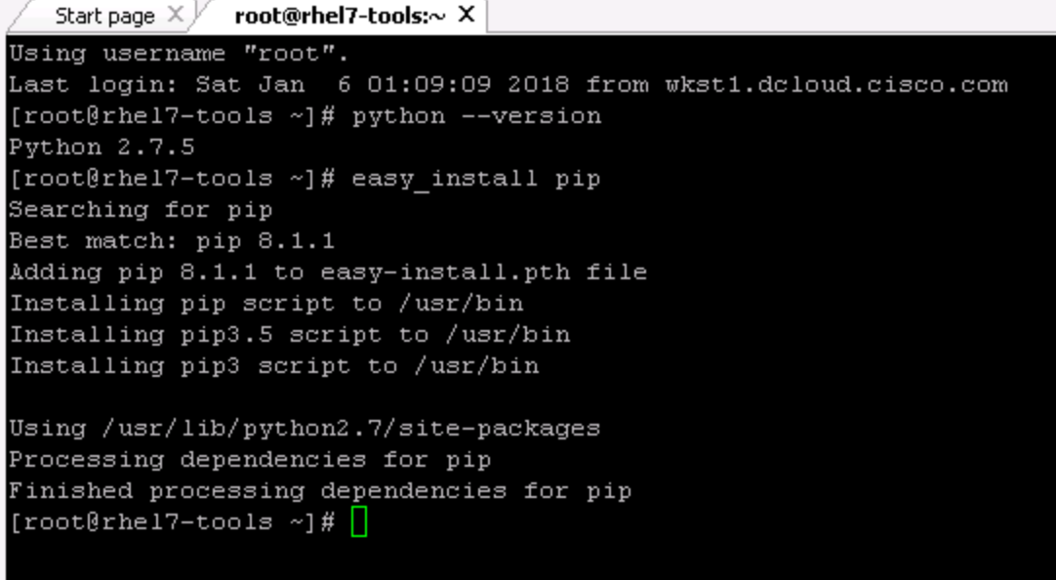

Update pip to latest version

|  |
| --- |
| [root@rhel7-tools ~]# pip install --upgrade pip |

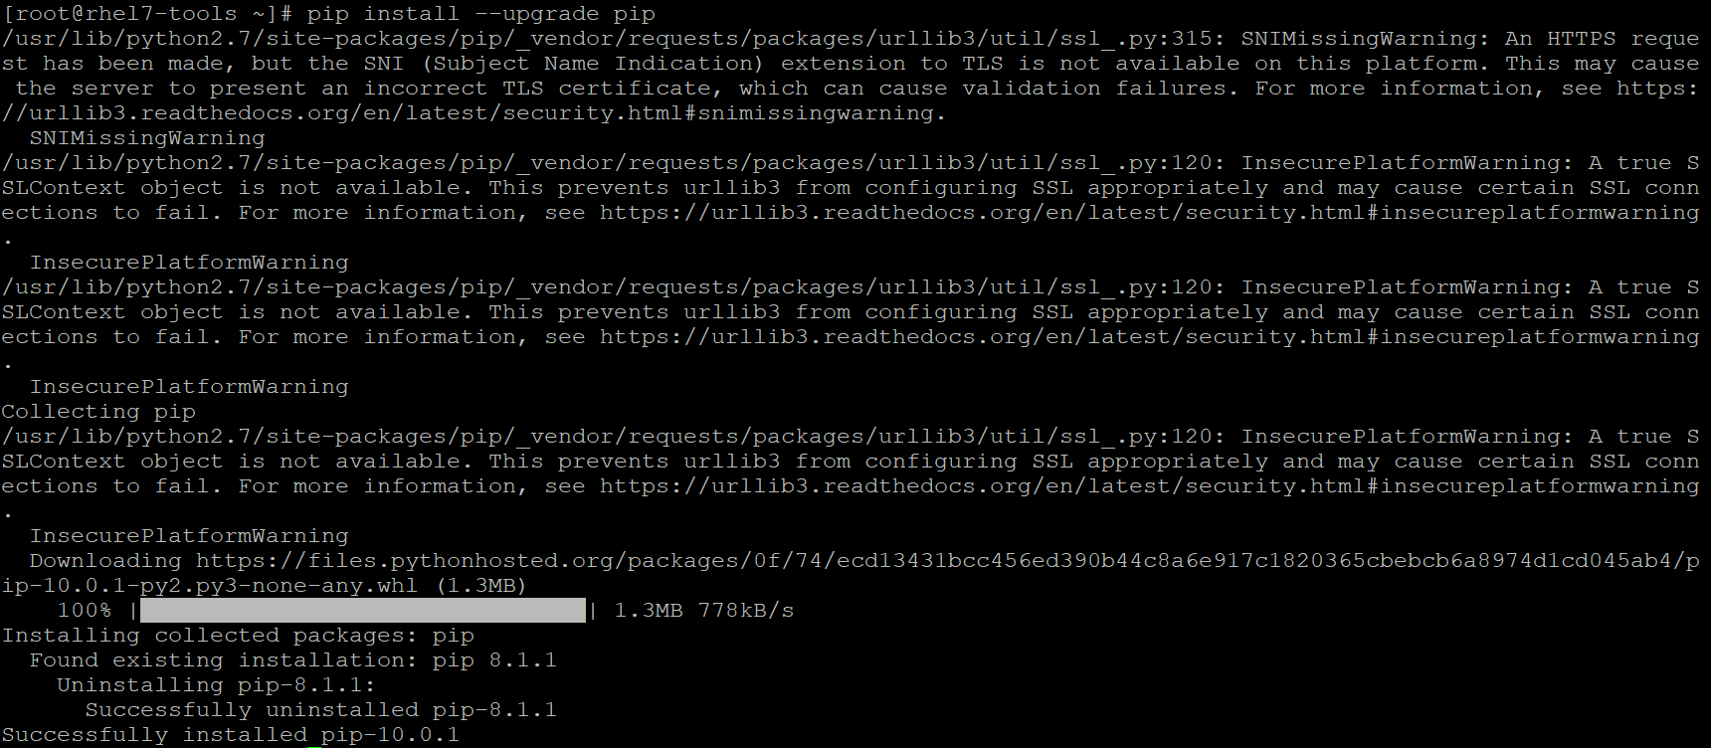

After installing PIP package, we are going to add the relevant packages that are needed for this Ansible based VXLAN lab. Below are the packages required for this lab

* Paramiko
* PyYAML
* Jinj2
* Httplib2

|  |
| --- |
| [root@rhel7-tools ~]# pip install paramiko PyYAML jinja2 httplib2 |

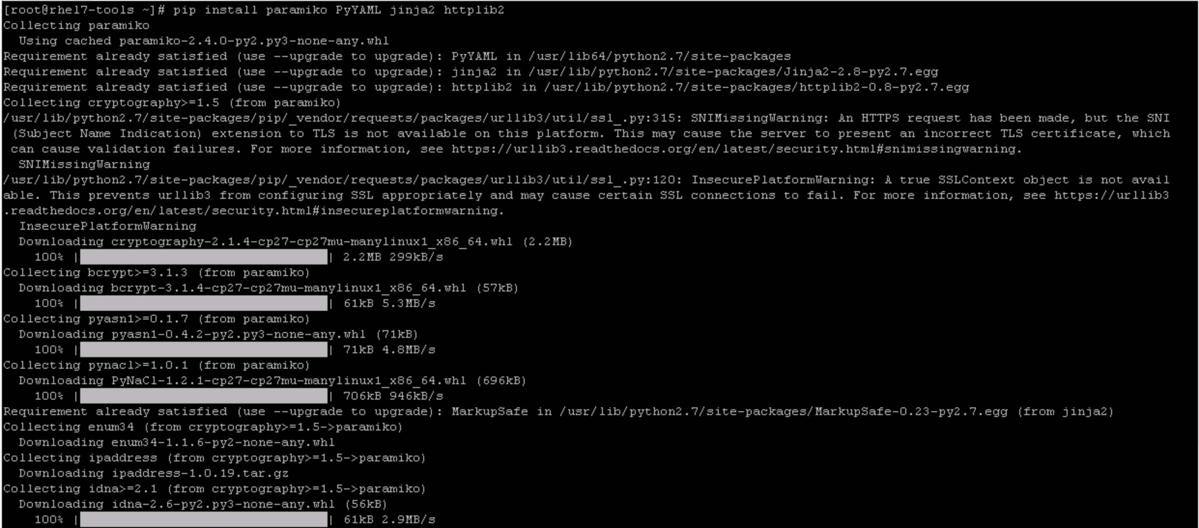

As a final step, we are going to install Ansible on this RHEL. Once the install is initiated with the below command, it will take few minutes for it to download and install.

|  |
| --- |
| [root@rhel7-tools ~]# **pip install ansible==2.8.0b1** |

After installation is complete, check Ansible version with the below command

|  |
| --- |
| [root@rhel7-tools ~]# ansible --version  ansible 2.8.0b1  config file = None  configured module search path = [u'/root/.ansible/plugins/modules', u'/usr/share/ansible/plugins/modules']  ansible python module location = /usr/lib/python2.7/site-packages/ansible  executable location = /usr/bin/ansible  python version = 2.7.5 (default, Mar 26 2019, 22:13:06) [GCC 4.8.5 20150623 (Red Hat 4.8.5-36)]  [root@rhel7-tools ~]# |

### Step 8: Now, we are going to create inventory, host variables and Configuration file. This is important as Ansible works against multiple systems in the system by selecting portions of systems listed in Ansible inventory. Similarly, configuration settings in Ansible are adjustable via configuration file

Create folder named **LTRDCN-1572** as working environment and verify that it’s empty

|  |
| --- |
| [root@rhel7-tools ~]# **mkdir LTRDCN-1572 && cd LTRDCN-1572**  [root@rhel7-tools LTRDCN-1572]# **ls** |

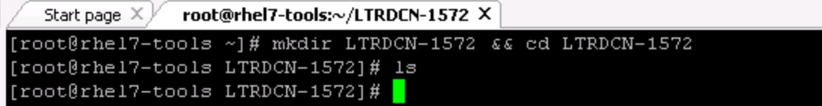

* Create Ansible inventory file to include Spine and Leaf switches.
* By default Ansible has inventory file saved in location **/etc/ansible/hosts**.
* In this lab we will create hosts file in the working environment. Use ‘**vi**’ to create inventory file ‘hosts’.

|  |
| --- |
| [root@rhel7-tools LTRDCN-1572]# **cat << EOF >> hosts** |

* At the bottom of the inventory file, insert (**type i**) the following lines

|  |
| --- |
| #define global variables, groups and host variables  [all:vars]  ansible_connection = local  user=admin  pwd=C1sco12345  gather_fact=no  [jinja2_spine]  198.18.4.202  [jinja2_leaf]  198.18.4.104  [spine]  198.18.4.201  [leaf]  198.18.4.101  198.18.4.103  [server]  198.18.134.50 eth1=172.21.140.10 gw=172.21.140.1  198.18.134.52 eth1=172.21.140.11 gw=172.21.140.1  198.18.134.53 eth1=172.21.141.11 gw=172.21.141.1  EOF |

* Quit and save vi editor by press ‘Esc’ key and then type ‘**:wq**!’

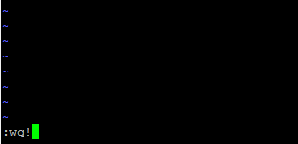

* Create Ansible config **(ansible.cfg)** file via **vi** editor pointing to local ‘**hosts**’ file for inventory. Use ‘**vi**’ to create **ansible.cfg** file

|  |
| --- |
| [root@rhel7-tools LTRDCN-1572]# **vi ansible.cfg** |

* At the bottom of the **ansible.cfg** file, insert (**type i**) the following lines

|  |
| --- |
| [defaults]  inventory = hosts  host_key_checking = false  record_host_key = true  stdout_callback = debug  deprecation_warnings = False |

* Quit and save vi editor by press ‘Esc’ key and then type ‘**:wq**!’
* Do ‘ls’ to verify the file that you just creted under project folder **LTRDCN-1572**

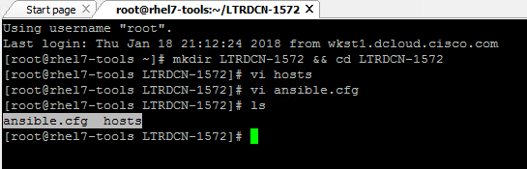

* Create host variable folder named **host_vars** in folder **LTRDCN-1572.** Host varilables can be placed in different places in Ansible. In this lab, we will use **host_vars** for host variables;

|  |
| --- |
| [root@rhel7-tools LTRDCN-1572]# **mkdir host_vars && cd host_vars** |

* Create host variable file for each host in inventory. Use **‘vi’** to create following files.

|  |
| --- |
| [root@rhel7-tools host_vars]# cat << EOF >> 198.18.4.101.yml |

|  |
| --- |
| ---  hostname: leaf_1  loopback0: 192.168.0.8  loopback1: 192.168.0.18  router_id: 192.168.0.8 |

* Quit and save vi editor by press ‘Esc’ key and then type ‘**:wq**!’

|  |
| --- |
| [root@rhel7-tools host_vars]# cat << EOF >> 198.18.4.103.yml |

|  |
| --- |
| ---  hostname: leaf_3  loopback0: 192.168.0.10  loopback1: 192.168.0.110  router_id: 192.168.0.10  EOF |

* Quit and save vi editor by press ‘Esc’ key and then type ‘**:wq**!’

|  |
| --- |
| [root@rhel7-tools host_vars]# cat << EOF >> 198.18.4.104.yml |

|  |
| --- |
| ---  hostname: leaf_4  loopback0: 192.168.0.11  loopback1: 192.168.0.111  router_id: 192.168.0.11 |

* Quit and save vi editor by press ‘Esc’ key and then type ‘**:wq**!’

|  |
| --- |
| [root@rhel7-tools host_vars]# cat << EOF >> 198.18.4.201.yml |

|  |
| --- |
| ---  hostname: spine-1  loopback0: 192.168.0.6  loopback1: 192.168.0.100  router_id: 192.168.0.6  EOF |

* Quit and save vi editor by press ‘Esc’ key and then type ‘**:wq**!’

|  |
| --- |
| [root@rhel7-tools host_vars]# cat << EOF >> 198.18.4.202.yml |

|  |
| --- |
| ---  hostname: spine-2  loopback0: 192.168.0.7  loopback1: 192.168.0.100  router_id: 192.168.0.7  EOF |

* Quit and save vi editor by press ‘Esc’ key and then type ‘**:wq**!’

### Step 9: Ansible role structure

Role is very useful technique to manage a set of playbooks in Ansible.

In this lab, we will use two different playbooks to manage configuration for Spine and Leaf switches.

We will use role structure and manage the two plays into single playbook.

A role directory structure contains several directories of defaults, vars, files, handlers, meta, tasks and templates.

In this lab, we will use vars, templates and tasks folders.

**/vars**

main.yml file in vars folder contains dictionary of variables for this role.

**/tasks**

main.yml file in tasks folder contains the Ansible playbook for this role.

* Create roles directory in folder **LTRDCN-1572**

|  |
| --- |
| [root@rhel7-tools host_vars]# **cd ~/LTRDCN-1572/**  [root@rhel7-tools LTRDCN-1572]# **mkdir roles** |

Task 2: First simple Ansible Playbook

In this section, we will create the first Ansible Playbook. In the playbook, we will configure VLANs on leaf switches, and assign VLANs to the server facing port.

You will learn create variables inside playbook, learn simple loop using “**with_items**”, learn simple logical using “**when**” and learn “**tags**” to isolate tasks from whole playbook.

Step 1: Open “Atom” text editor by double click the icon on desktop. Atom is the recommended text editor for this lab.



Step 2: After opening ATOM, Click “No Never” to the “Register as default atom:// URI handlre” message as show below:

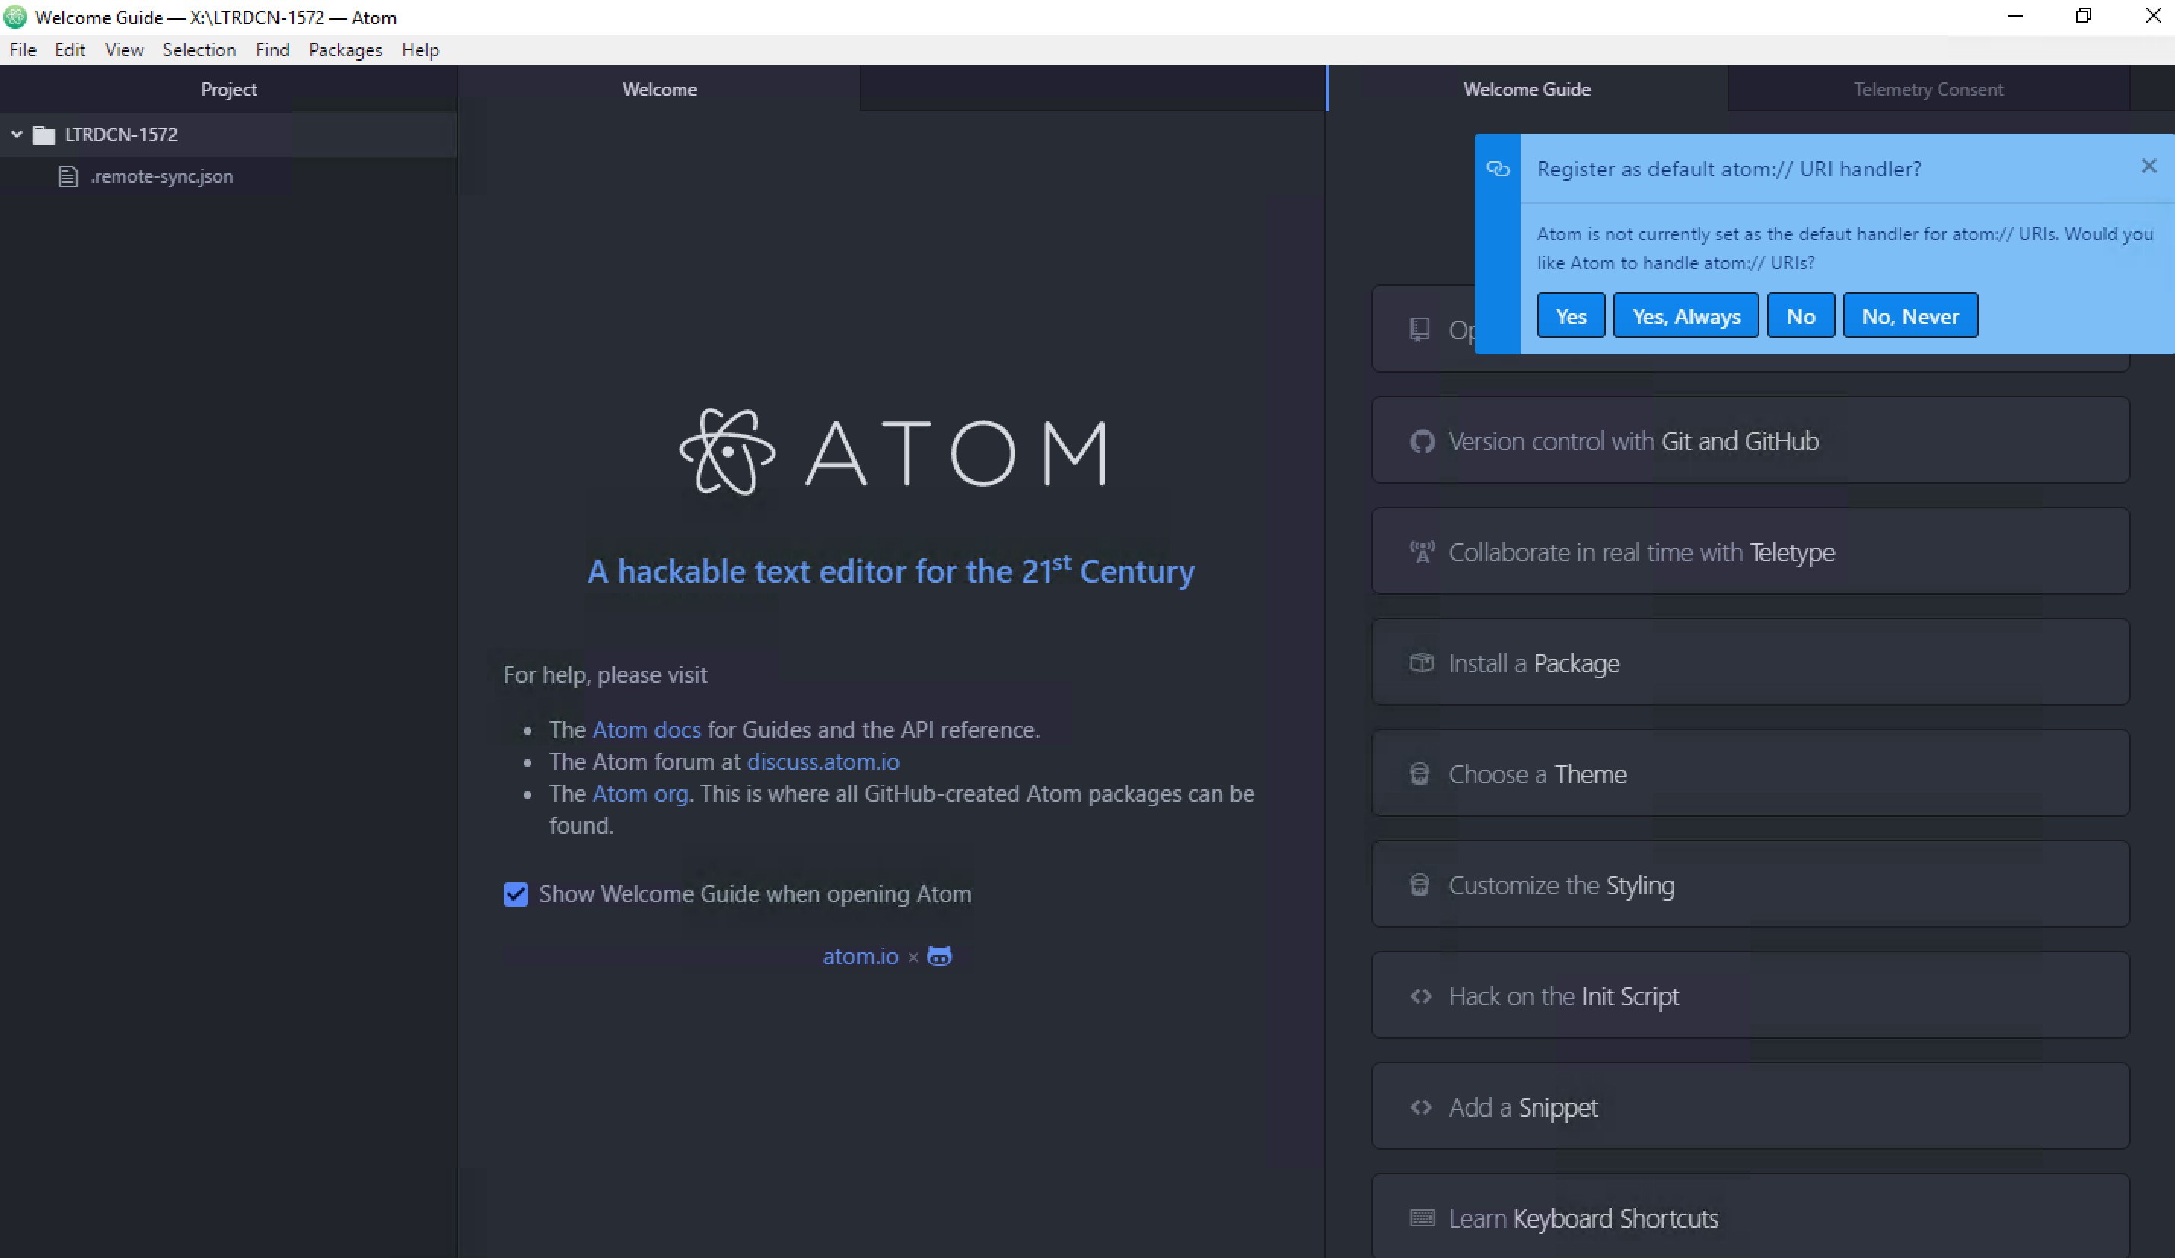

Step 3: After opening ATOM, there should be a folder in the left pane named “LTRDCN-1572.”

* Right click the pre-configured project folder ‘LTRDCN-1572’ and select ‘New File’

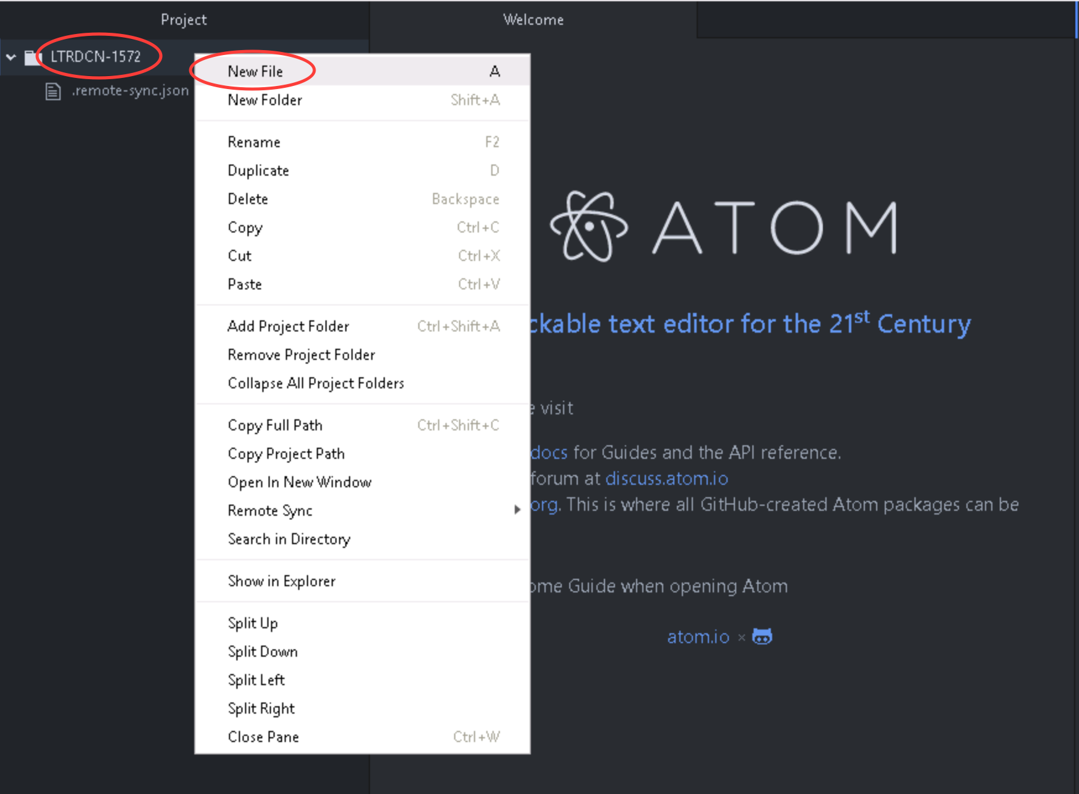

* Name the new file ‘**vlan_provision.yml**’ and hit enter. This will creat the new file

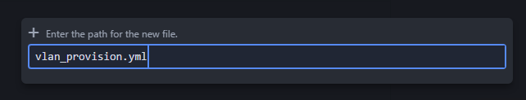

Step4: Here, we are going to define the scope, variable for playbook and tasks

In the opened window for ‘**vlan_provision.yml’** file, type

***NOTE: Be careful with the spaces. Use spaces in carefully as described in the below sections***

|  |
| --- |
| ---  #Task 2: Simple playbook assign VLAN to server facing port  - hosts: leaf:jinja2_leaf  vars:  nxos_provider:  username: "{{ user }}"  password: "{{ pwd }}"  transport: nxapi  host: "{{ inventory_hostname }}" |

* “**hosts**” defines the scope of this playbook applies to all switches in group ‘leaf’ and ‘jinja2_leaf’.
  + **Note** you can review the IP addresses of the three (2) “leaf” and one (1) “jinja2_leaf” in the “**hosts**” file (configured in previous steps). The IP addresses are:
    - jinja2_leaf: 198.18.4.104
    - leaf: 198.18.4.101
    - leaf: 198.18.4.103
* **“vars”** defines one variable **“nxos_provider”** that will be used in this playbook.
* “**nxos_provider”** is variable that includes all value that will be used for connection and autnentication.
  + This variable will be referenced in playbook via “**provider”** argument.

Step 5: Continue on the playbook with defining tasks

|  |
| --- |
| tasks:  - name: provision VLAN  nxos_config:  lines: "vlan {{item}}"  provider: "{{nxos_provider}}"  with_items:  - 140  - 141  tags: add vlans |

* Multiple plays can be defined in one playbook under**“tasks”,** each starts with “-“ .
* This kind of play creates multiple VLANs using **nxos_config** module.
  + The “lines” option is used to pass only one configuration command. This commands must be the exact same commands as found in the device running-config.
  + Though one or multiple configuration commands can be configured under the “lines” option. For multiple, ordered set of commands can be configured under this “line” section.
* At the end of this play, we use **“tags”** to name the play **“add vlans”.** This is useful to run a specific part of the configuration without running whole playbook.

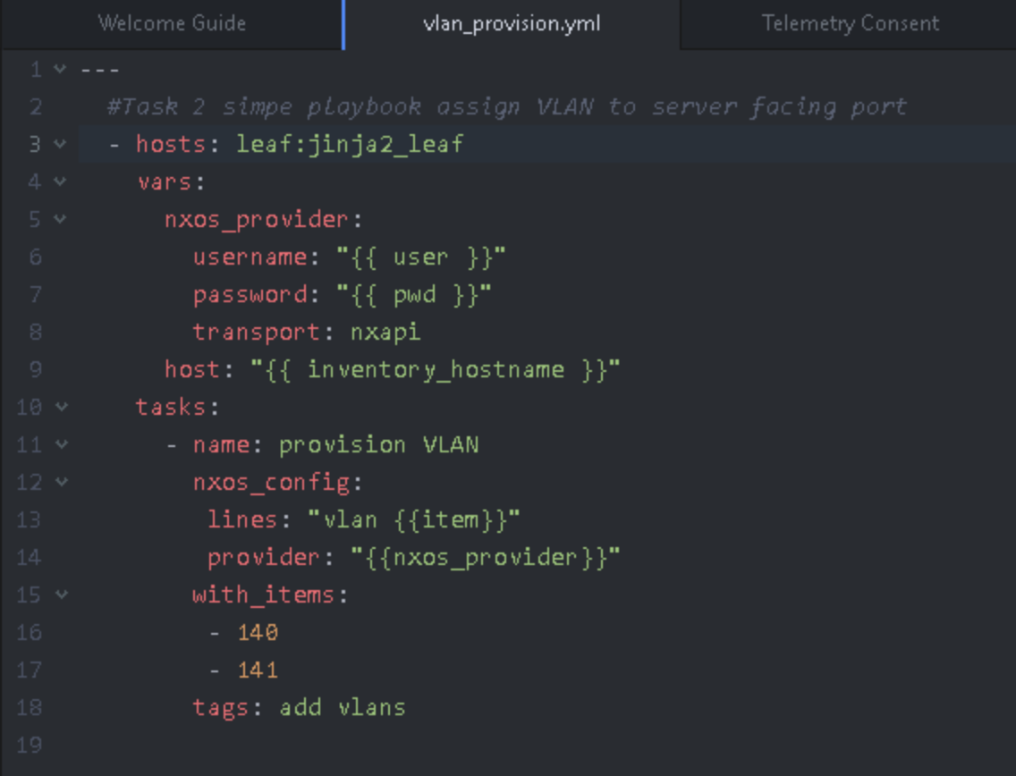

***NOTE: Formatting is extremenly important when working with Ansible. Ansible playbook would return errors if the spaces are not properly alighed or formatting is not correct***

* Click **“File” “Save”** . This will save the playbook, and also ftp the playbook to Ansible server using pre-configured “**remote-sync”** package.

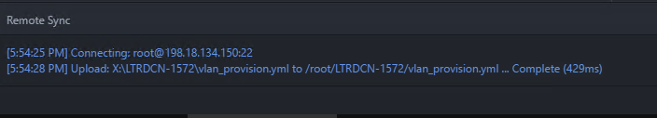

***NOTE: Once the Save button is pressed, then at the lower part of ATOM app, you will see message about connecting to Ansibe host (198.18.134.150) and saving the vlan_provision.yml file***

Step 6: After creating the playbook, it is now time to execute the playbook.

* Before executing the playbook, we will verify the leaf switch if it has any vlan configuration present on it.
* Login to leaf-3 switch using the Mputty client, or any leaf switch and execute "**show vlan brief**". This will show us the vlans that currently exist on the leaf switch. As you note from below screenshot only the default VLAN (vlan number 1) is configured

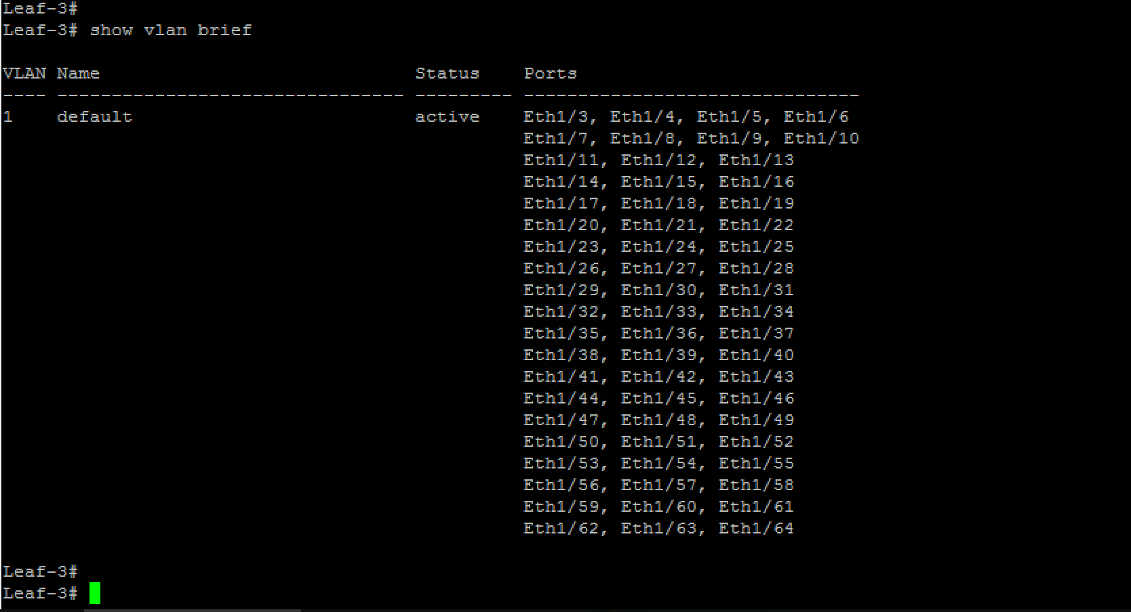

* Now, go to mputty, login or launch a new ssh into Ansible node (198.18.134.150)
* Use command **ansible-playbook vlan_provision.yml --tags "add vlans"** under folder "LTRDCN-1572"

|  |
| --- |
| [root@rhel7-tools LTRDCN-1572]# **ansible-playbook vlan_provision.yml --tags "add vlans"** |

***NOTE:***

* ***If the playbook fails first time, re-run the playbook again.***
* ***Make sure to save all the changes in the playbook first before executing the playbook in Ansible***

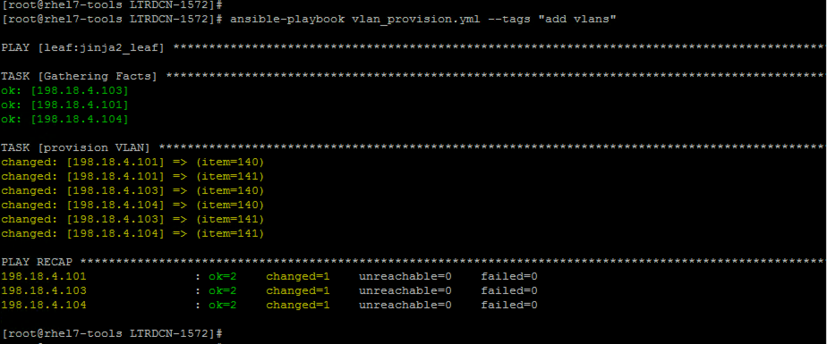

* After playbook is run successfully, login to leaf 3 again and check if vlan 140 and vlan 141 appears. There would also be a log message on the screen indicating a configuration change was pushed to the device

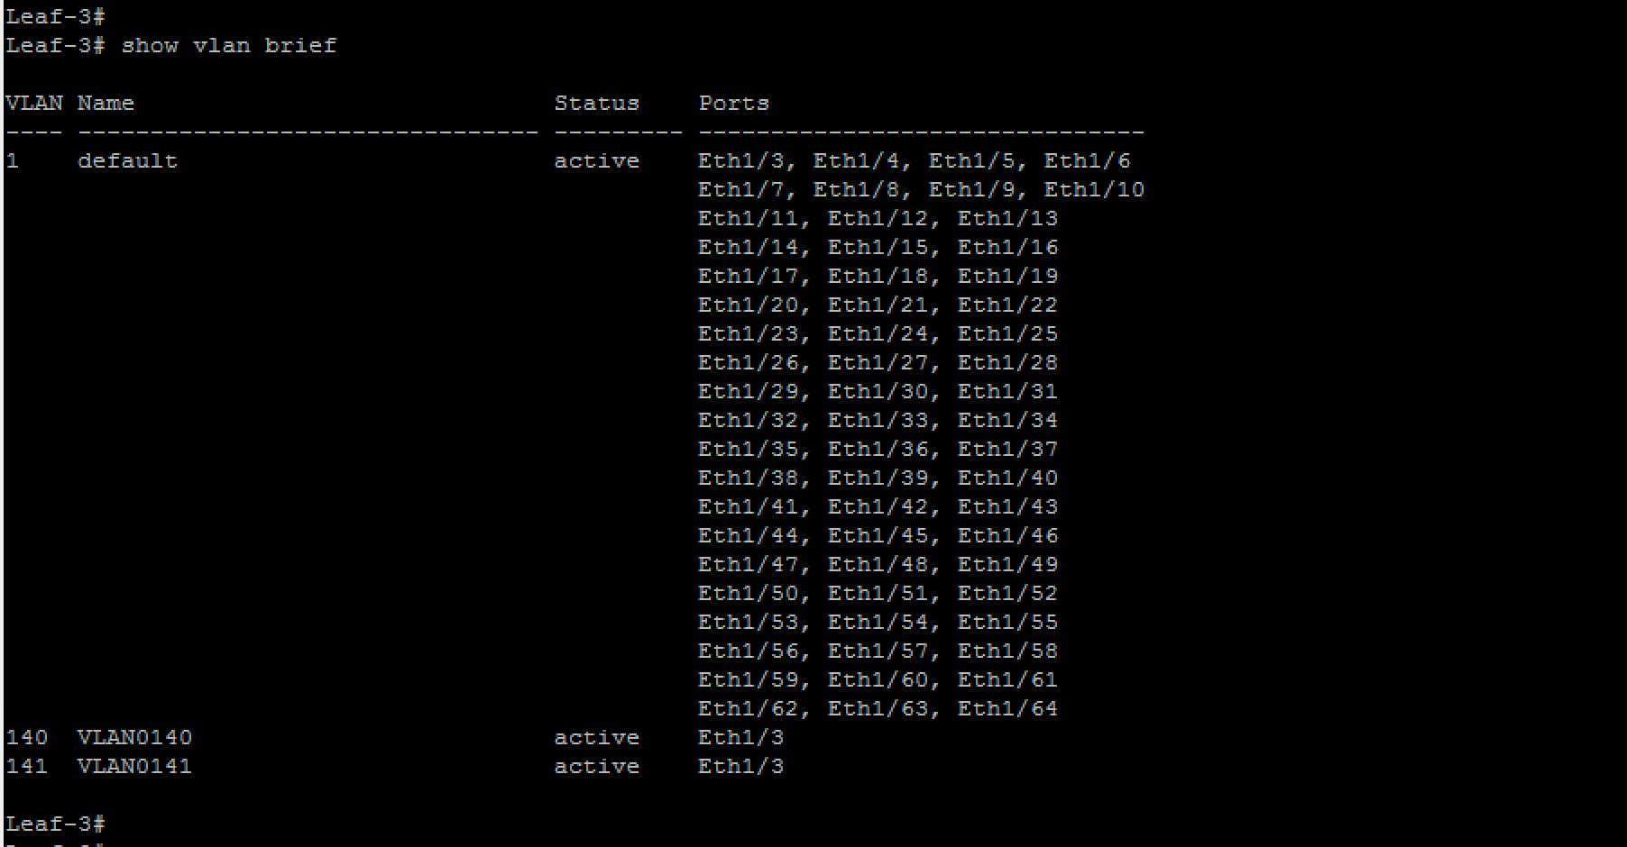

Step 7: Now, we have tested our first playbook with basic configuration ( adding 2 VLANS), we are now going to add more tasks in our existing playbook “**vlan_provision.yml**”

* we will add new plays in the playbook to assign VLANs to server facing port. This time, we will configure VLAN towards the server facing ports
* Go back to **ATOM** and **add** the following plays to the **existing playbook**

|  |
| --- |
| - name: configure server facing port to L2  nxos_interface:  interface: eth1/3  mode: layer2  provider: "{{nxos_provider}}"  - name: configure VLAN for server port  when: ("101" in inventory_hostname) or ("103" in inventory_hostname)  nxos_switchport:  interface: eth1/3  mode: access  access_vlan: 140  provider: "{{nxos_provider}}"  - name: configure VLAN for server port  when: ("102" in inventory_hostname) or ("104" in inventory_hostname)  nxos_switchport:  interface: eth1/3  mode: access  access_vlan: 141  provider: "{{nxos_provider}}" |

* In this new play, we used nxos module “**nxos_interface**” and “**nxos_switchport**”.
* “**nxos_interface**” provides the capability to manage the physical attributes of an interface
  + In this example, it is used to configure “layer 2” on interface Ethernet 1/3
* “**nxos_switchport**” provides the capability to manage the Layer 2 switchport attributes
  + In this example, it is used to configuration it is used to configure mode access on Ethernet ports 1/3
* We used **“when”** argument to provide little logic of the play.
  + In our example, the playbook assign VLAN 140 on leaf1 and leaf3 switches; assign VLAN 141 on leaf2 and leaf4 switches.
* Click **“File” “Save”** will save the playbook, and also ftp the playbook to Ansible server using pre-configured “**remote-sync”** package.

Step 8: Now, we are going to execute the playbook with the command “**ansible-playbook vlan_provision.yml**”.

* Open MTPuttY and log back into (or launch a new ssh) into **“Ansible”** node.
* Execute command “**ansible-playbook vlan_provision.yml**” in the “LTRDCN-1572” directory as show below:

[root@rhel7-tools LTRDCN-1572]# **ansible-playbook vlan_provision.yml**

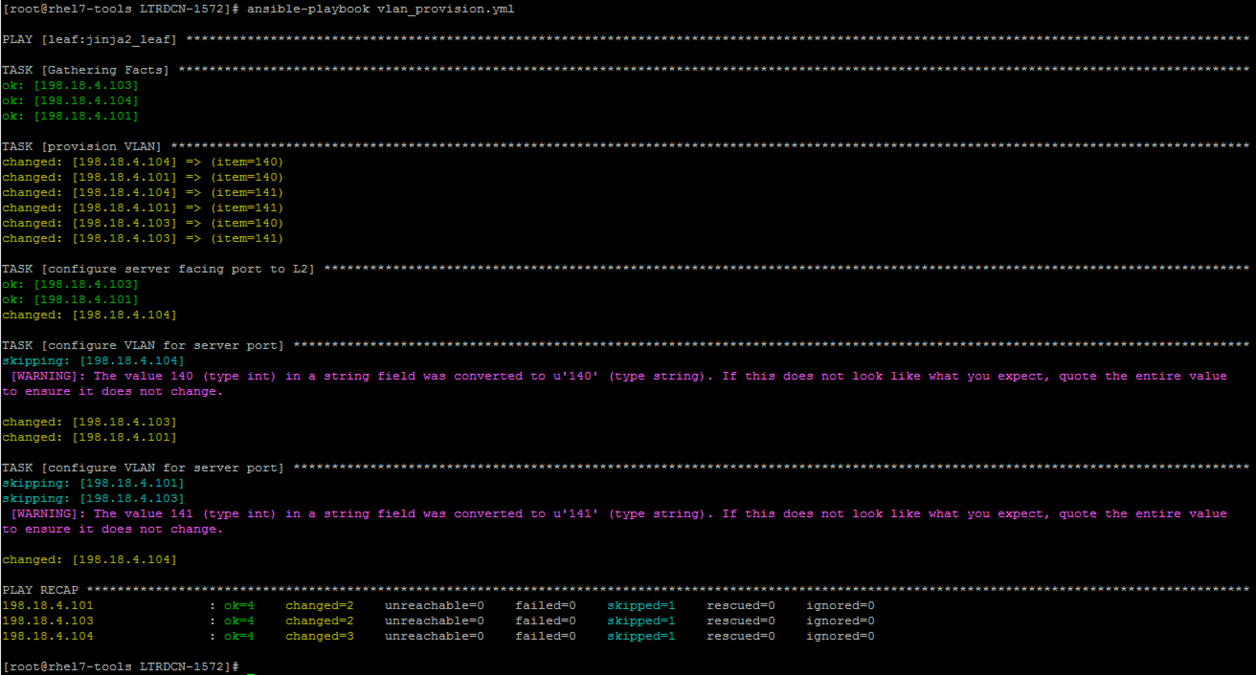

* After we push the configuration, **login** to **leaf-3** switch, and check if the server facing port has the access vlan configured with the below command:

show run interface ethernet1/3

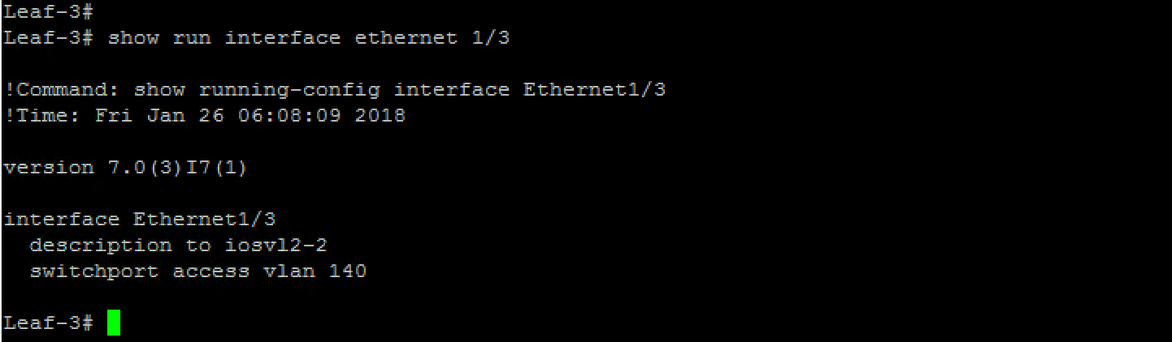

**Congratulation! You have created your first ansible playbook, automatically provisioned new VLANs and assigned port to new created VLANs using Ansible. Next we are going to create VXLAN Fabric using Ansible.**

Task 3: Provision VXLAN Fabric using Ansible + Jinja2

In this task, we are going to install Jinja2. It is one of the python template engines. In this section, we use Jinja2 to create template for spine and leaf and configure VXLAN fabric using this Jinja2 templates.

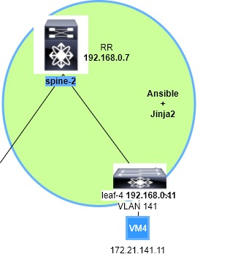

Jinja2 template looks just like the NXOS configurations. We abstract the variables out of the configuration and use simple **for** loop to feed variables into the template.

Install jinja2 , create new roles for **jinja2_spine** & **jinja2_leaf. If it is already installed, we will get the message “requirement is satisfied”**

|  |
| --- |
| [root@rhel7-tools ~]# **cd ~**  [root@rhel7-tools ~]# **pip install jinja2**  Requirement already satisfied (use --upgrade to upgrade): jinja2 in /usr/lib/python2.7/site-packages/Jinja2-2.8-py2.7.egg  Requirement already satisfied (use --upgrade to upgrade): MarkupSafe in /usr/lib/python2.7/site-packages/MarkupSafe-0.23-py2.7.egg (from jinja2) |



### Step 1: Create new playbook

In this section, we will use Jina2 template and Ansible to provision the VXLAN Fabric.

* Switch to “**Atom”**, right click on the folder LTRDDCN-1572 and create a new playbook **‘jinja2_fabric.yml’**. Enter the file name and hit enter



|  |
| --- |
| ---  - hosts: jinja2_spine  connection: local  roles:  - jinja2_spine |

Contents of the **‘jinja2_fabric.yml’** file should look like below:

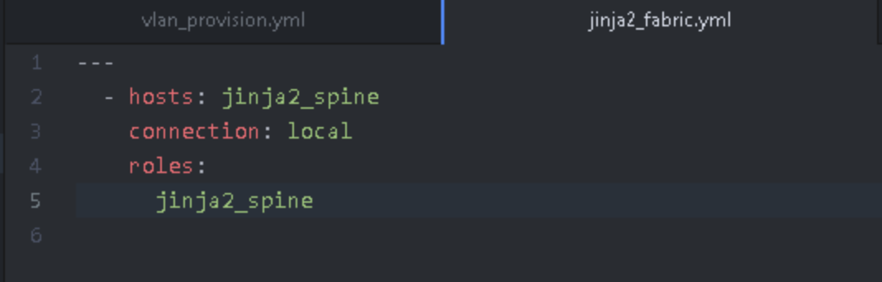

* Click **“File” “Save”** . This will save the playbook, and also ftp the playbook to Ansible server using pre-configured “**remote-sync”** package.
* Go back to **mputty** and go back to Ansible Server node (**198.18.134.150**). Verify that the below 2 groups exists in the inventory file "**hosts"** under the folder LTRDCN-1572
* Run the “**cat hosts**” command to read the file for verification and make sure below lines are present

|  |
| --- |
| [jinja2_spine]  198.18.4.202  [jinja2_leaf]  198.18.4.104 |

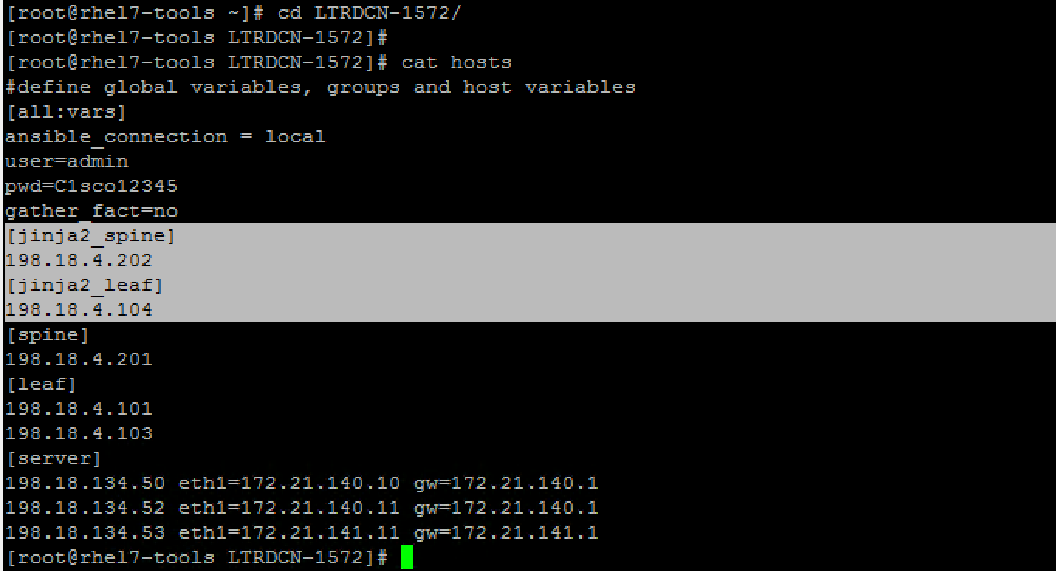

### Step 2: Create new roles and vars

In this section, we will create two new roles for provisioning Fabric with Jina2 template.

* Open **MTPuttY**, ssh into **“Ansible”** node; switch to ‘**roles’** folder; create ‘jinja2_spine’ and ‘jinja2_leaf’ roles using **ansible-galaxy**.

|  |
| --- |
| [root@rhel7-tools ~]# **cd ~/LTRDCN-1572/roles/**  [root@rhel7-tools roles]# **ansible-galaxy init jinja2_spine&&ansible-galaxy init jinja2_leaf** |

Below screenshot shows the output of above command:

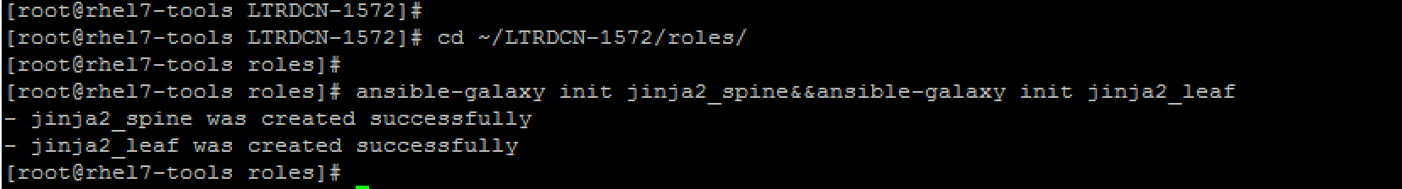

* **‘ansible-galaxy’** will initialize the role structure and create necessary folders with default name like ‘tasks’, ‘template’, ‘vars’ etc.

change directory path to LTRDCN-1572/roles/jinja2_spine and check the content of local directory

|  |
| --- |
| [root@rhel7-tools]# **cd ~/LTRDCN-1572/roles/jinja2_spine/**  [root@rhel7-tools jinja2_spine]# **ls** |

Below screenshot shows the output of above file. Note that various directories including tasks, templates, vars exists. We will use these in later steps.



* Create empty jinja2 template files for spine and leaf under **templates** folder for each role by running below commands:

|  |
| --- |
| [root@rhel7-tools roles]# **cd ~/LTRDCN-1572/roles**  [root@rhel7-tools roles]# **touch jinja2_spine/templates/spine.j2**  [root@rhel7-tools roles]# **touch jinja2_leaf/templates/leaf.j2** |

* Switch to “**Atom”** and sync the new created folders between Ansible node and remote desktop.
* Right click on project folder “**LTRDCN-1572”,** open “**Remote Sync”** select **“Download Folder”**

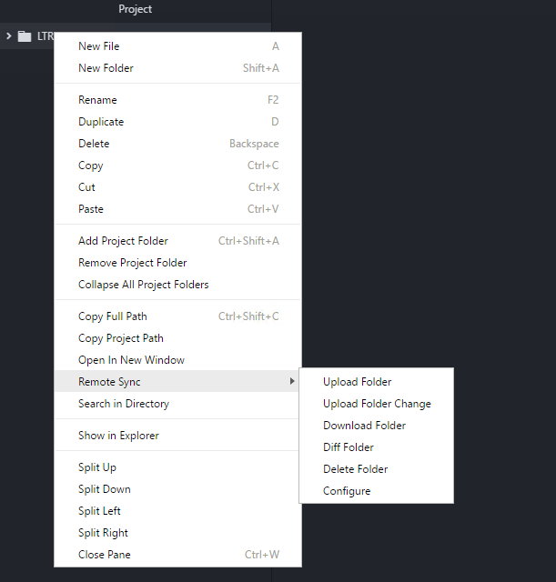

Step 3: Create variable file for “**jina2_spine”** role

* “ansible-galaxy” automatically creates empty “**main.yml**” file under “**vars”** folder. We can use “**Atom”** to edit the main.yml file to include the following variables that will be used in jinja2 template.
* Open up the project folder **“LTRDCN-1572” from the left pane** and open **main.yml** file under **“roles/jinja2_spine/vars/”**

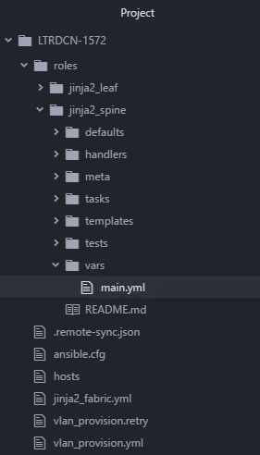

* use “**Atom”** to edit the “**main.yml**” file to include the following variables that will be used in jinja2 template.

|  |
| --- |
| ---  # vars file for jinja2_spine  nxos_provider:  username: "{{ user }}"  password: "{{ pwd }}"  timeout: 100  host: "{{ inventory_hostname }}"  asn: 65000  bgp_neighbors:  - remote_as: 65000  neighbor: 192.168.0.8  update_source: Loopback0  - remote_as: 65000  neighbor: 192.168.0.10  update_source: Loopback0  - remote_as: 65000  neighbor: 192.168.0.11  update_source: Loopback0  L3_interfaces:  - interface: Ethernet 1/1  - interface: Ethernet 1/2  - interface: Ethernet 1/3  - interface: Ethernet 1/4  - interface: loopback 0  - interface: loopback 1  s1_loopback: 192.168.0.6  s2_loopback: 192.168.0.7 |

* Contents of the **‘main.yml’** file should look like below:

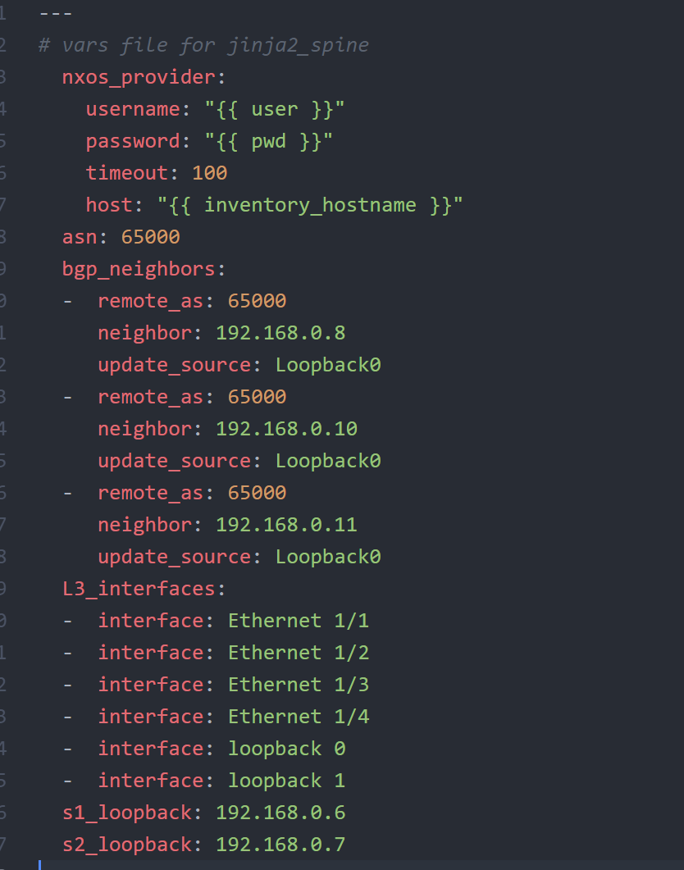

• Click “File” “Save” . This will save the playbook, and also ftp the playbook to Ansible server using pre-configured “remote-sync” package.

### Step 4: Create Jinja2 template for spine role

* Open up the project folder **“LTRDCN-1572”**.
* Open up file **“spine.j2”** under **“roles/jinja2_spine/templates/”**.

***NOTE: it is possible that the file might not appear. Go ahead and execute the below 4 steps to get it sync***

1. Change Directory (cd) to folder **LTRDC-1572 on** Ansible server (198.18.134.150)
2. Change Directory (cd) to folder **roles/jinja2_spine/templates**
3. Type “**touch spine.j2**”
4. After entering the command, go back to ATOM, right click on **folder LTRDCN**, scroll to choose option **Remote Sync** and choose **download**.

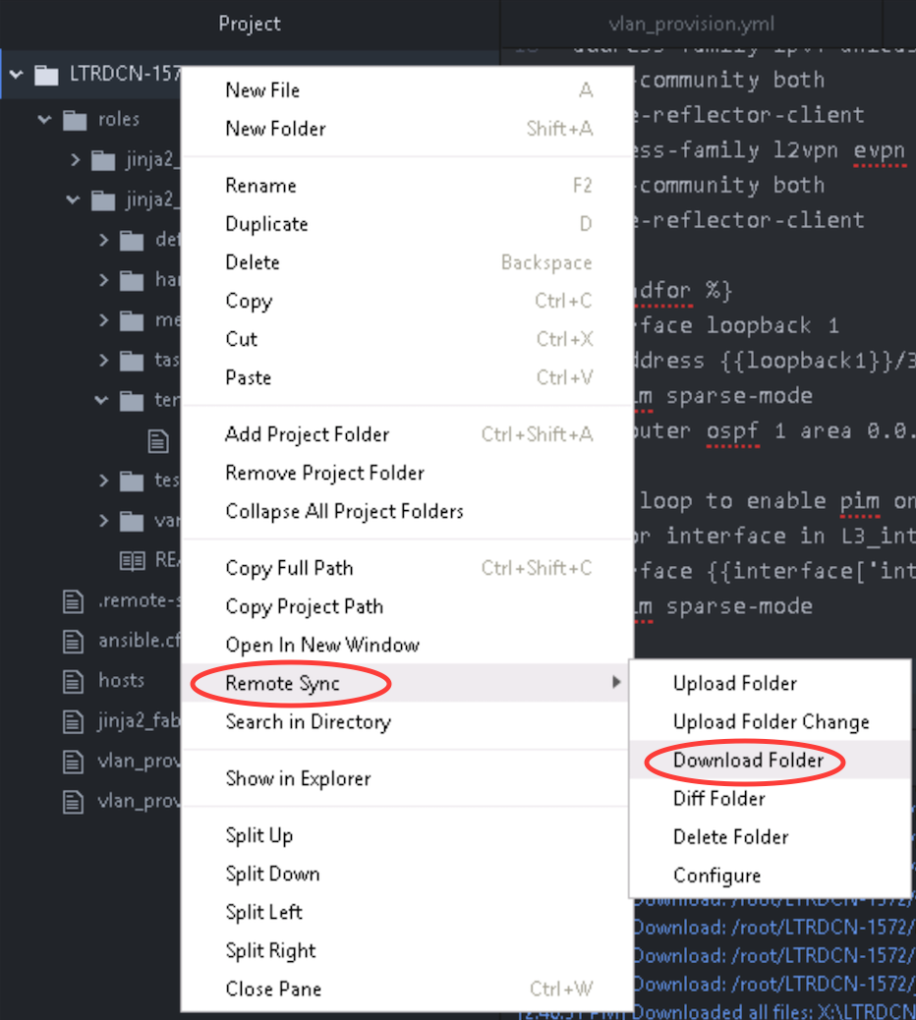

* Download jina2 tempalte from the **box folder** spine.j2. Below is the link to the folder

[**https://cisco.app.box.com/v/LTRDCN1572**](https://cisco.app.box.com/v/LTRDCN1572)

* The file would be under LTRDCN-1572/roles/jinja2_spine/templates/spine.j2

<https://cisco.app.box.com/v/LTRDCN1572/folder/44981931157>

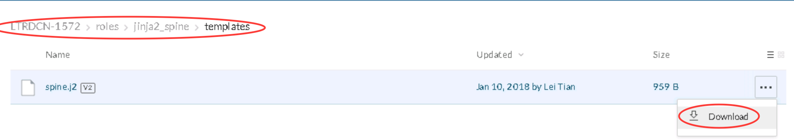

* + - After the file is downloaded, go to the downloads folder. Move (or copy) the file from the downloads folder and paste the file in the projects folder
      * TFTP_Data (\\AD1) (X:) 🡪 LTRDC-1572 🡪roles 🡪 jinja2_spine 🡪 templates

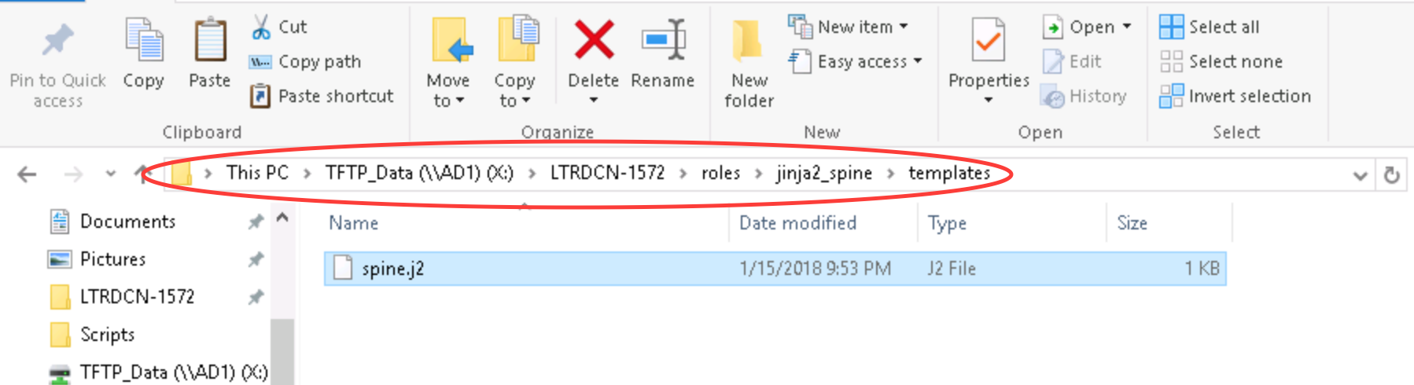

* Go to ATOM “**File” – “Open File…”** and browse to this “**spine.j2”** that was just saved in X:\LTRDCN-1572\roles\jinja2_spine\templates

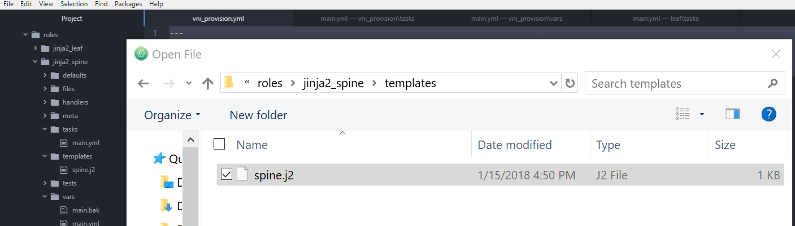

* After opening “spine.j2” from ATOM, go to **“File” – “Save”** to push template file to Ansible node

1. 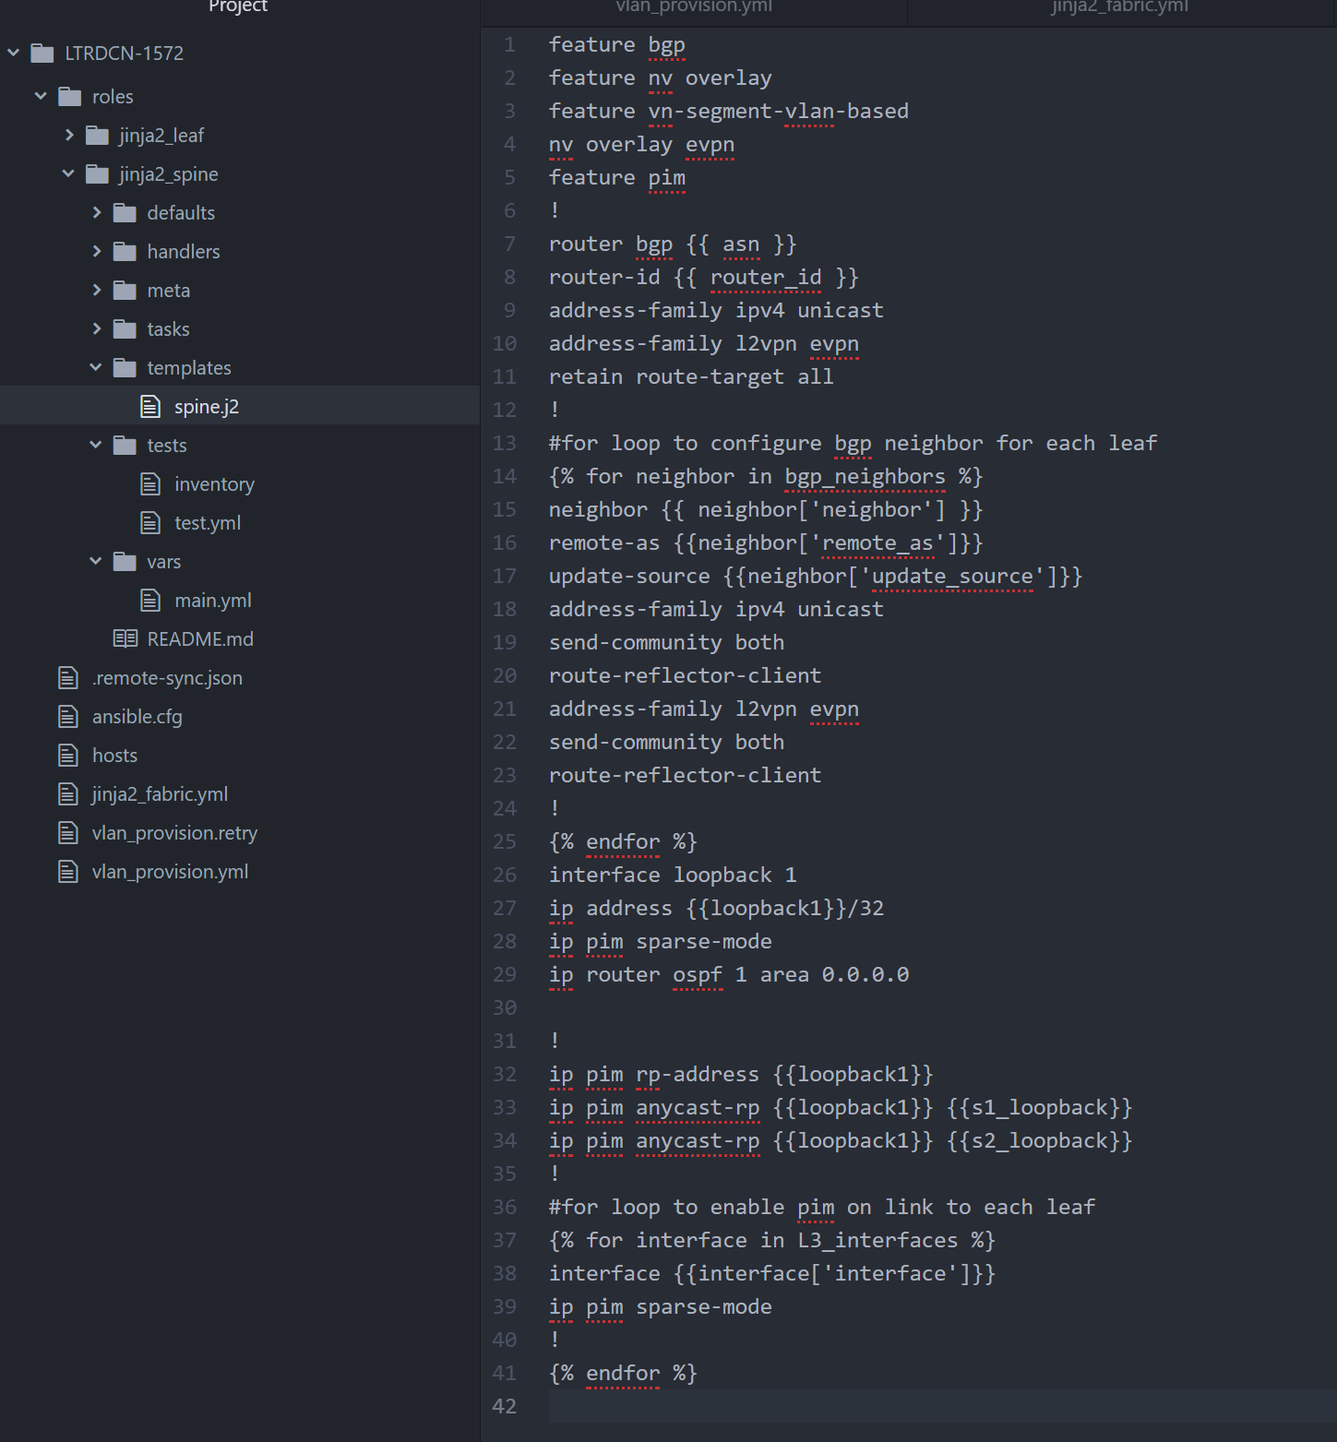

Step 5: Create playbook for jinja2_spine role

* The playbook for jinja2_spine roles has two tasks. First task uses ansible **template** module to generate configuration file based on jinja2 template created in last step. The configuration file is saved in “**file”** folder. Second task is push the configuration to switch.
* “ansible-galaxy” automatically creates empty “**main.yml**” file under “**tasks”** folder.
* We are going to use “**Atom”** to edit the main.yml file.
* Open up the project folder **“LTRDCN-1572”** and edit main.yml file under **“roles/jinja2_spine/tasks/”** to include following

|  |
| --- |
| ---  # tasks file for jinja2_spine  - name: Generate Spine Config  template: src=spine.j2 dest=roles/jinja2_spine/files/{{inventory_hostname}}.cfg  - name: Push Spine Config  nxos_config:  src: roles/jinja2_spine/files/{{inventory_hostname}}.cfg  match: none  provider: "{{ nxos_provider }}" |

* Contents of the ‘main.yml’ file should look like below:

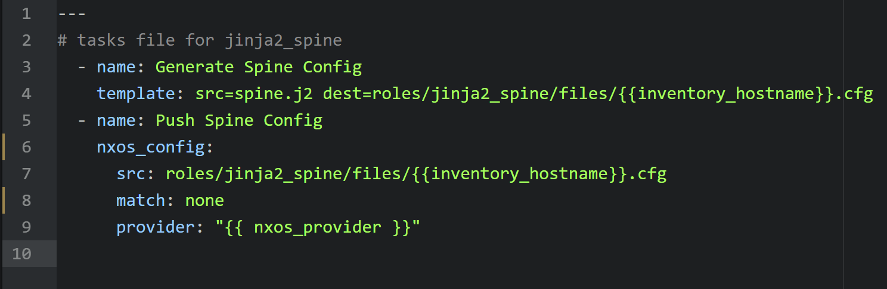

* Click “File” “Save” . This will save the playbook, and also ftp the playbook to Ansible server using pre-configured “remote-sync” package.
* In the above YAML file, ansible module named “**ios_config”** is used. This module performs below activities:
  + It uses source path of the file (“***src”***) that contains the configuration or configuration template to load into spine
  + Since “***force***” option is set to true, hence the contents of src file will be pushed into device without checking if these already exist in device

Step 6: Run Jinja2_fabric playbook

* In this section you will run the playbook created in step 1, this will generate configuration file for Spine-2 switche from the template.
* The playbook will also push the configuration file to Spine-2 switch~~es~~.
* Run the ansible playbook by going to folder LTRDC-1572 and executing the below command

**Note It will take few minutes to push configuration**

|  |
| --- |
| [root@rhel7-tools roles]# **cd ~/LTRDCN-1572/**  [root@rhel7-tools LTRDCN-1572]# **ansible-playbook jinja2_fabric.yml** |

Below screenshot shows the execution of above playbook:

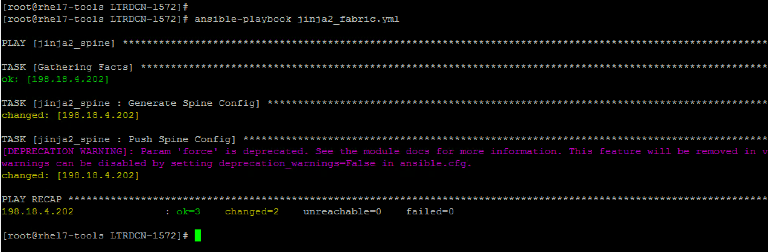

* Login to Spine-2 switch to verify configuration has been pushed. Double click the spine-2 icon in the left pane
* Login with credentials admin/C1sco12345

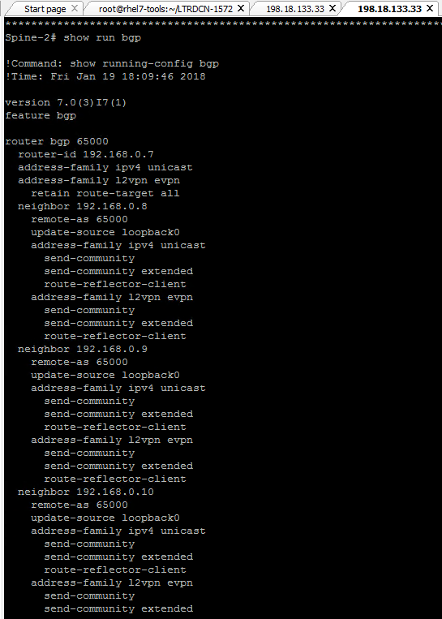

### Step 7: Edit existing playbook

In this section, we will use Jina2 template and Ansible to provision the VXLAN Fabric on leaf-4.

* We are going to **add** jinja2_leaf this time to the already created playbook in step 1
* Switch to “**Atom”**, click on the folder LTRDDCN-1572, **edit** the existing playbook **‘jinja2_fabric.yml’**.

Below screenshot shows the contents of **jinja2_fabric.yml** file in Atom:

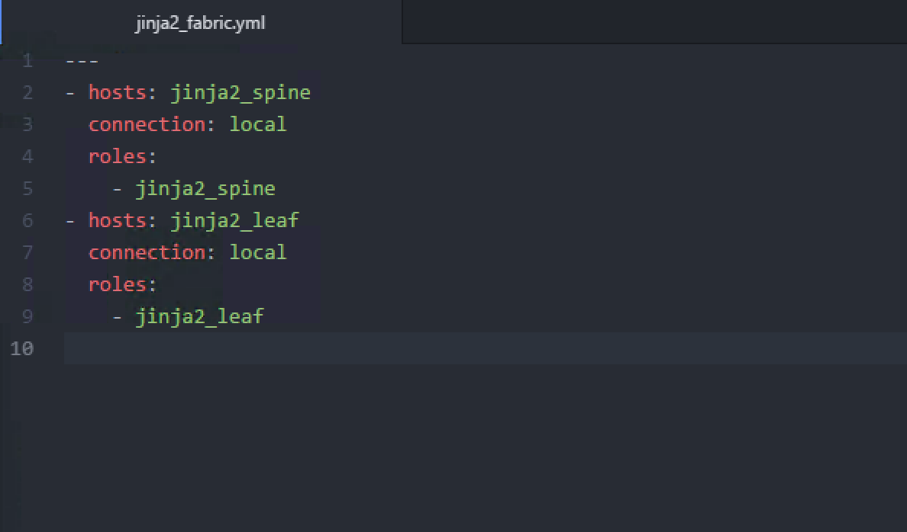

* Click “**File**” “**Save**” . This will save the playbook, and also ftp the playbook to Ansible server using pre-configured “remote-sync” package.

Step 8: Create variable file for jinja2_leaf role

* On **ATOM**, open up the project folder **“LTRDCN-1572”** and edit **main.yml** file under **“roles/jinja2_leaf/vars/”** to include following

|  |
| --- |
| ---  # vars file for jinja2_leaf  nxos_provider:  username: "{{ user }}"  password: "{{ pwd }}"  timeout: 100  host: "{{ inventory_hostname }}"  asn: 65000  bgp_neighbors:  - remote_as: 65000  neighbor: 192.168.0.6  update_source: Loopback0  - remote_as: 65000  neighbor: 192.168.0.7  update_source: Loopback0  rp_address: 192.168.0.100  L3_interfaces:  - interface: Ethernet 1/1  - interface: Ethernet 1/2  - interface: loopback 0  - interface: loopback 1  L2VNI:  - vlan_id: 140  vni: 50140  ip_add: 172.21.140.1  mask: 24  vlan_name: L2-VNI-140-Tenant1  mcast: 239.0.0.140  - vlan_id: 141  vni: 50141  ip_add: 172.21.141.1  mask: 24  vlan_name: L2-VNI-141-Tenant1  mcast: 239.0.0.141  L3VNI:  - vlan_id: 999  vlan_name: L3-VNI-999-Tenant1  vni: 50999 |

Below screenshot shows the contents of **jinja2_leaf\vars\main.yml** file in Atom:

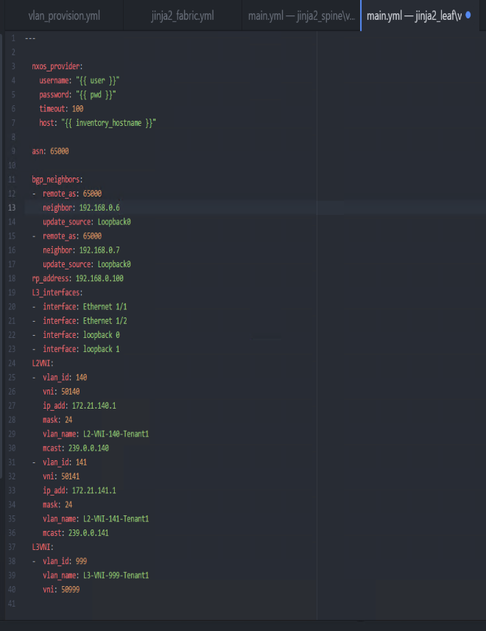

* Click “File” “Save” . This will save the playbook, and also ftp the playbook to Ansible server using pre-configured “remote-sync” package

Step 9: Create Jinja2 template for leaf role

* Open up the project folder **“LTRDCN-1572”** and open file **‘leaf.j2’** under **“roles/jinja2_leaf/templates/”.**

***NOTE: it is possible that the file might not appear. Go ahead and execute the below 4 steps to get it sync just like it was done for the spine. This time, we will do it for leaf***

1. Change directory (cd) to folder **LTRDC-1572 on** Ansible server (198.18.134.150)
2. Change directory (cd) to folder **roles/jinja2_leaf/templates**
3. Type “**touch leaf.j2**”
4. After entering the command, go back to ATOM, right click on **folder LTRDCN**, scroll to choose option **Remote Sync** and choose **download**.

* To reduce typo, you can copy the jinja2 template from box folder

[**https://cisco.app.box.com/v/LTRDCN1572**](https://cisco.app.box.com/v/LTRDCN1572)

* The file would be under LTRDCN-1572/roles/jinja2_leaf/templates/leaf.j2

[https://cisco.app.box.com/v/LTRDCN1572/folder/44981518497](https://cisco.app.box.com/v/LTRDCN1572/folder/44981518497%20)

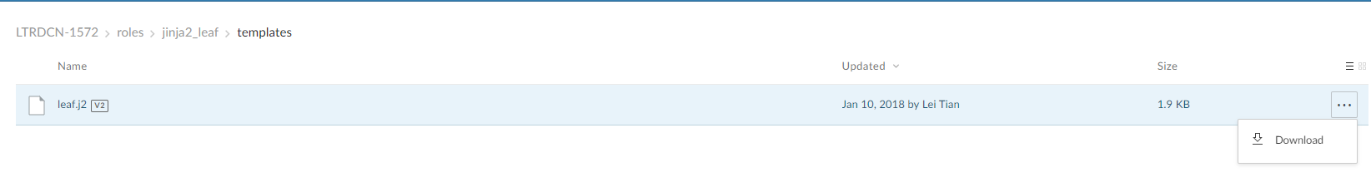

* + - After the file is downloaded, go to the downloads folder. Copy the file from the downloads folder and paste this file in the projects folder
      * TFTP_Data (X:) 🡪 LTRDC-1572 🡪 roles 🡪 jinja2_leaf 🡪 templates

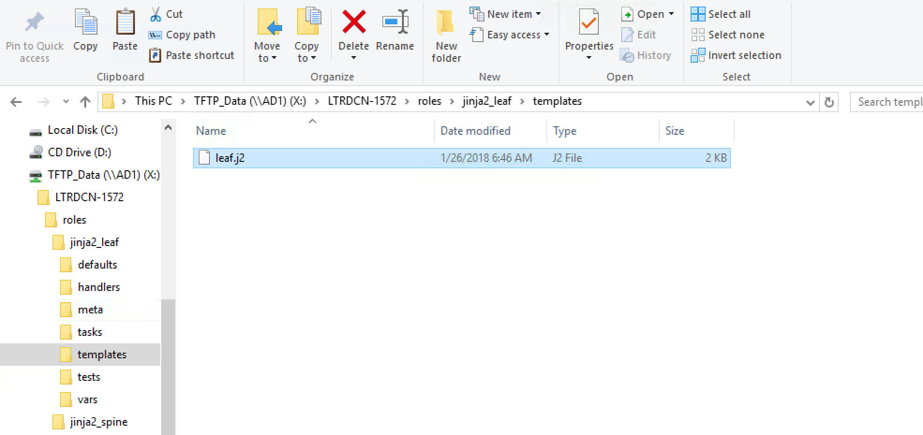

* + - Go to **ATOM** open file **leaf.j2** under roles\jinja2_leaf\templates

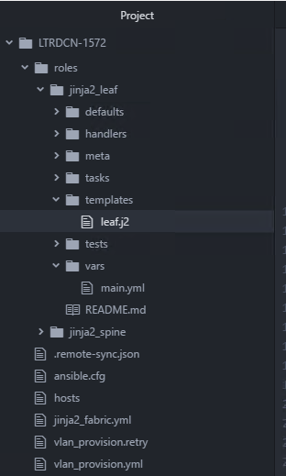

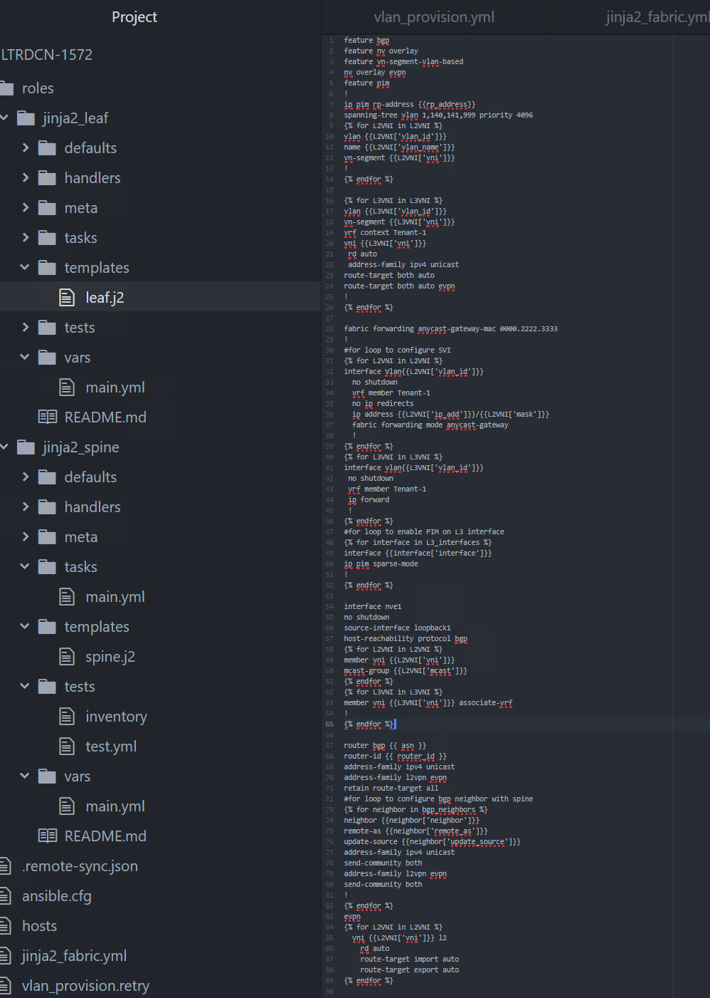

* After opening “**leaf.j2**” from ATOM, go to **“File” – “Save”** to push template file to Ansible node

Step 10: Create playbook for jinja2_leaf role

* The playbook for jinja2_leaf roles has two tasks.
* First task uses ansible **template** module to generate configuration file based on jinja2 template created in last step. The configuration file is saved in “**file”** folder.
* Second task is to push the configuration to switch.
* “ansible-galaxy” automatically creates empty “main.yml” file under “**tasks”** folder.
* We are going to use “**Atom”** to edit the main.yml file.
* Open up the project folder **“LTRDCN-1572”** and edit “**main.yml”** file under **“roles/jinja2_leaf/tasks/”** to include following

|  |
| --- |
| ---  # tasks file for jinja2_leaf  - name: Generate Leaf Config  template: src=leaf.j2 dest=roles/jinja2_leaf/files/{{inventory_hostname}}.cfg  - name: Push Leaf Config  nxos_config:  src: roles/jinja2_leaf/files/{{inventory_hostname}}.cfg  match: none  provider: "{{ nxos_provider }}" |

* The screenshot shows how **jinja2_leaf/taks/main,yml** looks like in Atom

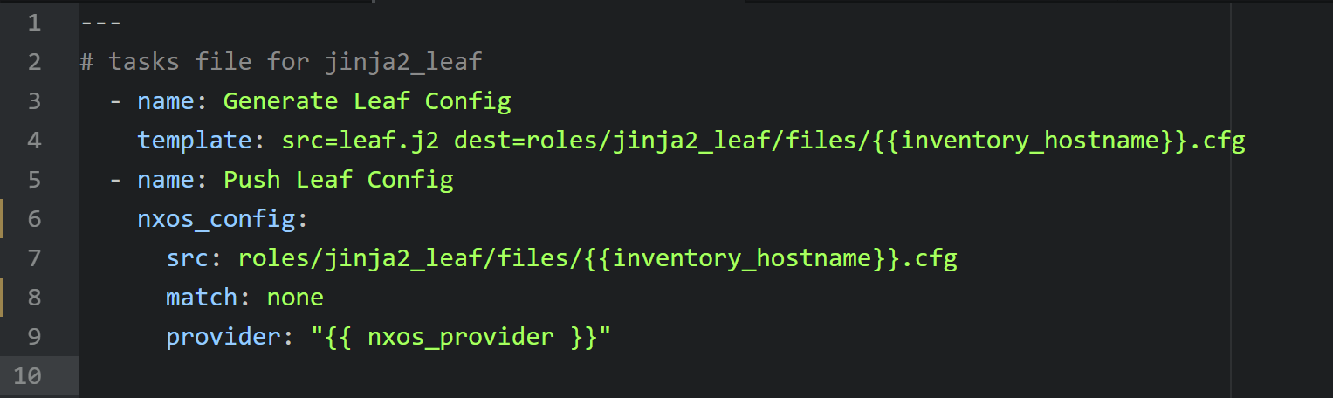

Step 11: Run Jinja2_fabric.yml playbook

In this section you will run the playbook created in step 7, this will generate configuration file for Spine-2 and Leaf-4 switches. It will also push the configuration file to both switches.

***NOTE: It might take couple of minutes for the configuration to be pushed to via the Ansible Server. It is working in the background.***

|  |
| --- |
| [root@rhel7-tools LTRDCN-1572]# **ansible-playbook jinja2_fabric.yml** |

Below screenshot shows the output of above command:

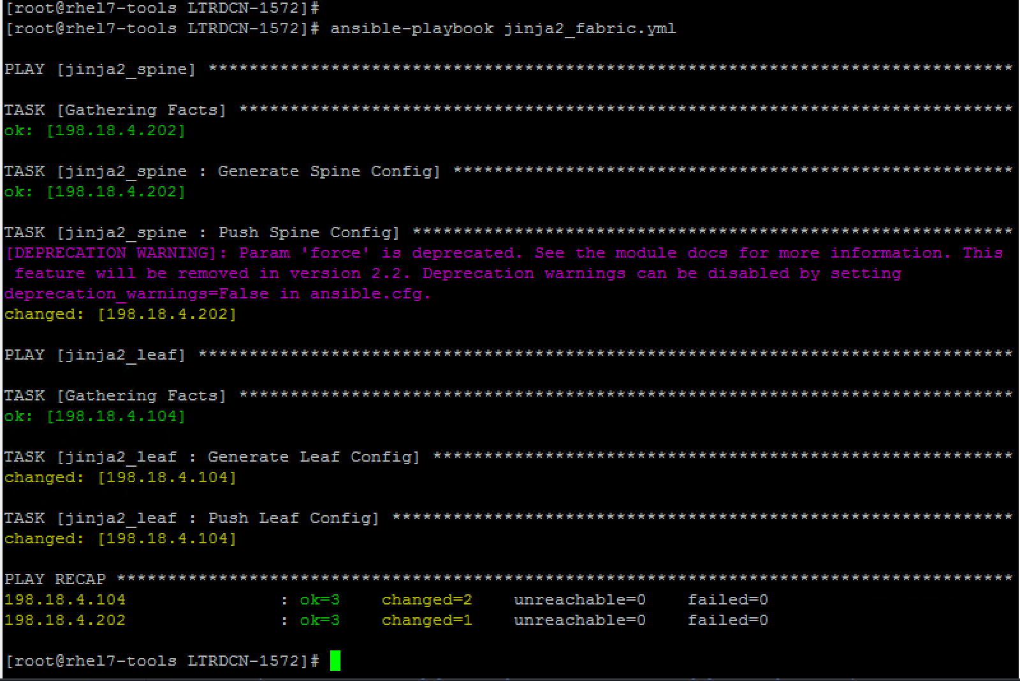

After the configuration push is successful, **login** to **leaf-4** switch to verify configuration has been pushed by running below command:

show running-config bgp

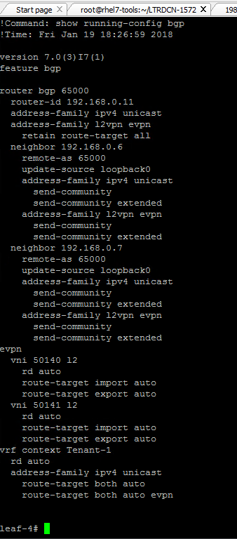

Task 4: Provision VXLAN Fabric using Ansible + NXOS

In this section, you will build remining VXLAN fabric using Ansible NXOS modules.

Compare of using Jinja2 to build the fabric, NXOS modules are more abstract from configurations. There is no knowledge of NXOS CLI required to use NXOS modules. You will follow the steps to configure BGP, Multicast, VXLAN and EVPN. In each step, you will use different Ansible NXOS modules to accomplish the step.

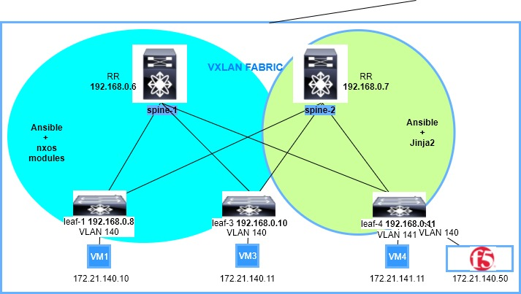

After each step, you can login the switches to verify configuration changes.

### Step 1: Create new playbook

Switch to “**Atom”**  LTRDCN-1572 project folder and create new playbook **‘nxos_fabric.yml’.**

Again we will use roles structure to make the playbook more modular, and the roles included in the playbook are “**spine”** and “**leaf”**.

Save this file **(File 🡪 Save)** on Atom with below content**:**

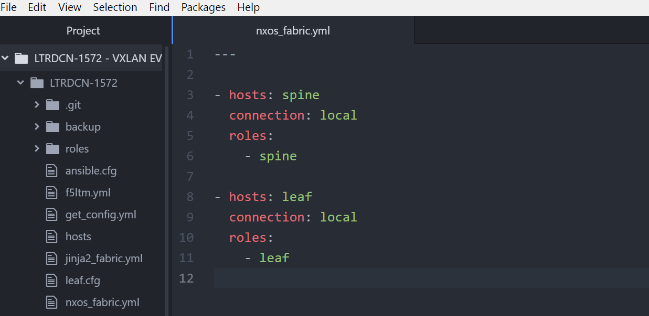

### Step 2: Create new roles and vars

Switch to **MTPuTTY** SSH into ‘ansible’ node, switch to ‘role’ folder under project folder; create roles ‘spine’ and ‘leaf’ using **ansible-galaxy**

|  |
| --- |
| [root@rhel7-tools LTRDCN-1572]# **cd ~/LTRDCN-1572/roles/** |

Ansible-galaxy init will create new role with base role structure and empty main.yml file as role requires.

|  |
| --- |
| [root@rhel7-tools roles]# **ansible-galaxy init spine&&ansible-galaxy init leaf** |

Below screeshot shows the output of above command:

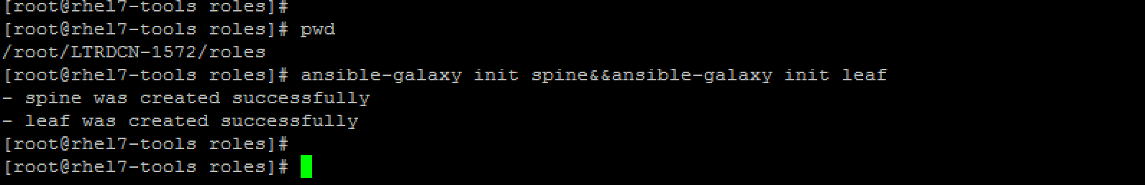

Switch to “**Atom”** and sync the new created folders between Ansible node and remote desktop. Right click on project folder “**LTRDCN-1572”,** open “**Remote Sync”** select **“Download Folder”**

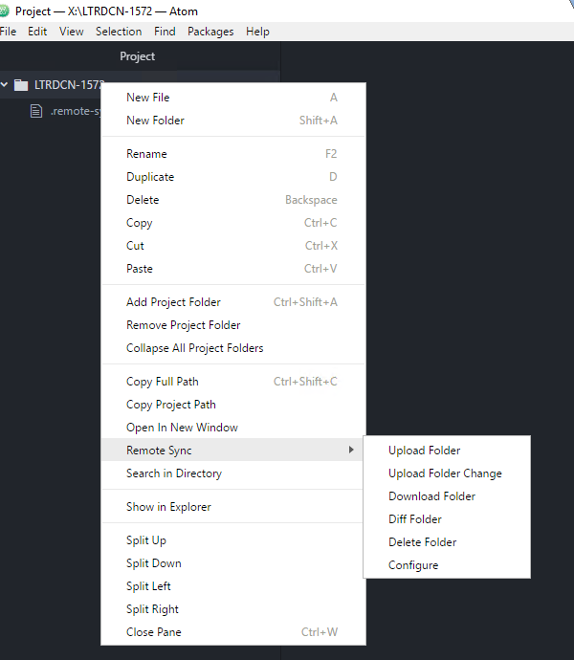

### Step 3: Configure BGP using Ansible NXOS

In this section we will configure BGP neighbors between spine and leaf switching by using Ansible NXOS modules. The following NXOS ansible modules are used:

|  |  |
| --- | --- |
| nxos_feature | Manage features on Nexus switches |
| nxos_bgp | Manage BGP config |
| nxos_bgp_neighbor | Manage BGP neighbor config |
| Nxos_bgp_af | Manage BGP address-famility config |
| Nxos_bgp_neighbor_af | Manage BGP neighbor address-famility config |

### Build playbook for spine role

“ansible-galaxy” automatically creates empty “main.yml” file under “**tasks”** folder. You can use “**Atom”** to edit the “**main.yml**” file. Open up the project folder **“LTRDCN-1572”** and open “**main.yml**” file under **“roles/spine/tasks/”.** Save this file **(File 🡪 Save)** on **Atom** with below content**:**

**Note: It is recommended to write your playbook and learn from mistakes, but file is also available in the box folder if you prefer to reuse.**

|  |
| --- |
| ---  # tasks file for spine  #task to configure bgp neighbor to all leaf switches  - name: Enable BGP  nxos_feature:  feature: bgp  provider: "{{nxos_provider}}"  state: enabled  tags: bgp  - name: Configure BGP AS  nxos_bgp:  asn: "{{ asn }}"  router_id: "{{ router_id }}"  provider: "{{ nxos_provider }}"  state: present  tags: bgp  - name: Configure BGP AF  nxos_bgp_af:  asn: "{{ asn }}"  afi: ipv4  safi: unicast  provider: "{{ nxos_provider }}"  tags: bgp  - name: Configure iBGP neighbors  nxos_bgp_neighbor:  asn: "{{ asn }}"  neighbor: "{{ item.neighbor }}"  remote_as: "{{ item.remote_as }}"  update_source: "{{ item.update_source }}"  provider: "{{ nxos_provider }}"  with_items: "{{ bgp_neighbors }}"  tags: bgp  - name: Configure iBGP neighbor AF  nxos_bgp_neighbor_af:  asn: "{{ asn }}"  neighbor: "{{ item.neighbor }}"  afi: ipv4  safi: unicast  route_reflector_client: "true"  send_community: both  provider: "{{ nxos_provider }}"  with_items: "{{ bgp_neighbors }}"  tags: bgp |

Note, in the above task/main.yml file multiple NXOS ansible modules have been used:

* **“nxos_feature”** module provides the capability to manage features in NX-OS features. It is used to enable bgp as a feature in above configurations.
* **“nxos_bgp”** module provides the capability to manage BGP configuration in NX-OS. Here it is used to configure bgp
* **“nxos_bgp_af”** module provides the capability to manage BGP Address-family configuration in NX-OS.
* **“nxos_bgp_neighbor”** module is used to configure the BGP Neighbour in NX-OS.
* **“nxos_bgp_neighbor_af”** module provides the capability to manage BGP Address-family Neighbour configuration in NX-OS.

### Build variable file for Spine role

Use “**Atom”** to edit the main.yml file. Open up the project folder **“LTRDCN-1572”** and open “**main.yml**” file under **“roles/spine/vars/”.** Save this file **(File 🡪 Save)** on Atom with below content**:**

**Note:** the variables in this file are being referred to in the above tasks/main.yml file

|  |
| --- |
| ---  # vars file for spine  nxos_provider:  username: "{{ user }}"  password: "{{ pwd }}"  transport: nxapi  timeout: 30  host: "{{ inventory_hostname }}"  asn: 65000  bgp_neighbors:  - { remote_as: 65000, neighbor: 192.168.0.8, update_source: Loopback0 }  - { remote_as: 65000, neighbor: 192.168.0.10, update_source: Loopback0 }  - { remote_as: 65000, neighbor: 192.168.0.11, update_source: Loopback0 } |

**Build playbook for leaf role**

“ansible-galaxy” automatically creates empty “main.yml” file under “**tasks”** folder. You can use “**Atom”** to edit the “**main.yml**” file. Open up the project folder **“LTRDCN-1572”** and open “**main.yml**” file under **“roles/leaf/tasks/”.** Save this file **(File 🡪 Save)** on Atom with below content**:**

**Note: It is recommended to write your playbook and learn from mistakes, but file is also available in the box folder if you prefer to reuse.**

|  |
| --- |
| ---  # tasks file for leaf  #task to configure bgp neighbor to all spine switches  - name: Enable BGP  nxos_feature:  feature: bgp  provider: "{{nxos_provider}}"  state: enabled  tags: bgp  - name: Configure BGP AS  nxos_bgp:  asn: "{{ asn }}"  router_id: "{{ router_id }}"  provider: "{{ nxos_provider }}"  state: present  tags: bgp  - name: Configure BGP AF  nxos_bgp_af:  asn: "{{ asn }}"  afi: ipv4  safi: unicast  provider: "{{ nxos_provider }}"  tags: bgp  - name: Configure iBGP neighbors  nxos_bgp_neighbor:  asn: "{{ asn }}"  neighbor: "{{ item.neighbor }}"  remote_as: "{{ item.remote_as }}"  update_source: "{{ item.update_source }}"  provider: "{{ nxos_provider }}"  with_items: "{{ bgp_neighbors }}"  tags: bgp  - name: Configure iBGP neighbor AF  nxos_bgp_neighbor_af:  asn: "{{ asn }}"  neighbor: "{{ item.neighbor }}"  afi: ipv4  safi: unicast  send_community: both  provider: "{{ nxos_provider }}"  with_items: "{{ bgp_neighbors }}"  tags: bgp |

### Build variable file for leaf role

Use “**Atom”** to edit the main.yml file. Open up the project folder **“LTRDCN-1572”** and open main.yml file under **“roles/leaf/vars/”.** Save this file **(File 🡪 Save)** on Atom with below content**:**

|  |
| --- |
| ---  # vars file for leaf  nxos_provider:  username: "{{ user }}"  password: "{{ pwd }}"  transport: nxapi  timeout: 30  host: "{{ inventory_hostname }}"  asn: 65000  bgp_neighbors:  - { remote_as: 65000, neighbor: 192.168.0.6, update_source: Loopback0 }  - { remote_as: 65000, neighbor: 192.168.0.7, update_source: Loopback0 } |

### Run the playbook and verify configuration changes

|  |
| --- |
| [root@rhel7-tools LTRDCN-1572]# **cd ~/LTRDCN-1572**  [root@rhel7-tools LTRDCN-1572]# **ansible-playbook nxos_fabric.yml --tags "bgp"** |

Below screenshots shows the output of above commands:

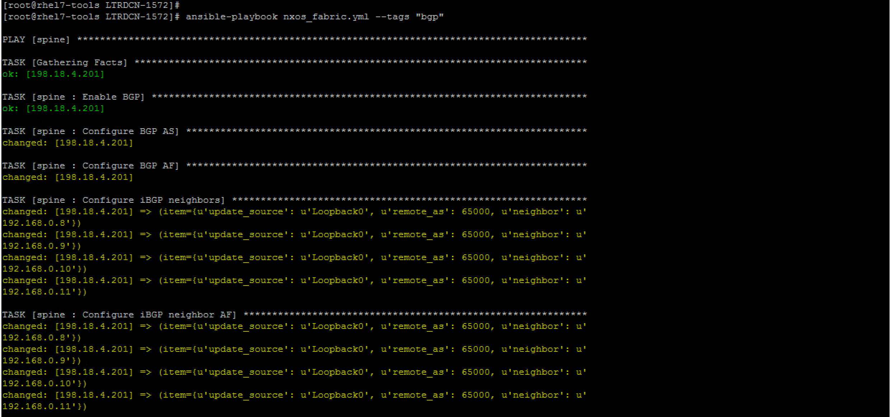  
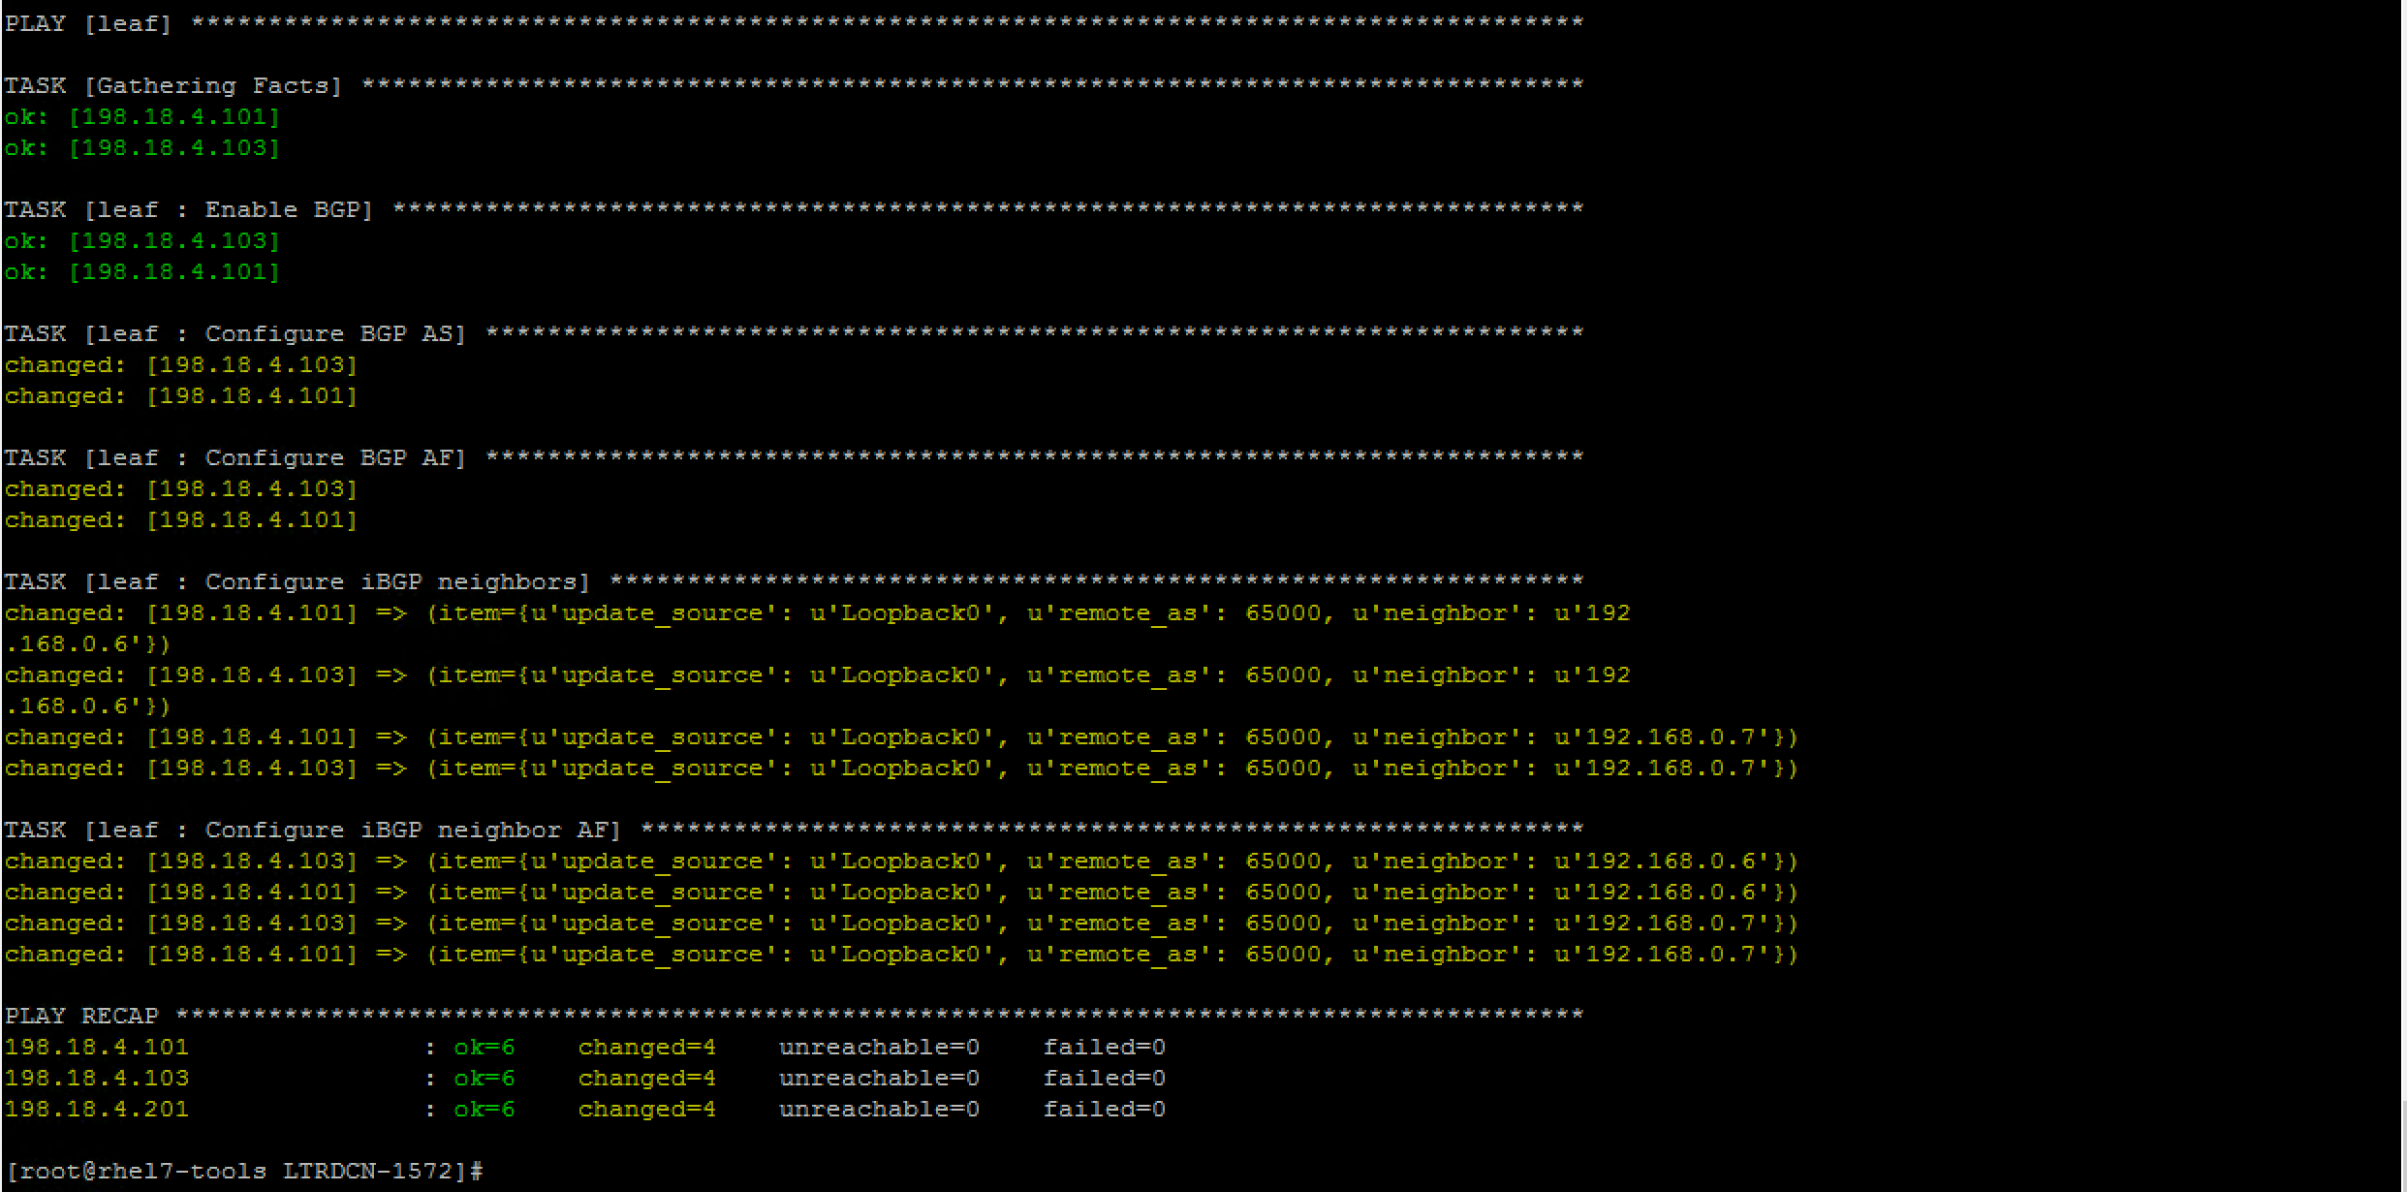

**Note:** login to any of the leaf switches (leaf1, leaf3, leaf4), or spine-1 switch to verify BGP configuration and BGP neighbors from ‘**show ip bgp sum’**

Below screenshot shows the ouptut from Spine-1 and Leaf3:

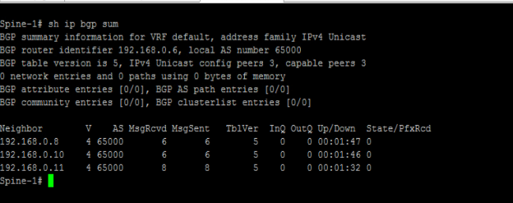

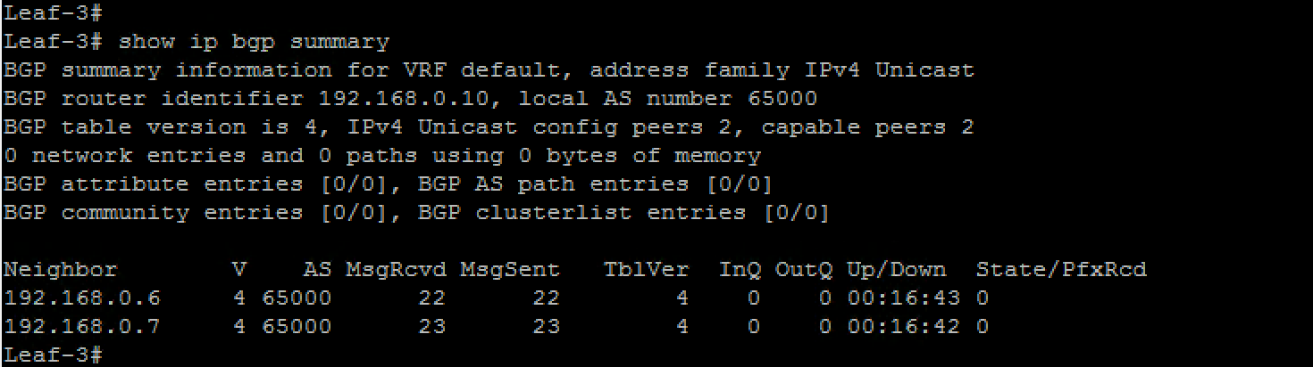

### Step 4: Configure Multicast using Ansible NXOS

In this section, we will be configuring underlay multicast to support BUM traffic in the VXLAN fabric. The NXOS modules we will be using in this section are

|  |  |
| --- | --- |
| nxos_feature | Manage fatures on Nexus switchs |
| nxos_pim_interface | Manage PIM interface configuration |
| nxos_pim_rp_address | Manage static RP configuration |
| nxos_config | Manage NXOS arbitrary configuration command |
| nxos_interface_ospf | Manage configuration OSPF interface instance |
| nxos_interface | Manage physical attribute of interface |

**Note: there is no nxos ansible module for Anycast RP, we will use nxos_config to push the Anycast RP configuration**

### Edit playbook for spine role

Use “**Atom”** to edit the “**main.yml**” file. Open up the project folder **“LTRDCN-1572”** and open “**main.yml**” file under **“roles/spine/tasks/”** and save the below tasks at the end the file:

**Note: It is recommended to write your playbook and learn from mistakes, but file is also available in the box folder if you prefer to reuse.**

|  |
| --- |
| #task to enable pim and configure anycast rp for underlay multicast  - name: Enable PIM  nxos_feature:  feature: pim  provider: "{{nxos_provider}}"  state: enabled  tags: multicast  - name: Configure Anycast RP interfce  nxos_interface:  interface: loopback1  provider: "{{ nxos_provider }}"  tags: multicast  - name: Configure IP Address on New LP1  nxos_ip_interface:  interface: loopback1  version: v4  addr: "{{ loopback1 }}"  mask: 32  provider: "{{ nxos_provider }}"  tags: multicast  - name: Configure PIM int  nxos_pim_interface:  interface: "{{ item.interface }}"  sparse: true  provider: "{{ nxos_provider }}"  with_items: "{{L3_interfaces}}"  tags: multicast  - name: Enable OSPF on New LP1  nxos_interface_ospf:  interface: loopback1  ospf: 1  area: 0  provider: "{{ nxos_provider }}"  tags: multicast  - name: Configure PIM RP  nxos_pim_rp_address:  rp_address: "{{ loopback1 }}"  provider: "{{ nxos_provider }}"  tags: multicast  - name: Configure Anycast RP  nxos_config:  lines:  - "ip pim anycast-rp {{ loopback1 }} {{ s1_loopback }}"  - "ip pim anycast-rp {{ loopback1 }} {{ s2_loopback }}"  provider: "{{ nxos_provider }}"  tags: multicast |

### Edit variable file for Spine role

Use “**Atom”** to edit the **main.yml** file. Open up the project folder **“LTRDCN-1572”** and open **main.yml** file under **“roles/spine/vars/”**

|  |
| --- |
| L3_interfaces:  - { interface: Ethernet1/1 }  - { interface: Ethernet1/2 }  - { interface: Ethernet1/3 }  - { interface: Ethernet1/4 }  - { interface: loopback0 }  - { interface: loopback1 }  s1_loopback: 192.168.0.6  s2_loopback: 192.168.0.7 |

### Edit playbook for leaf role

use “**Atom”** to edit the **main.yml** file. Open up the project folder **“LTRDCN-1572”** and open **main.yml** file under **“roles/leaf/tasks/”.**  On **Atom**,Make sure to click **File 🡪 Save** after entering the below data in this file so it is pushed to Ansible server:

**Note: It is recommended to write your playbook and learn from mistakes, but file is also available in the box folder if you prefer to reuse.**

|  |
| --- |
| #task to enable PIM for underlay multicast  - name: Enable PIM  nxos_feature:  feature: pim  provider: "{{nxos_provider}}"  state: enabled  tags: multicast  - name: Configure PIM int  nxos_pim_interface:  interface: "{{ item.interface }}"  sparse: true  provider: "{{ nxos_provider }}"  with_items: "{{L3_interfaces}}"  tags: multicast  - name: Configure PIM RP  nxos_pim_rp_address:  rp_address: "{{ rp_address }}"  provider: "{{ nxos_provider }}"  tags: multicast |

### Edit variable file for leaf role

Use “**Atom”** to edit the **main.yml** file. Open up the project folder **“LTRDCN-1572”** and open **main.yml** file under **“roles/leaf/vars/”.** On **Atom**,Make sure to click **File 🡪 Save** after entering the below data in this file so it is pushed to Ansible server:

|  |
| --- |
| rp_address: 192.168.0.100  L3_interfaces:  - { interface: Ethernet1/1 }  - { interface: Ethernet1/2 }  - { interface: loopback0 }  - { interface: loopback1 } |

### Run the playbook and verify configuration changes

|  |
| --- |
| [root@rhel7-tools LTRDCN-1572]# **ansible-playbook nxos_fabric.yml --tags "multicast"** |

Below screenshots shows the output of above command:

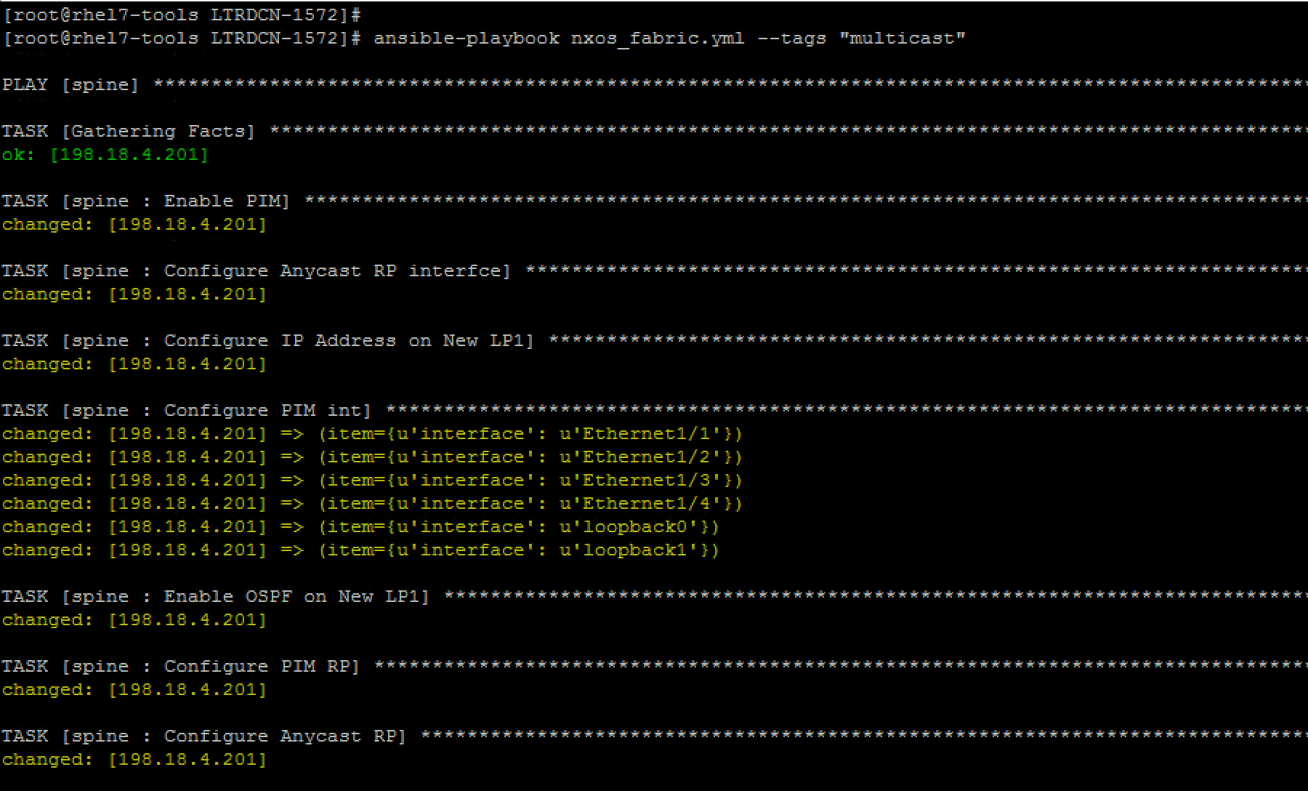

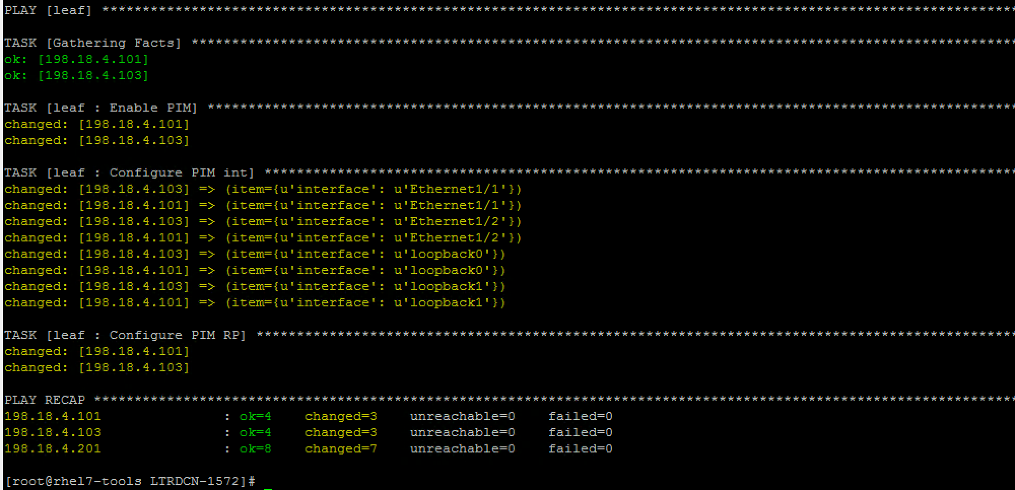

**Note: login to any leaf (leaf1, leaf3, leaf4) or spine-1 switch to verify multicast configuration and PIM neighbors from ‘show ip pim nei’**

Below screenshot shows the output of above command from Spine-1

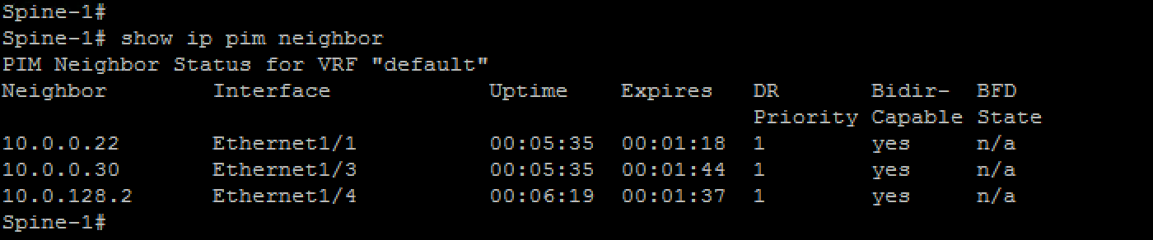

### Step 5: Configure VXLAN using Ansible

In this section, we will be configuring VXLAN on leaf and spine switches. The NXOS modules we will be using in this section are

|  |  |
| --- | --- |
| nxos_feature | Manages features on Nexus switches |
| nxos_evpn_global | Handles EVPN control plane for VXLAN |
| nxos_vlan | Manages VLAN resources and attributes |
| nxos_vrf | Manages global VRF configuration |
| nxos_vrf_af | Manages VRF address falimily |
| nxos_overlay_global | Configuration anycast gateway MAC |
| nxos_vxlan_vtep | Manages VXLAN Network Virtualization Endpoint |
| nxos_vxlan_vtep_vni | Creates Virtual Network Identifier member |

### Edit playbook for spine role

Use “**Atom”** to edit the “**main.yml**” file. Open up the project folder **“LTRDCN-1572”** and open “**main.yml**” file under **“roles/spine/tasks/”.** Add the below content in the file in addition to existing content, and then make sure to click “**File**” 🡪 “**Save**” on Atom so that the updated file is pushed to Ansible server.

**Note: It is recommended to write your playbook and learn from mistakes, but file is also available in the box folder if you prefer to reuse.**

|  |
| --- |
| #task to configure vxlan fabric  - name: Enable VXLAN Feature  nxos_feature:  feature: "{{item}}"  provider: "{{nxos_provider }}"  state: enabled  with_items:  - nv overlay  - vn-segment-vlan-based  tags: vxlan  - name: Enable NV Overlay  nxos_evpn_global:  nv_overlay_evpn: true  provider: "{{ nxos_provider }}"  tags: vxlan |

### Edit variable file for Spine role

No new variable required for Spine

### Edit playbook for leaf role

use “**Atom”** to edit the **main.yml** file. Open up the project folder **“LTRDCN-1572”** and open “**main.yml”** file under **“roles/leaf/tasks/”.** Add the below content in the file in addition to existing content, and then make sure to click “**File**” 🡪 “**Save**” on Atom, so that the updated file is pushed to Ansible server.

**Note: It is recommended to write your playbook and learn from mistakes, but file is also available in the box folder if you prefer to reuse.**

|  |
| --- |
| #task to configure VXLAN fabric  - name: Enable VXLAN Feature  nxos_feature:  feature: "{{ item }}"  provider: "{{nxos_provider}}"  state: enabled  with_items:  - nv overlay  - vn-segment-vlan-based  tags: vxlan  - name: Enable NV Overlay  nxos_evpn_global:  nv_overlay_evpn: true  provider: "{{ nxos_provider }}"  tags: vxlan  - name: Configure VLAN to VNI  nxos_vlan:  vlan_id: "{{ item.vlan_id }}"  mapped_vni: "{{ item.vni }}"  name: "{{ item.vlan_name }}"  provider: "{{ nxos_provider }}"  with_items:  - "{{ L2VNI }}"  - "{{ L3VNI }}"  tags: vxlan  - name: Configure Tenant VRF  nxos_vrf:  vrf: Tenant-1  rd: auto  vni: "{{ L3VNI[0].vni }}"  provider: "{{ nxos_provider }}"  tags: vxlan  - name: Configure VRF AF  nxos_vrf_af:  vrf: Tenant-1  route_target_both_auto_evpn: true  afi: ipv4  provider: "{{ nxos_provider }}"  tags: vxlan  - name: Configure Anycast GW  nxos_overlay_global:  anycast_gateway_mac: 0000.2222.3333  provider: "{{ nxos_provider }}"  tags: vxlan  - name: Configure L2VNI  nxos_interface:  interface: vlan"{{ item.vlan_id }}"  provider: "{{ nxos_provider }}"  with_items: "{{ L2VNI }}"  tags: vxlan  - name: Configure L3VNI  nxos_interface:  interface: vlan"{{ L3VNI[0].vlan_id }}"  provider: "{{ nxos_provider }}"  tags: vxlan  - name: Assign interface to Tenant VRF  nxos_vrf_interface:  vrf: Tenant-1  interface: "vlan{{ item.vlan_id }}"  provider: "{{ nxos_provider }}"  with_items:  - "{{ L2VNI }}"  - "{{ L3VNI }}"  tags: vxlan  - name: Configure SVI IP  nxos_ip_interface:  interface: "vlan{{ item.vlan_id }}"  addr: "{{ item.ip_add }}"  mask: "{{ item.mask }}"  provider: "{{ nxos_provider }}"  with_items: "{{ L2VNI }}"  tags: vxlan  - name: Configure L2VNI SVI  nxos_interface:  interface: vlan"{{ item.vlan_id }}"  fabric_forwarding_anycast_gateway: true  provider: "{{ nxos_provider }}"  with_items: "{{ L2VNI }}"  tags: vxlan  - name: Configure L3VNI SVI  nxos_interface:  interface: vlan"{{ L3VNI[0].vlan_id }}"  ip_forward: enable  provider: "{{ nxos_provider }}"  tags: vxlan  - name: Configure VTEP Tunnel  nxos_vxlan_vtep:  interface: nve1  shutdown: "false"  source_interface: Loopback1  host_reachability: "true"  provider: "{{ nxos_provider }}"  tags: vxlan  - name: Configure L2VNI to VTEP  nxos_vxlan_vtep_vni:  interface: nve1  vni: "{{ item.vni }}"  multicast_group: "{{ item.mcast }}"  provider: "{{ nxos_provider }}"  with_items: "{{ L2VNI }}"  tags: vxlan  - name: Configure L3VNI to VTEP  nxos_vxlan_vtep_vni:  interface: nve1  vni: "{{ L3VNI[0].vni }}"  assoc_vrf: true  provider: "{{ nxos_provider }}"  tags: vxlan |

### Edit variable file for leaf role

Use “**Atom”** to edit the **main.yml** file. Open up the project folder **“LTRDCN-1572”** and open **main.yml** file under **“roles/leaf/vars/”.** Add the below content in the file in addition to existing content, and then make sure to click “**File**” 🡪 “**Save**” on Atom, so that the updated file is pushed to Ansible server.

|  |
| --- |
| L2VNI:  - { vlan_id: 140, vni: 50140, ip_add: 172.21.140.1, mask: 24, vlan_name: L2-VNI-140-Tenant1, mcast: 239.0.0.140 }  - { vlan_id: 141, vni: 50141, ip_add: 172.21.141.1, mask: 24, vlan_name: L2-VNI-141-Tenant1, mcast: 239.0.0.141 }  L3VNI:  - { vlan_id: 999, vlan_name: L3-VNI-999-Tenant1, vni: 50999 } |

### Run the playbook and verify configuration changes

|  |
| --- |
| [root@rhel7-tools LTRDCN-1572]# ansible-playbook nxos_fabric.yml --tags “vxlan” |

Below is a partial screenshot for the output of above command:

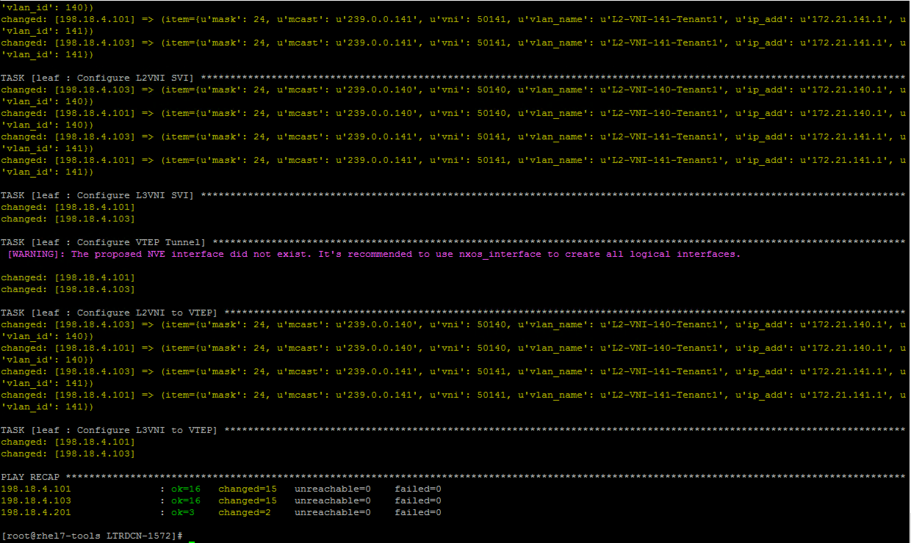

After finishing this task:

**Note: login to any leaf switch to verify vxlan configuration and vni from ‘show nve vni’**

Below screenshot is shown from Leaf-4:

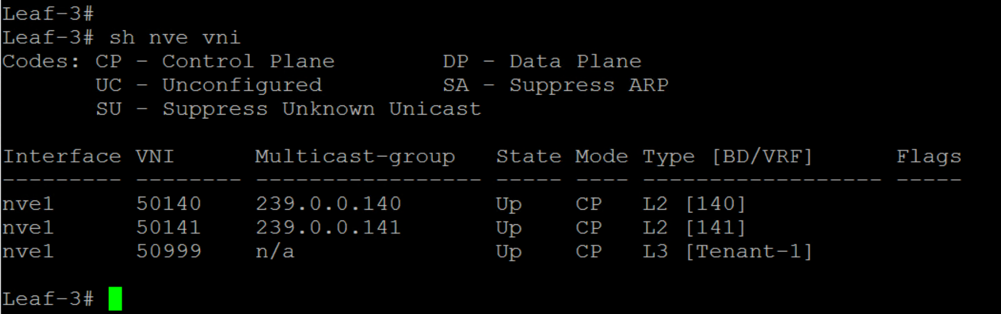

Step 6: Configure EVPN using Ansible

In this section, we will be configuring BGP EVPN on leaf and spine switches. The NXOS modules we will be using in this section are

|  |  |
| --- | --- |
| nxos_bgp_af | Manage BGP address-famility config |
| nxos_bgp_neighbor_af | Manage BGP neighbor address-famility config |
| nxos_evpn_vni | Manage Cisco EVPN VXLAN Network Identifier |

### Edit playbook for spine role

Use “**Atom”** to edit the **main.yml** file. Open up the project folder **“LTRDCN-1572”** and open “**main.yml**” file under **“roles/spine/tasks/”.** Add the below content in the file in addition to existing content, and then make sure to click “**File**” 🡪 “**Save**” on Atom, so that the updated file is pushed to Ansible server.

**Note: It is recommended to write your playbook and learn from mistakes, but file is also available in the box folder if you prefer to reuse.**

|  |
| --- |
| # task to configure BGP EVPN  - name: Configure BGP EVPN  nxos_bgp_af:  asn: "{{ asn }}"  afi: l2vpn  safi: evpn  provider: "{{ nxos_provider }}"  tags: evpn  - name: Configure iBGP neighbor EVPN AF  nxos_bgp_neighbor_af:  asn: "{{ asn }}"  neighbor: "{{ item.neighbor }}"  afi: l2vpn  safi: evpn  route_reflector_client: "true"  send_community: both  provider: "{{ nxos_provider }}"  with_items: "{{ bgp_neighbors }}"  tags: evpn |

### Edit variable file for Spine role

No new variables required for Spine

### Edit playbook for leaf role

use “**Atom”** to edit the “**main.yml**” file. Open up the project folder **“LTRDCN-1572”** and open “**main.yml**” file under **“roles/leaf/tasks/”.** Add the below content in the file in addition to existing content, and then make sure to click “**File**” 🡪 “**Save**” on Atom, so that the updated file is pushed to Ansible server.

**Note: It is recommended to write your playbook and learn from mistakes, but file is also available in the box folder if you prefer to reuse.**

|  |
| --- |
| #task to configure BGP EVPN  - name: Configure BGP EVPN  nxos_bgp_af:  asn: "{{ asn }}"  afi: l2vpn  safi: evpn  provider: "{{ nxos_provider }}"  tags: evpn  - name: Configure iBGP neighbor EVPN AF  nxos_bgp_neighbor_af:  asn: "{{ asn }}"  neighbor: "{{ item.neighbor }}"  afi: l2vpn  safi: evpn  send_community: both  provider: "{{ nxos_provider }}"  with_items: "{{ bgp_neighbors }}"  tags: evpn  - name: Configure L2VNI RD/RT  nxos_evpn_vni:  vni: "{{ item.vni }}"  route_distinguisher: auto  route_target_both: auto  provider: "{{ nxos_provider }}"  with_items: "{{ L2VNI }}"  tags: evpn |

### Edit variable file for leaf role

No new variables required for Leaf

### Run the playbook and verify configuration changes

|  |
| --- |
| [root@rhel7-tools LTRDCN-1572]# **ansible-playbook nxos_fabric.yml --tags “evpn”** |

Below screenshot shows the output of above playbook:

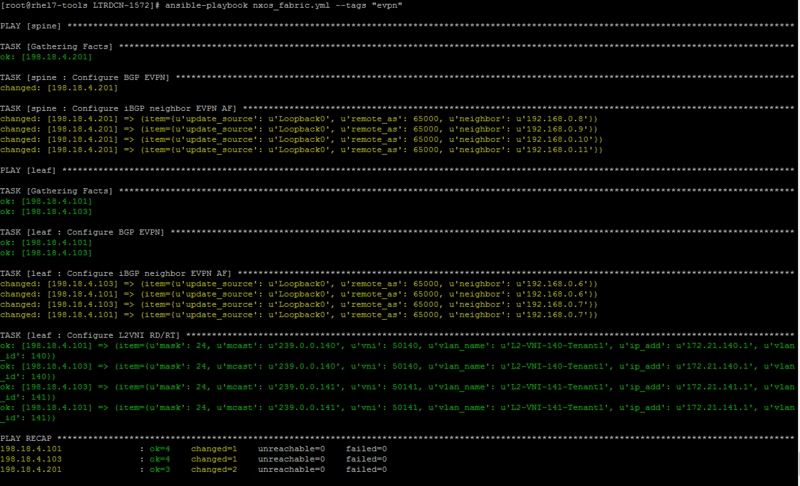

After successful execution of the playbook:

**Note: login to any leaf or spine switch to verify BGP EVPN configuration and evpn negibor from ‘show bgp l2vpn evpn summary’**

Below screenshot shows the output of above command from leaf-4 switch:

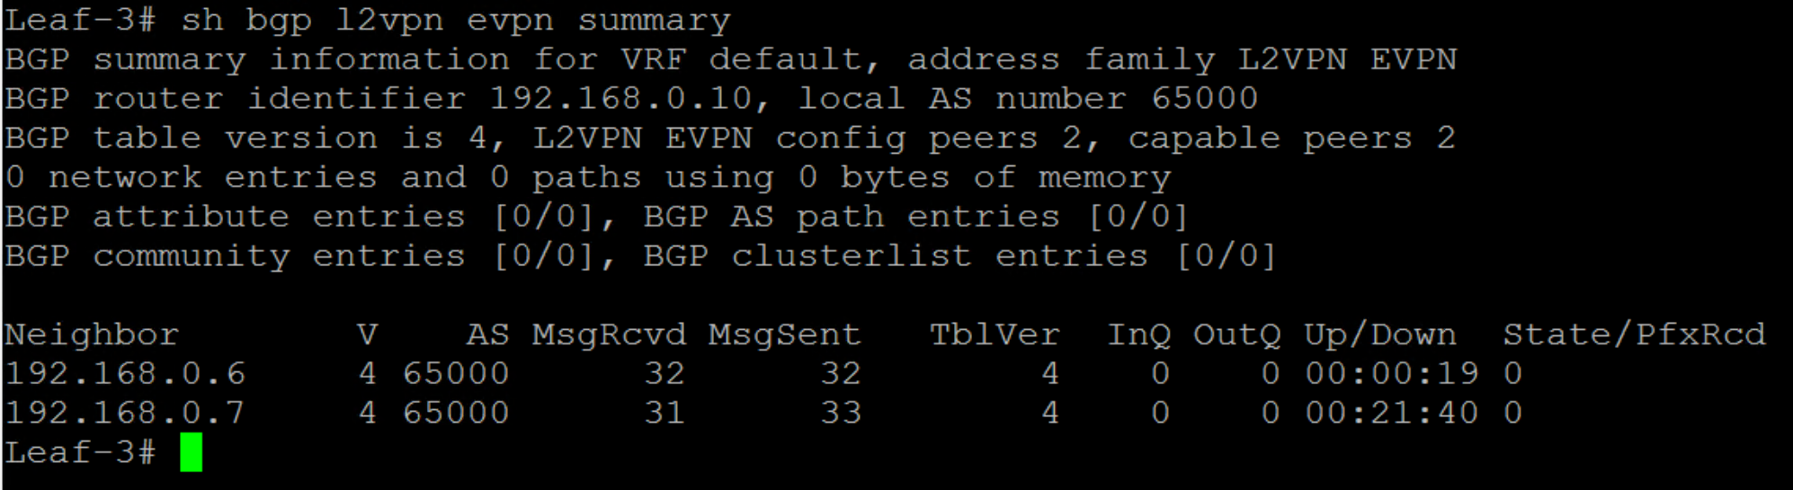

### Step 7: Run nxos_fabric playbook

Up on this point, you have run the playbook during each step. You could re-run the whole playbook without giving any tags, but no new changes should be maded to the switches.

|  |
| --- |
| [root@rhel7-tools LTRDCN-1572]# **ansible-playbook nxos_fabric.yml** |

Congratulation! You have just built VXLAN fabric using ansible + Jinja2 template and ansible + NXOS modules. Let’s verify the VXLAN bridging and VXLAN routing from servers that are pre-configured in following VLANs and IPs

|  |  |  |  |
| --- | --- | --- | --- |
| **Server Name** | **Connect to switch** | **In VLAN** | **IP** |
| Server-1 | Leaf-1 | 140 | 172.21.140.10 |
| Server-3 | Leaf-3 | 140 | 172.21.140.11 |
| Server-4 | Leaf-4 | 141 | 172.21.141.11 |

* Switch to **MTPuTTY** and connect to **server-1** with root/C1sco12345
* Ping default gateway from server-1

|  |
| --- |
| [root@server-1 ~]# ping 172.21.140.1  PING 172.21.140.1 (172.21.140.1) 56(84) bytes of data.  64 bytes from 172.21.140.1: icmp_seq=2 ttl=255 time=15.7 ms  64 bytes from 172.21.140.1: icmp_seq=3 ttl=255 time=4.11 ms |

* Ping server 3 and server 4

|  |
| --- |
| [[root@server-1 ~]# ping 172.21.140.11  PING 172.21.140.11 (172.21.140.11) 56(84) bytes of data.  64 bytes from 172.21.140.11: icmp_seq=1 ttl=64 time=1032 ms  64 bytes from 172.21.140.11: icmp_seq=2 ttl=64 time=35.7 ms  64 bytes from 172.21.140.11: icmp_seq=3 ttl=64 time=14.4 ms  ^C  --- 172.21.140.11 ping statistics ---  3 packets transmitted, 3 received, 0% packet loss, time 2112ms  rtt min/avg/max/mdev = 14.431/360.839/1032.335/474.899 ms, pipe 2  [root@server-1 ~]# ping 172.21.141.11  PING 172.21.141.11 (172.21.141.11) 56(84) bytes of data.  64 bytes from 172.21.141.11: icmp_seq=994 ttl=62 time=30.2 ms  64 bytes from 172.21.141.11: icmp_seq=995 ttl=62 time=16.1 ms  64 bytes from 172.21.141.11: icmp_seq=996 ttl=62 time=18.0 ms |

Task 5: Day 2 operation using Ansible

In this section, we will use automation to perform following day 2 operation tasks.

* Backup running configurations on all leaf and spine switches
* Verify underlay ospf, bgp and pim neighbors
* Verify overlay nve peer, host route, bgp update
* Baseline configuration comparison
* Add new VNIs into the existing fabric

### Step 1: backup running configurations

In this section, you will use **ios_config** module to backup running configuration on each switch, the backup file will be saved to a local **“backup”** folder. The backup argument create a full backup of the current running-config of each switch. The backup file is written to the backup folder in the playbook root directory. If the directory does not exist, it is created.

On **Atom**, open up the project folder **“LTRDCN-1572”** and create newfile under **“LTRDCN-1572”.** Name the new file **“get_config.yml”**. After entering below data in the file, make sure to save this file by Clicking on “File” 🡪 “Save” to make sure the file is uploaded to Ansible server.

|  |
| --- |
| ---  - hosts: spine,leaf,jinja2_leaf,jinja2_spine  connection: local  vars:  nxos_provider:  transport: nxapi  username: "{{ user }}"  password: "{{ pwd }}"  host: "{{ inventory_hostname }}"  tasks:  - name: save running  nxos_config:  provider: "{{ ios_provider }}"  backup: yes  timeout: 20 |

Run “**get_config.yml”** playbook and verify the backup configurations in “**backup”** folder.

|  |
| --- |
| [root@rhel7-tools LTRDCN-1572]# **ansible-playbook get_config.yml** [root@rhel7-tools LTRDCN-1572]# **ls -lrt** [root@rhel7-tools LTRDCN-1572]# **ls backup** |

You may further view the contents of the files under backup folder by using cat, less or more commands. Below screenshot shows the output of above commands

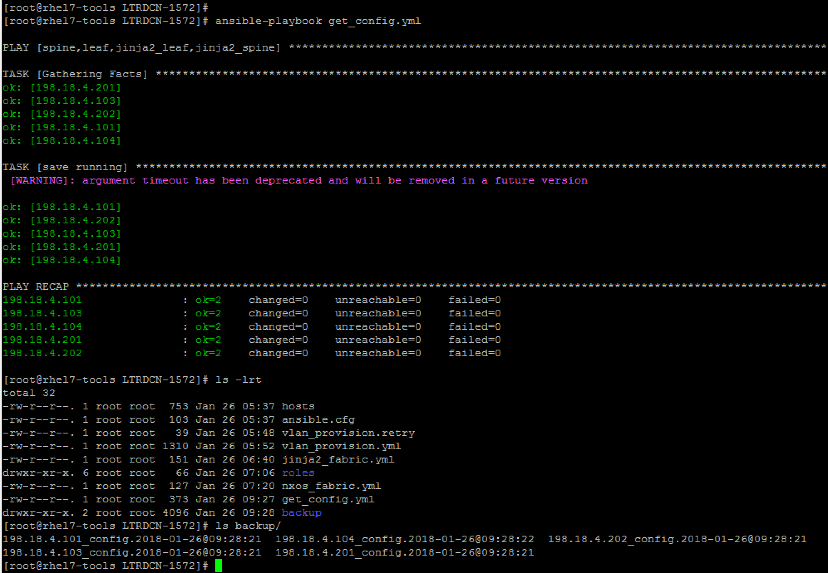

### Step 2: Verify underlay and overlay

In this section you will verify underlay and overlay operation using ansible playbook. The playbook will be applied to all leaf switches to verify

Underlay

* show ip ospf neighbor
* show ip bgp sum
* show ip pim neighbor

Overlay

* show nve vni
* show nve peer
* show ip route vrf Tenant-1
* show bgp l2vpn evpn
* show l2route evpn mac-ip all

On Atom, Open up the project folder **“LTRDCN-1572”** and create newfile under **“LTRDCN-1572”.** Name the new file **“verify_fabric.yml”**

|  |
| --- |
| ---  - hosts: leaf, jinja2_leaf  connection: local  gather_facts: false  vars:  ios_provider:  username: "{{ user }}"  password: "{{ pwd }}"  timeout: 30  host: "{{ inventory_hostname }}"  tasks:  - name: verify underlay  register: underlay_output  ios_command:  provider: "{{ ios_provider }}"  commands:  - show ip ospf neighbors  - show ip bgp sum  - show ip pim neighbor  tags: underlay  - debug: var=underlay_output.stdout_lines  tags: underlay  # - copy: content="{{underlay_output | to_nice_json}}" dest="verify/{{inventory_hostname}}_underlay"  - name: Verify Overlay  register: overlay_output  ios_command:  provider: "{{ ios_provider }}"  commands:  - show nve vni  - show nve peer  - show ip route vrf Tenant-1  - show bgp l2vpn evpn  - show l2route evpn mac-ip all  tags: overlay  - debug: var=overlay_output.stdout_lines  tags: overlay |

Run “**verify_fabric.yml”** playbook and verify the output for underlay

The output shows ospf, bgp and pim neighbors for all leaf switches

|  |
| --- |
| [root@rhel7-tools LTRDCN-1572]# **ansible-playbook verify_fabric.yml --tags “underlay”** |

Below screenshot shows the partial output of above command:

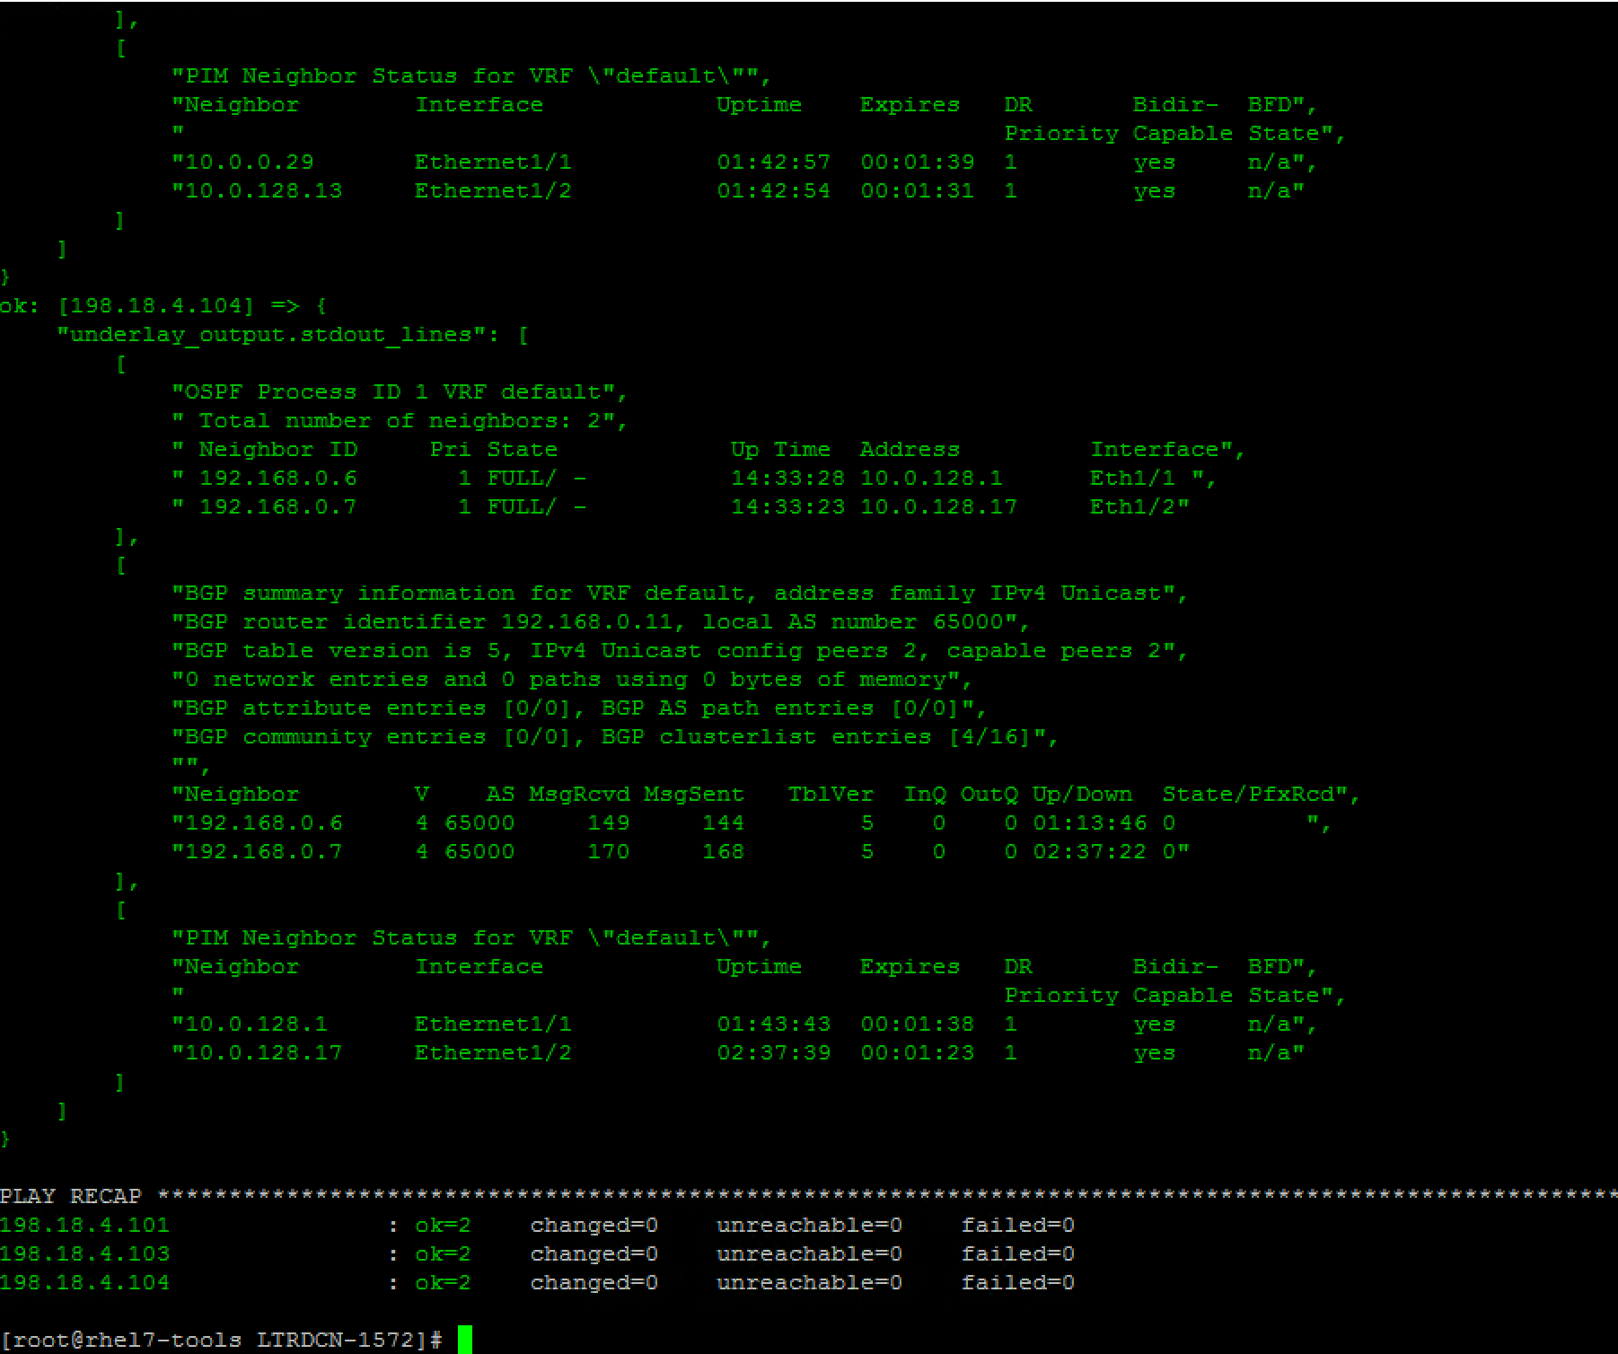

|  |
| --- |
| [root@rhel7-tools LTRDCN-1572]# ansible-playbook verify_fabric.yml --tags "underlay"  PLAY [leaf, jinja2_leaf] ************************************************************************************************************************************************  TASK [verify underlay] **************************************************************************************************************************************************  [WARNING]: argument username has been deprecated and will be removed in a future version  [WARNING]: argument timeout has been deprecated and will be removed in a future version  [WARNING]: argument password has been deprecated and will be removed in a future version  ok: [198.18.4.101]  ok: [198.18.4.104]  ok: [198.18.4.103]  TASK [debug] ************************************************************************************************************************************************************  ok: [198.18.4.101] => {  "underlay_output.stdout_lines": [  [  "OSPF Process ID 1 VRF default",  " Total number of neighbors: 2",  " Neighbor ID Pri State Up Time Address Interface",  " 192.168.0.6 1 FULL/ - 1d03h 10.0.0.21 Eth1/1 ",  " 192.168.0.7 1 FULL/ - 1d03h 10.0.128.5 Eth1/2"  ],  [  "BGP summary information for VRF default, address family IPv4 Unicast",  "BGP router identifier 192.168.0.8, local AS number 65000",  "BGP table version is 8, IPv4 Unicast config peers 2, capable peers 2",  "0 network entries and 0 paths using 0 bytes of memory",  "BGP attribute entries [0/0], BGP AS path entries [0/0]",  "BGP community entries [0/0], BGP clusterlist entries [0/0]",  "",  "Neighbor V AS MsgRcvd MsgSent TblVer InQ OutQ Up/Down State/PfxRcd",  "192.168.0.6 4 65000 52 54 8 0 0 00:24:18 0 ",  "192.168.0.7 4 65000 47 49 8 0 0 00:30:45 0"  ],  [  "PIM Neighbor Status for VRF \"default\"",  "Neighbor Interface Uptime Expires DR Bidir- BFD",  " Priority Capable State",  "10.0.0.21 Ethernet1/1 00:15:51 00:01:43 1 yes n/a",  "10.0.128.5 Ethernet1/2 00:15:45 00:01:23 1 yes n/a"  ]  ]  }  ok: [198.18.4.104] => {  "underlay_output.stdout_lines": [  [  "OSPF Process ID 1 VRF default",  " Total number of neighbors: 2",  " Neighbor ID Pri State Up Time Address Interface",  " 192.168.0.6 1 FULL/ - 10:20:18 10.0.128.1 Eth1/1 ",  " 192.168.0.7 1 FULL/ - 10:20:15 10.0.128.17 Eth1/2"  ],  [  "BGP summary information for VRF default, address family IPv4 Unicast",  "BGP router identifier 192.168.0.11, local AS number 65000",  "BGP table version is 4, IPv4 Unicast config peers 2, capable peers 2",  "0 network entries and 0 paths using 0 bytes of memory",  "BGP attribute entries [0/0], BGP AS path entries [0/0]",  "BGP community entries [0/0], BGP clusterlist entries [0/0]",  "",  "Neighbor V AS MsgRcvd MsgSent TblVer InQ OutQ Up/Down State/PfxRcd",  "192.168.0.6 4 65000 32 32 4 0 0 00:24:03 0 ",  "192.168.0.7 4 65000 34 34 4 0 0 00:25:16 0"  ],  [  "PIM Neighbor Status for VRF \"default\"",  "Neighbor Interface Uptime Expires DR Bidir- BFD",  " Priority Capable State",  "10.0.128.1 Ethernet1/1 00:19:15 00:01:31 1 yes n/a",  "10.0.128.17 Ethernet1/2 00:25:43 00:01:18 1 yes n/a"  ]  ]  }  ok: [198.18.4.103] => {  "underlay_output.stdout_lines": [  [  "OSPF Process ID 1 VRF default",  " Total number of neighbors: 2",  " Neighbor ID Pri State Up Time Address Interface",  " 192.168.0.6 1 FULL/ - 1d03h 10.0.0.29 Eth1/1 ",  " 192.168.0.7 1 FULL/ - 1d03h 10.0.128.13 Eth1/2"  ],  [  "BGP summary information for VRF default, address family IPv4 Unicast",  "BGP router identifier 192.168.0.10, local AS number 65000",  "BGP table version is 8, IPv4 Unicast config peers 2, capable peers 2",  "0 network entries and 0 paths using 0 bytes of memory",  "BGP attribute entries [0/0], BGP AS path entries [0/0]",  "BGP community entries [0/0], BGP clusterlist entries [0/0]",  "",  "Neighbor V AS MsgRcvd MsgSent TblVer InQ OutQ Up/Down State/PfxRcd",  "192.168.0.6 4 65000 52 53 8 0 0 00:24:19 0 ",  "192.168.0.7 4 65000 47 49 8 0 0 00:30:47 0"  ],  [  "PIM Neighbor Status for VRF \"default\"",  "Neighbor Interface Uptime Expires DR Bidir- BFD",  " Priority Capable State",  "10.0.0.29 Ethernet1/1 00:15:53 00:01:23 1 yes n/a",  "10.0.128.13 Ethernet1/2 00:15:47 00:01:37 1 yes n/a"  ]  ]  }  PLAY RECAP **************************************************************************************************************************************************************  198.18.4.101 : ok=2 changed=0 unreachable=0 failed=0  198.18.4.103 : ok=2 changed=0 unreachable=0 failed=0  198.18.4.104 : ok=2 changed=0 unreachable=0 failed=0 |

Run “**verify_fabric.yml”** playbook and verify the output for overlay

The output shows nve tunnel peer, host route in bgp EVPN from all leaf switches

|  |
| --- |
| [root@rhel7-tools LTRDCN-1572]# **ansible-playbook verify_fabric.yml --tags “overlay”** |

Below screenshot of the partial output of above command:

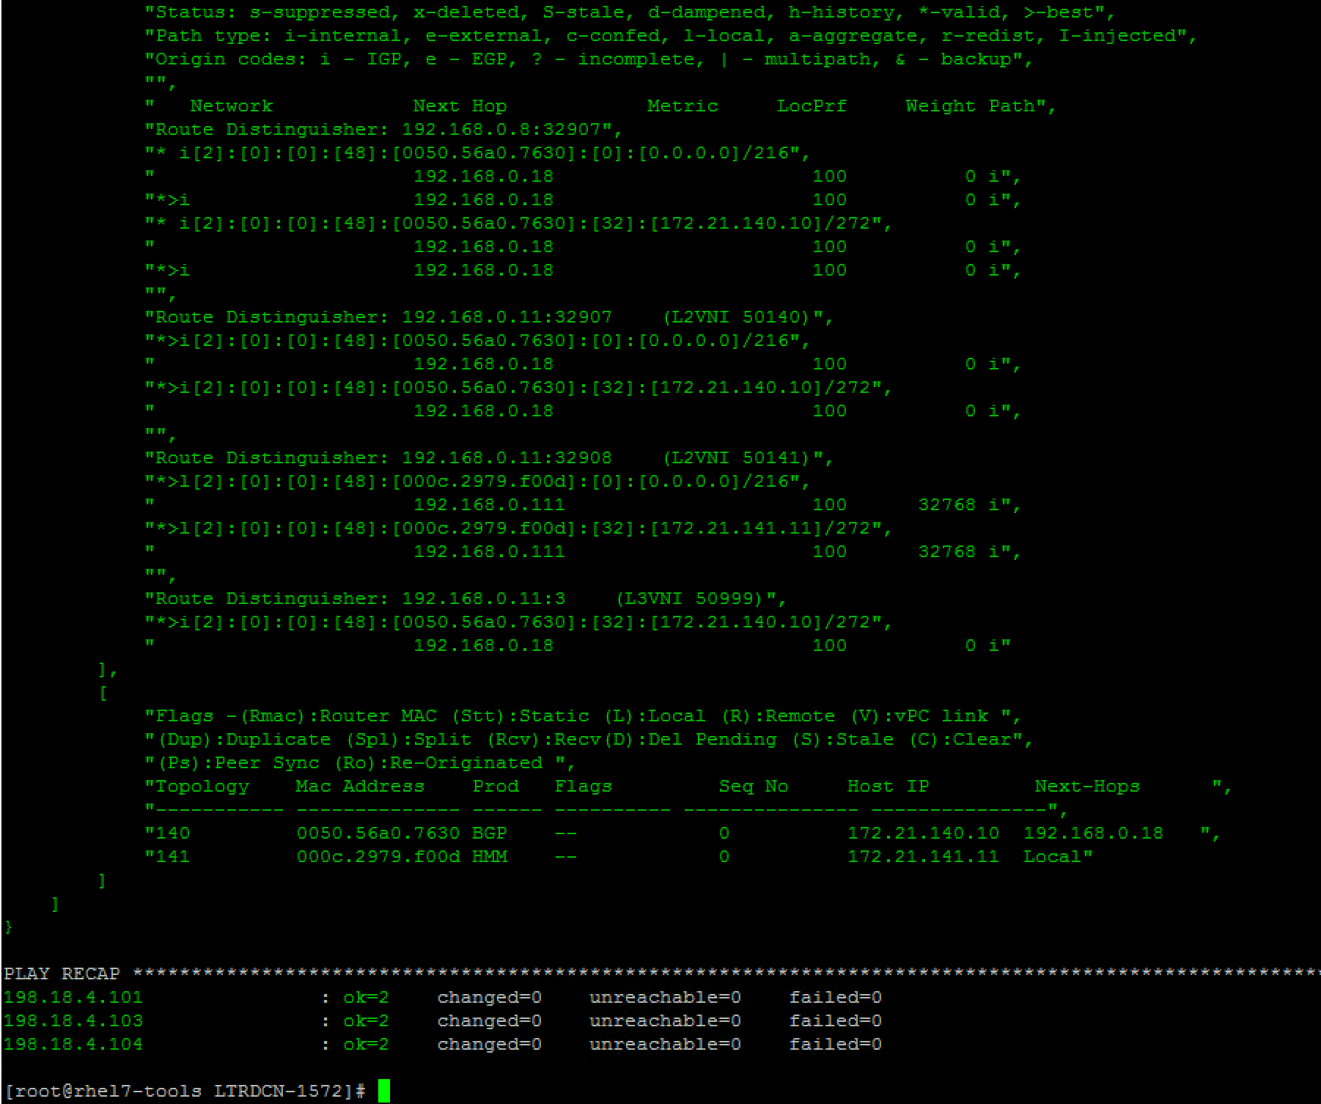

Verify the output for **vne vni** status, **vne** dynamic neighbors, **type host mac+ip evpn route update for each L2VNI, l2fib** information.

|  |
| --- |
| [root@rhel7-tools LTRDCN-1572]# ansible-playbook verify_fabric.yml --tags "overlay"  PLAY [leaf, jinja2_leaf] **********************************************************************************************************************************************  TASK [Verify Overlay] *************************************************************************************************************************************************  [WARNING]: argument username has been deprecated and will be removed in a future version  [WARNING]: argument timeout has been deprecated and will be removed in a future version  [WARNING]: argument password has been deprecated and will be removed in a future version  ok: [198.18.4.101]  ok: [198.18.4.104]  ok: [198.18.4.103]  TASK [debug] **********************************************************************************************************************************************************  ok: [198.18.4.101] => {  "overlay_output.stdout_lines": [  [  "Codes: CP - Control Plane DP - Data Plane ",  " UC - Unconfigured SA - Suppress ARP ",  " SU - Suppress Unknown Unicast",  " ",  "Interface VNI Multicast-group State Mode Type [BD/VRF] Flags",  "--------- -------- ----------------- ----- ---- ------------------ -----",  "nve1 50140 239.0.0.140 Up CP L2 [140] ",  "nve1 50141 239.0.0.141 Up CP L2 [141] ",  "nve1 50999 n/a Up CP L3 [Tenant-1]"  ],  [  "Interface Peer-IP State LearnType Uptime Router-Mac ",  "--------- --------------- ----- --------- -------- -----------------",  "nve1 192.168.0.110 Up CP 00:03:19 000c.2939.f53f ",  "nve1 192.168.0.111 Up CP 00:01:12 000c.2951.176f"  ],  [  "IP Route Table for VRF \"Tenant-1\"",  "'*' denotes best ucast next-hop",  "'**' denotes best mcast next-hop",  "'[x/y]' denotes [preference/metric]",  "'%<string>' in via output denotes VRF <string>",  "",  "172.21.140.0/24, ubest/mbest: 1/0, attached",  " *via 172.21.140.1, Vlan140, [0/0], 00:05:39, direct",  "172.21.140.1/32, ubest/mbest: 1/0, attached",  " *via 172.21.140.1, Vlan140, [0/0], 00:05:39, local",  "172.21.140.10/32, ubest/mbest: 1/0, attached",  " *via 172.21.140.10, Vlan140, [190/0], 00:05:33, hmm",  "172.21.140.11/32, ubest/mbest: 1/0",  " *via 192.168.0.110%default, [200/0], 00:01:50, bgp-65000, internal, tag 65000 (evpn) segid: 50999 tunnelid: 0xc0a8006e encap: VXLAN",  " ",  "172.21.141.0/24, ubest/mbest: 1/0, attached",  " *via 172.21.141.1, Vlan141, [0/0], 00:05:38, direct",  "172.21.141.1/32, ubest/mbest: 1/0, attached",  " *via 172.21.141.1, Vlan141, [0/0], 00:05:38, local",  "172.21.141.11/32, ubest/mbest: 1/0",  " *via 192.168.0.111%default, [200/0], 00:01:12, bgp-65000, internal, tag 65000 (evpn) segid: 50999 tunnelid: 0xc0a8006f encap: VXLAN"  ],  [  "BGP routing table information for VRF default, address family L2VPN EVPN",  "BGP table version is 35, Local Router ID is 192.168.0.8",  "Status: s-suppressed, x-deleted, S-stale, d-dampened, h-history, *-valid, >-best",  "Path type: i-internal, e-external, c-confed, l-local, a-aggregate, r-redist, I-injected",  "Origin codes: i - IGP, e - EGP, ? - incomplete, | - multipath, & - backup",  "",  " Network Next Hop Metric LocPrf Weight Path",  "Route Distinguisher: 192.168.0.8:32907 (L2VNI 50140)",  "*>i[2]:[0]:[0]:[48]:[0050.56a0.b5d1]:[0]:[0.0.0.0]/216",  " 192.168.0.110 100 0 i",  "*>l[2]:[0]:[0]:[48]:[0050.56a0.7630]:[32]:[172.21.140.10]/272",  " 192.168.0.18 100 32768 i",  "*>i[2]:[0]:[0]:[48]:[0050.56a0.b5d1]:[32]:[172.21.140.11]/272",  " 192.168.0.110 100 0 i",  "",  "Route Distinguisher: 192.168.0.8:32908 (L2VNI 50141)",  "*>i[2]:[0]:[0]:[48]:[000c.2979.f00d]:[0]:[0.0.0.0]/216",  " 192.168.0.111 100 0 i",  "*>i[2]:[0]:[0]:[48]:[000c.2979.f00d]:[32]:[172.21.141.11]/272",  " 192.168.0.111 100 0 i",  "",  "Route Distinguisher: 192.168.0.10:32907",  "* i[2]:[0]:[0]:[48]:[0050.56a0.b5d1]:[0]:[0.0.0.0]/216",  " 192.168.0.110 100 0 i",  "*>i 192.168.0.110 100 0 i",  "*>i[2]:[0]:[0]:[48]:[0050.56a0.b5d1]:[32]:[172.21.140.11]/272",  " 192.168.0.110 100 0 i",  "* i 192.168.0.110 100 0 i",  "",  "Route Distinguisher: 192.168.0.11:32908",  "* i[2]:[0]:[0]:[48]:[000c.2979.f00d]:[0]:[0.0.0.0]/216",  " 192.168.0.111 100 0 i",  "*>i 192.168.0.111 100 0 i",  "*>i[2]:[0]:[0]:[48]:[000c.2979.f00d]:[32]:[172.21.141.11]/272",  " 192.168.0.111 100 0 i",  "* i 192.168.0.111 100 0 i",  "",  "Route Distinguisher: 192.168.0.8:3 (L3VNI 50999)",  "*>i[2]:[0]:[0]:[48]:[000c.2979.f00d]:[32]:[172.21.141.11]/272",  " 192.168.0.111 100 0 i",  "*>i[2]:[0]:[0]:[48]:[0050.56a0.b5d1]:[32]:[172.21.140.11]/272",  " 192.168.0.110 100 0 i"  ],  [  "Flags -(Rmac):Router MAC (Stt):Static (L):Local (R):Remote (V):vPC link ",  "(Dup):Duplicate (Spl):Split (Rcv):Recv(D):Del Pending (S):Stale (C):Clear",  "(Ps):Peer Sync (Ro):Re-Originated ",  "Topology Mac Address Prod Flags Seq No Host IP Next-Hops ",  "----------- -------------- ------ ---------- --------------- ---------------",  "140 0050.56a0.7630 HMM -- 0 172.21.140.10 Local ",  "140 0050.56a0.b5d1 BGP -- 0 172.21.140.11 192.168.0.110 ",  "141 000c.2979.f00d BGP -- 1 172.21.141.11 192.168.0.111"  ]  ]  } |

### Step 3: Baseline configuration comparison

In this section we will compare the running configuration with baseline configuration for configuration compliance check. The configuration file that we backed in tak 1 will be used as baseline configuration.

In this playbook, you will use “**lookup”** module to find the backup filename generated in Step 1. Then you will use **diff_against** function in **nxos_config** module to compare running configuration.

On Atom, Open up the project folder **“LTRDCN-1572”** and create newfile under **“LTRDCN-1572”.** Name the new file **“verify_config.yml”**

|  |
| --- |
| ---  - hosts: jinja2_leaf,leaf,jinja2_spine,spine  connection: local  gather_facts: flase  vars:  nxos_provider:  transport: nxapi  username: "{{ user }}"  password: "{{ pwd }}"  timeout: 30  host: "{{ inventory_hostname }}"  filename: "{{ lookup('pipe', 'ls backup/{{ inventory_hostname}}_config.*')}}"  tasks:  - name: configure compliance  register: diff_config  # when: (inventory_hostname in groups['leaf']) or (inventory_hostname in groups['jinja2_leaf'])  nxos_config:  provider: "{{ nxos_provider }}"  diff_against: intended  intended_config: "{{ lookup('file', '{{filename}}') }}" |

**Before** you run this playbook, SSH into leaf-4 to make some configuration change.

|  |
| --- |
| Leaf-4# **conf t**  Enter configuration commands, one per line. End with CNTL/Z.  Leaf-4(config)# **no router bgp 65000**  Leaf-4(config)# **copy run start**  [########################################] 100%  Leaf-4(config)# **end** |

On the Ansible server, run the playbook for configuration compliance check

The delta between current running config and base line config are highlighted in RED from the result

|  |
| --- |
| [root@rhel7-tools LTRDCN-1572]# **ansible-playbook --diff verify_config.yml** |

Below partial screenshot shows the output of above command:

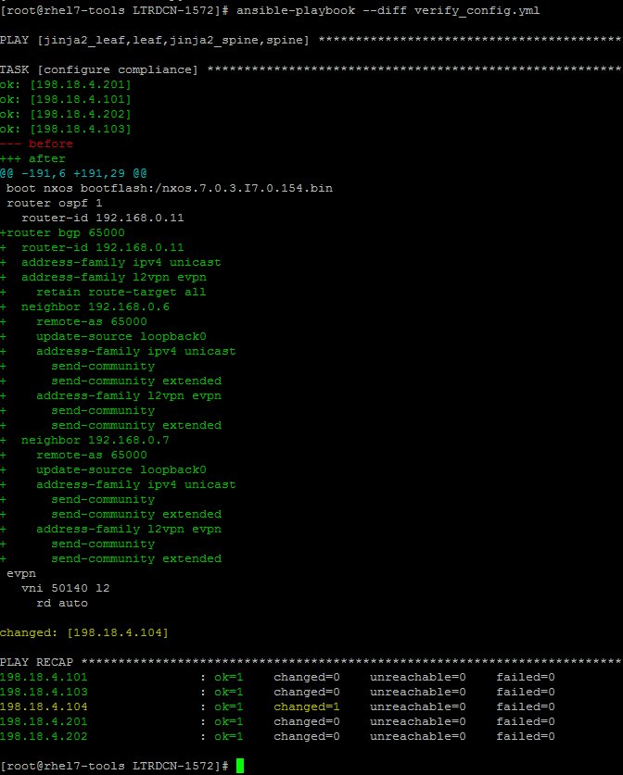

Bring leaf-4 back to the baseline config

|  |
| --- |
| [root@rhel7-tools LTRDCN-1572]# **ansible-playbook jinja2_fabric.yml --limit=198.18.4.104** |

Below screenshot shows the output of above command. You can also log into leaf-4 and verify that bgp configurations are back:

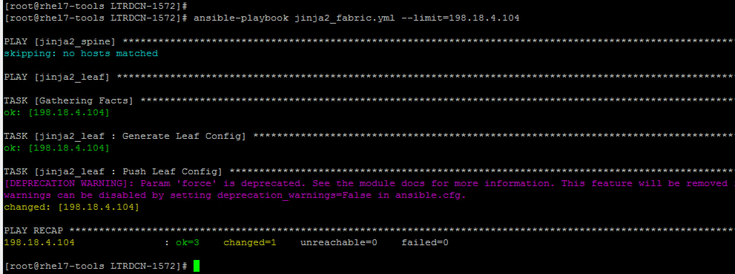

### Step 4: Add new VNI

In this section, we will introduce following new VNI into the VXLAN fabric.

|  |  |  |  |  |  |
| --- | --- | --- | --- | --- | --- |
| VLAN ID | VLAN Name | VNI | IP_Add | mask | Mcast |
| 200 | L2-VNI-200-Tenant1 | 50200 | 172.21.200.1 | 24 | 239.0.0.200 |
| 201 | L2-VNI-201-Tenant1 | 50201 | 172.21.201.1 | 24 | 239.0.0.201 |

* First we will creat a new role, and name it “**vni_provision”** under folder roles using **ansible-galaxy**

|  |
| --- |
| [root@rhel7-tools LTRDCN-1572]# **cd roles/**  [root@rhel7-tools roles]# **ansible-galaxy init vni_provision**  - vni_provision was created successfully |

* Ansible-galaxy init will create new role with base role structure and empty main.yml file as role requires.
* Switch to “**Atom”** and sync the new created folders between Ansible node and remote desktop. Right click on project folder “**LTRDCN-1572”,** open “**Remote Sync”** select **“Download Folder”**

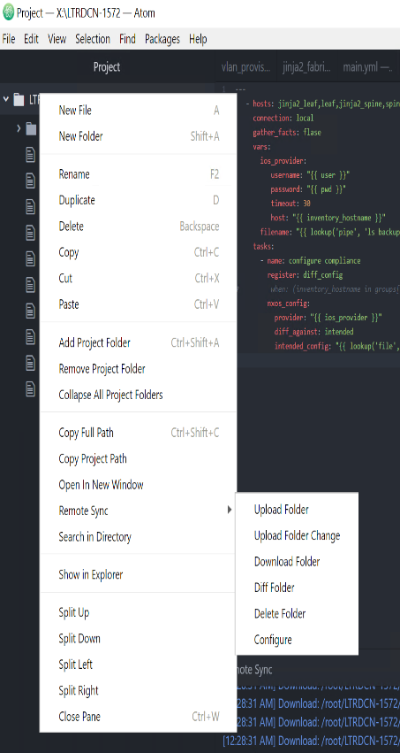

* Edit variable file **main.yml** for “**vni_provision”** role under “/root/LTRDCN-1572/roles/vni_provision/vars”

|  |
| --- |
| ---  # vars file for vni_provision  nxos_provider:  username: "{{ user }}"  password: "{{ pwd }}"  transport: nxapi  timeout: 30  host: "{{ inventory_hostname }}"  L2VNI:  - { vlan_id: 200, vni: 50200, ip_add: 172.21.200.1, mask: 24, vlan_name: L2-VNI-200-Tenant1, mcast: 239.0.0.200 }  - { vlan_id: 201, vni: 50201, ip_add: 172.21.201.1, mask: 24, vlan_name: L2-VNI-201-Tenant1, mcast: 239.0.0.201 } |

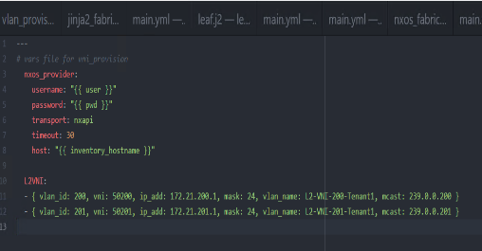

Edit playbook file **‘mail.yml’** for “**vni_provision”** role under **“/root/LTRDCN-1572/roles/vni_provision/tasks**”

**Note: It is recommended to write your playbook and learn from mistakes, but file is also available in the box folder if you prefer to reuse.**

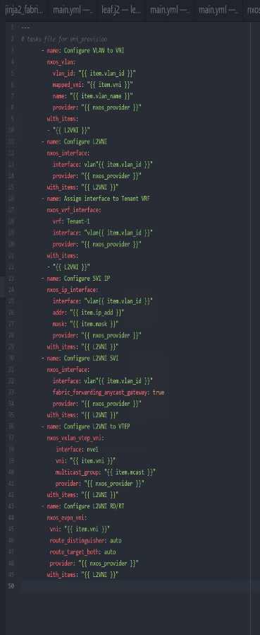

|  |
| --- |
| ---  # tasks file for vni_provision  - name: Configure VLAN to VNI  nxos_vlan:  vlan_id: "{{ item.vlan_id }}"  mapped_vni: "{{ item.vni }}"  name: "{{ item.vlan_name }}"  provider: "{{ nxos_provider }}"  with_items:  - "{{ L2VNI }}"  - name: Configure L2VNI  nxos_interface:  interface: vlan"{{ item.vlan_id }}"  provider: "{{ nxos_provider }}"  with_items: "{{ L2VNI }}"  - name: Assign interface to Tenant VRF  nxos_vrf_interface:  vrf: Tenant-1  interface: "vlan{{ item.vlan_id }}"  provider: "{{ nxos_provider }}"  with_items:  - "{{ L2VNI }}"  - name: Configure SVI IP  nxos_ip_interface:  interface: "vlan{{ item.vlan_id }}"  addr: "{{ item.ip_add }}"  mask: "{{ item.mask }}"  provider: "{{ nxos_provider }}"  with_items: "{{ L2VNI }}"  - name: Configure L2VNI SVI  nxos_interface:  interface: vlan"{{ item.vlan_id }}"  fabric_forwarding_anycast_gateway: true  provider: "{{ nxos_provider }}"  with_items: "{{ L2VNI }}"  - name: Configure L2VNI to VTEP  nxos_vxlan_vtep_vni:  interface: nve1  vni: "{{ item.vni }}"  multicast_group: "{{ item.mcast }}"  provider: "{{ nxos_provider }}"  with_items: "{{ L2VNI }}"  - name: Configure L2VNI RD/RT  nxos_evpn_vni:  vni: "{{ item.vni }}"  route_distinguisher: auto  route_target_both: auto  provider: "{{ nxos_provider }}"  with_items: "{{ L2VNI }}" |

* Switch to “Atom” create new playbook ‘**vni_provision.yml’** under project folder **LTRDCN-1572**.

|  |
| --- |
| ---  - hosts: leaf,jinja2_leaf  connection: local  roles:  - vni_provision |

* Run playbook **vni_provision.yml** to add new VNIs on the fabric

|  |
| --- |
| [root@rhel7-tools LTRDCN-1572]# **ansible-playbook vni_provision.yml** |

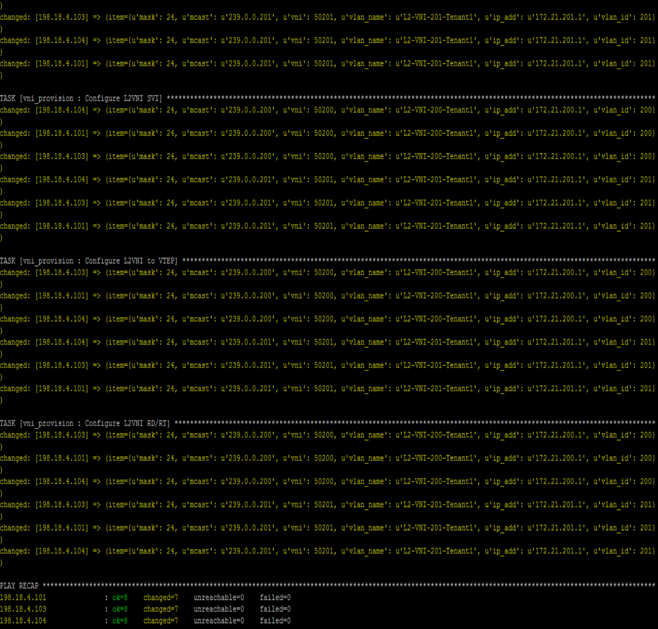

* Switch to **MTPutty** connect to **leaf-4,** verify the change on leaf switches using command **show nve vni.** Notice the new created L2VNI.

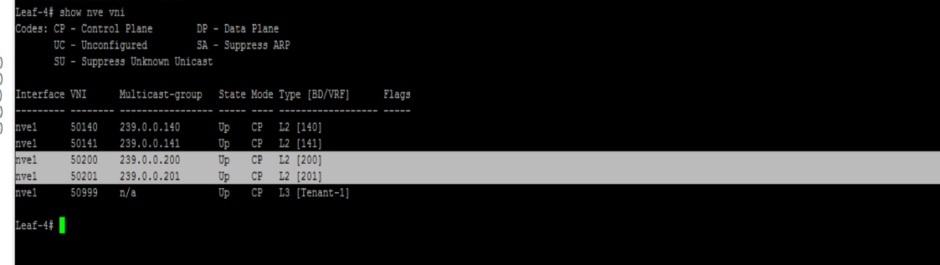

**Congratulation! You have completed VXLAN Fabric Lab.**

Appendix A: L4-L7 insertion

In this section, you will insert F5 BIG-IP load balancer into the fabric.

* First send out a http request from server-4 to a VIP, and you will notice no http service enabled on VIP.
* Run the playbook to enable http service on the VIP with server-1, server-2, server-3 and server-4 in the server pool.
* After successful execute the playbook, you will notice http request to VIP is load balanced across three servers.

### Step 1: Power on F5 Virtual Machine

* open **VMware vSphere Client** to login ESXi **(198.18.133.33)** using crendential **root/C1sco12345**

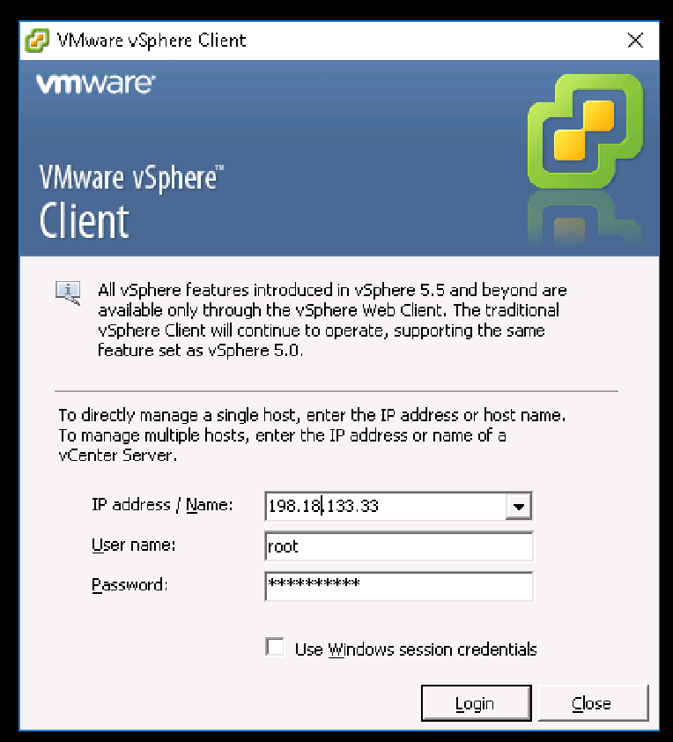

* Open up the VM under host **198.18.133.33,** and power on VM **F5_LTM**

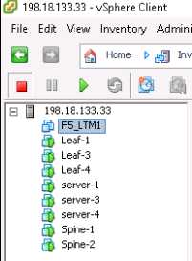

Step 2: Switch to **MTPuTTY** install prerequisites packages on **Ansible** node

|  |
| --- |
| [root@rhel7-tools LTRDCN-1572]# **pip install f5-sdk**  [root@rhel7-tools LTRDCN-1572]# **pip install setuptools --upgrade**  [root@rhel7-tools LTRDCN-1572]# **pip install bigsuds**  [root@rhel7-tools LTRDCN-1572]# **pip install netaddr** |

Step 3: Switch to **‘MTPuTTY’** ssh into server-4 and send http request to VIP 172.21.140.100 from server-4 using **curl**

|  |
| --- |
| [root@server-4 ~]# **curl http://172.21.140.100**  curl: (7) couldn't connect to host  [root@server-4 ~]# |

Step 4: Switch to Atom, create new file name **‘f5ltm.yml’** under project folder **LTRDCN-1572**

|  |
| --- |
| ---  - name: Configurating BIG-IP  hosts: localhost  gather_facts: false  tasks:  - name: Configure server facing port to L2  nxos_interface:  interface: eth1/4  mode: layer2  username: "{{ user }}"  password: "{{ pwd }}"  transport: nxapi  host: "198.18.4.104"  - name: Configure VLAN for F5 port  nxos_switchport:  interface: eth1/4  mode: access  access_vlan: 140  username: "{{ user }}"  password: "{{ pwd }}"  transport: nxapi  host: "198.18.4.104"  - name: Configure VLANs on the BIG-IP  bigip_vlan:  server: "198.18.4.10"  user: "admin"  password: "admin"  validate_certs: False  name: "External"  tag: "140"  untagged_interface: "1.1"  validate_certs: "no"  delegate_to: localhost  - name: Configure SELF-IPs on the BIG-IP  bigip_selfip:  server: "198.18.4.10"  user: "admin"  password: "admin"  validate_certs: False  name: "172.21.140.50"  address: "172.21.140.50"  netmask: "255.255.255.0"  vlan: "External"  allow_service: "default"  validate_certs: "no"  delegate_to: localhost  - name: Create static route  bigip_static_route:  server: "198.18.4.10"  user: "admin"  password: "admin"  validate_certs: False  destination: 0.0.0.0  netmask: 0.0.0.0  gateway_address: 172.21.140.1  name: "defult"  delegate_to: localhost  - name: Create nodes  bigip_node:  server: "198.18.4.10"  user: "admin"  password: "admin"  host: "{{item}}"  name: "{{item}}"  validate_certs: "no"  with_items:  - 172.21.140.10  - 172.21.140.11  - 172.21.141.10  - 172.21.141.11  delegate_to: localhost  - name: Create pool  bigip_pool:  server: "198.18.4.10"  user: "admin"  password: "admin"  name: "web-pool"  lb_method: "round-robin"  monitors: "/Common/http"  monitor_type: "and_list"  # quorum: 1  validate_certs: "no"  delegate_to: localhost  - name: Add Pool members  bigip_pool_member:  server: "198.18.4.10"  user: "admin"  password: "admin"  name: "{{item}}"  host: "{{item}}"  port: "80"  pool: "web-pool"  validate_certs: "no"  with_items:  - 172.21.140.10  - 172.21.140.11  - 172.21.141.10  - 172.21.141.11  delegate_to: localhost  - name: Add Virtual Server  bigip_virtual_server:  server: "198.18.4.10"  user: "admin"  password: "admin"  name: "http-virtualserver"  destination: "172.21.140.100"  port: "80"  enabled_vlans: "ALL"  all_profiles:  - http  pool: "web-pool"  snat: "Automap"  validate_certs: "no"  delegate_to: localhost |

Step 5: Run playbook **f5ltm.yml** to provision VIP (172.21.140.100) on F5 and also put all four servers into the server pool.

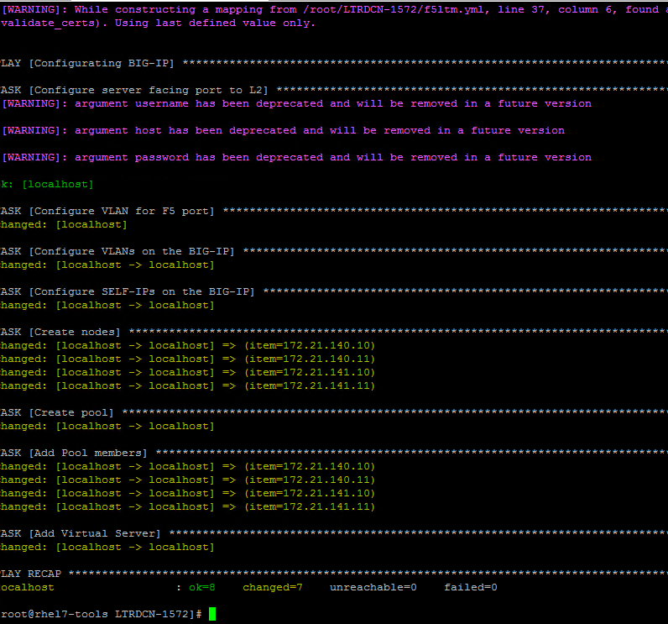

Step 6: Switch to **‘MTPuTTY’** login server-4, and run **‘curl <http://172.21.140.100>’** multiple times, you will see the request is load balanced to differernt servers in the sever pool.

|  |
| --- |
| [root@server-4 ~]# **curl http://172.21.140.100**  <html><body><h1>It works!</h1>  <p> Server-1 172.21.140.10 </p>  <p>This is the default web page for this server.</p>  <p>The web server software is running but no content has been added, yet.</p>  </body></html>  [root@server-4 ~]# **curl http://172.21.140.100**  <html><body><h1>It works!</h1>  <p> Server-3 172.21.140.11 </p>  <p>This is the default web page for this server.</p>  <p>The web server software is running but no content has been added, yet.</p>  </body></html>  [root@server-4 ~]# **curl http://172.21.140.100**  <html><body><h1>It works!</h1>  <p> Server-4 172.21.141.11 </p>  <p>This is the default web page for this server.</p>  <p>The web server software is running but no content has been added, yet.</p>  </body></html> |

Appendix B: Software compliance check and remediation

In this section, we will run software version compliance check using Ansible. For fabric switch that is not running on standard software version, we will perform software upgrade and bring all fabric switches into the standard version.

In this playbook, we will use “nxos_facts” to find the software version on each fabric switch. Then we will compare with standard software version, 7.0(3)I7(4) in this lab. For fabric switch that is not running on standard version, the playbook will upgrade and reboot the switch.

On **Atom,** open up the project folder “LTRDCN-1572” and create new file under “LTRDCN-1572”. Name the new file **“code_upgrade.yml”.**

|  |
| --- |
| ---  #Appendix code upgrade  - hosts: spine,leaf,jinja2_leaf,jinja2_spine  vars:  - standard: 7.0(3)I7(4)  - image_file: nxos.7.0.3.I7.4.bin  - nxos_provider:  username: "{{ user }}"  password: "{{ pwd }}"  transport: network_cli  timeout: 30  host: "{{ inventory_hostname }}"  tasks:  - name: "software complaince check"  nxos_facts:  gather_subset: all  provider: "{{nxos_provider}}"  - name: "change to standard code"  block:  - debug: msg="{{ansible_net_hostname}} is not running standard {{standard}}"  - nxos_feature:  feature: scp-server  provider: "{{nxos_provider}}"  state: enabled  - name: "upload image file"  nxos_file_copy:  local_file: "/root/downloads/{{image_file}}"  provider: "{{nxos_provider}}"  - name: "change boot statement"  nxos_config:  lines: boot nxos bootflash:{{image_file}}  save_when: modified  provider: "{{nxos_provider}}"  - name: "reload switch"  ios_command:  commands:  - command: reload  prompt: '(y/n)?'  answer: 'y'  username: "{{ user }}"  password: "{{ pwd }}"  when: ansible_net_version != standard  rescue:  - debug:  msg: "{{ansible_net_hostname}} is reloading"  - name: Wait For Device To Come Back Up  wait_for:  port: 22  state: started  timeout: 900  delay: 60  host: "{{ inventory_hostname }}"  always:  - debug:  msg: "All devices are running {{standard}}" |

On the Ansible server, run the playbook for software compliance check and code upgrade.

It is expected to see timeout error message when playbook reloads the switch.

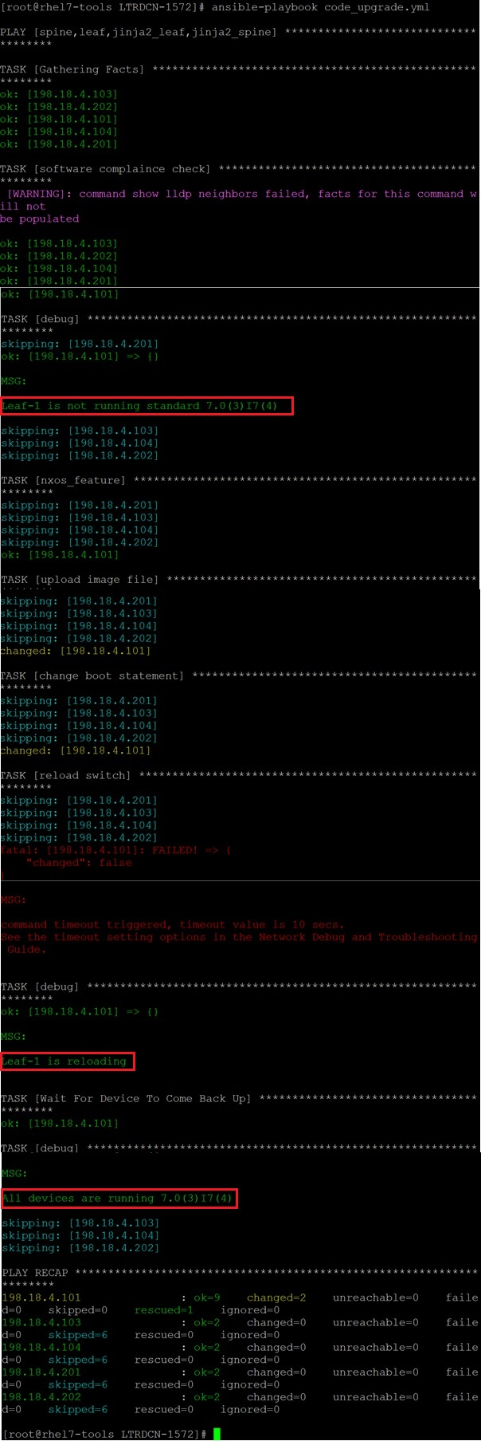

Switch will take 20 mins to bootup; up to this point, you have completed all tasks.

**Congratulation! You have completed the whole lab.**